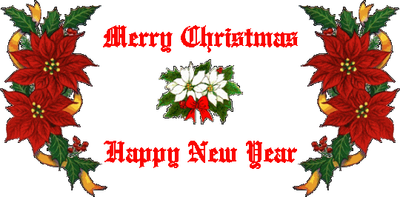

NFB OF UTAH CHRISTMAS PARTY
DECEMBER 17, 2016
11:00 – 1:00 PM
DSBVI CENTER 250 N. 1950 W.
$5.00 PER PERSON

It’s that time of year again. Our annual Christmas party is upon us. Come join us for a wonderful afternoon.
We will have lunch provided: ham, potatoes, salads, rolls and desert.
We are also having a talented group of people from the NFB perform for us. They will be playing instruments and singing songs.
We will be having a craft table for the kids to make and take home. We will also have lots of door prizes for you to win throughout the party.
We will also have a table set up for you to bring items to donate to the IRC refugees. This will be an awesome way to give back to our community.
So please mark your calendars and join us for a fun time.

A VERY SPECIAL VISITOR WILL BE ARRIVING DURING THE EVENT

