60th
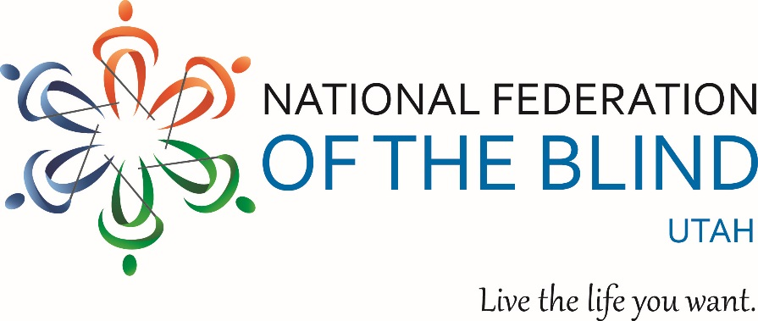

The National Federation of the Blind of Utah invites you to the

60th Anniversary Convention

A World of Promise & Possibility
April 13th, 14th & 15th, 2017
at the Marriot Downtown City Creek, in Salt Lake City.

Our 60th convention will feature:
- Dr. Fred Schroeder, President of the World Blind Union.
- Completely non-visual, beeping Easter Egg Hunt.
- Special sessions for parents of blind children, spouses, college students, and Vocational Rehab counselors.
- Information on the latest and best technology for persons with low vision or blindness.
- And much more…

Register for the convention by visiting: www.nfbutah.org.

Special hotel convention rate: ONLY $69 per night!
Follow this link to make on online reservation
Or call 1-800-228-9290
*Last date to reserve a room at this rate is: March 23, 2017

Join us for our Diamond Celebration in Salt Lake City!

