**Please join the partnership of Texas Roadhouse and the National Federation of the Blind.  Bring this flyer in and enjoy Legendary food and Texas Roadhouse will donate**

**10%**

**to the**

**National Federation of the Blind**

**Bring this flyer in on**

**Monday, October 9th**

**4:00 PM – 10:00 PM**

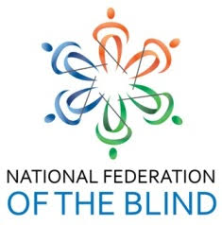

**801-572-7718**

**200 W 10600 S**

**Sandy, UT 84070**

**Please join the partnership of Texas Roadhouse and the National Federation of the Blind.  Bring this flyer in and enjoy Legendary food and Texas Roadhouse will donate**

**10%**

**to the**

**National Federation of the Blind**

**Bring this flyer in on**

**Monday, October 9th**

**4:00 PM – 10:00 PM**



**801-572-7718**

**200 W 10600 S**

**Sandy, UT 84070**

**801-572-7718**

**200 W 10600 S**

**Sandy, UT 84070**

**801-572-7718**

**200 W 10600 S**

**Sandy, UT 84070**