Save the Date
National Federation of the Blind of Utah 2018 Convention
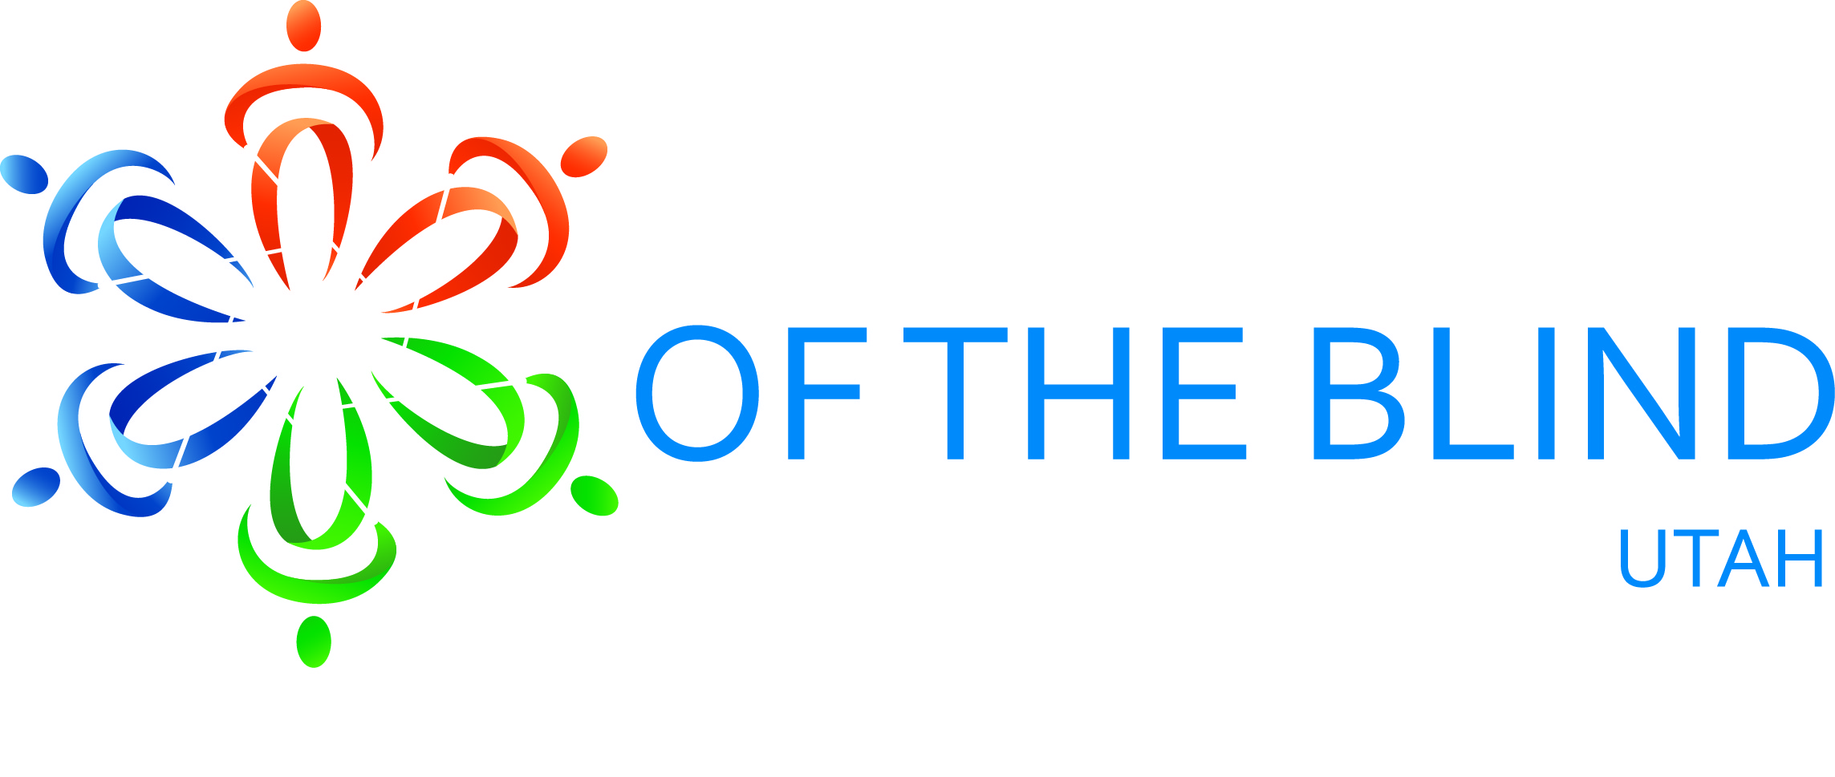

When: April 19th, 20th, & 21st, 2018

Where: Sheraton Hotel Downtown SLC
150 W 500 S, Salt Lake City, UT 84101
Room rates: $79/night
Reservations:

What to expect:
- Learn about the latest technology for the blind.
- Hear from blind professionals locally and nationally.
- Hear updates from state services for the blind and state library services.
- Mix and mingle with other parents of blind and VI children in Utah.
- Learn about services available for blind children and through vocational rehabilitation.
- Attend one of the state’s largest vendor fairs for blind and VI children and adults.
- Meet other blind people from around the state of Utah.

Keep checking the following for more details:
Website: www.nfbutah.org
Facebook: National Federation of the Blind of Utah/NFBU
Twitter: @NFBUtah

