2018 National Federation of the Blind of Utah/NFB of Utah
SCHOLARSHIP PROGRAM
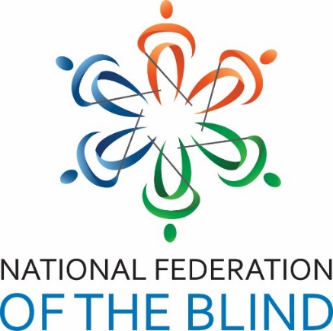
Where to Apply:
www.nfbutah.org
Email documents to deja.powell@gmail.com.

Who Can Apply?
- Anyone who is blind or visually impaired, and
- Anyone who is be currently residing in Utah, or plans to attend college in Utah for fall 2018, and
- Anyone who is pursuing or planning to pursue a full-time, postsecondary course of study in a program at a United States institution in the 2018 scholastic year, and
- Anyone who can commit to attending the entire NFB of Utah state convention April 19, 20, & 21, 2018 in Salt Lake City at the Sheraton Hotel, and
- Anyone who has not won two NFB of Utah scholarships in past.

Application Deadline:
March 31, 2018!!

Contact: NFB of Utah Scholarship Chairperson Deja Powell by email at deja.powell@gmail.com, or by phone at 801-891-3430.

