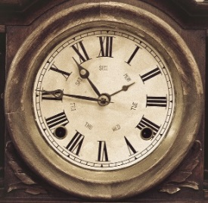
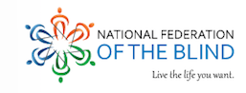
2018 National Federation of the Blind of Utah Convention

If not us, then who? If not now, then when?
The time is now!
― John E. Lewis

April 19th, 20th, & 21st, 2018
Register now: www.nfbutah.org

Sheraton Hotel Downtown SLC
150 W 500 S, Salt Lake City, UT 84101
Room rates: $79/night
Make your reservation by calling 1-888-627-8152.

Special Guests Include:
Utah Congressman Chris Stewart!

Ever Lee Hairston
NFB National Board Member, Advocate, Civil Right Leaders, Marched with Martin Luther King Jr., Motivational Speaker, and National Leader
Cary Supalo
President and founder of Independence Science, Research Developer at Educational Testing Service (ETS).
Highlights Include:
Important information for blind parents, spouses, family members, teachers, college students, educators, rehab professionals, and more.
The NFBU will be Awarding over $4,000 in college scholarships!!

