Taffy for Trip: Chance to WIN Two Roundtrip Airline Vouchers
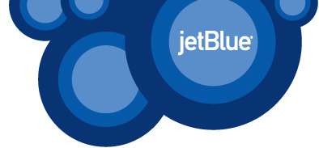
Are you dreaming of jetting off to an inspiring destination? Experiencing an uncommon, transformational, or once in a lifetime adventure? A romantic getaway? Or perhaps a vacation where you're lounging on the beach?
Your dream could become a reality with the purchase of a Taffy!
The National Federation of the Blind of Utah
is currently selling taffy for a chance to win FOUR ONE WAY (TWO ROUND TRIP) VOUCHERS donated by jetBlue Airlines to any destination jetBlue flies (jetBlue cities only, not affiliated airlines). Vouchers expire one year from date of issuance.
Taffy pieces are $10 each. For every taffy purchased, you will received one entry in the drawing, so the more you buy, the more chances you have to win. Taffy will be available for purchase from now until Saturday, April 21, 2018 at 12:00 PM. Cash, check, PayPal, or Venmo accepted, and credit cards will only be accepted at the NFBU 2018 Convention.
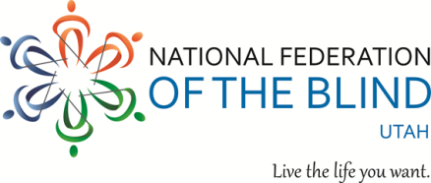
Options for purchasing taffy are:
In-Person
- National Federation of the Blind Utah Chapter Meetings
Follow link for more information: http://www.nfbutah.org/info/?page_id=22
- National Federation of the Blind Utah 2018 Convention
April 19th, 20th, & 21st, 2018
Sheraton Hotel Downtown SLC, 150 W 500 S, Salt Lake City, UT 84101
By Phone or Email Contact Jennifer Kennedy at msjenniferkennedy@gmail.com or 330-465-6245 to obtain information on purchasing taffy.
By Mail Purchase taffy by cash or a check made out to National Federation of the Blind: Utah, and mailed to 2900 West Lehman Avenue, Apt 180, West Valley City, UT 84119. Checks in the mail must be received no later than Saturday, April 14, 2018 to be eligible for the drawing. Please include the name, phone number and/or email address that you want on the entry(s). Upon receiving the check, entry(s) will be fill out with your information and photographed. The photographed copy will then be emailed to the purchaser; should no email be present, a copy will be mailed back to purchaser for record keeping purposes.
The winner will be selected Saturday, April 21, 2018
- Winner need not be present in order to win.
- Vouchers expire one year from date of issuance.
- Vouchers are subject to any restrictions and rules imposed by the airline including but not limited to tax(s), and blackout dates.
- For taffy purchased in person, the entry-holder must ensure that their name, email address and/or telephone number (including area code) are written on the portion of the entry(s) that is put in the drawing bin.
- Odds of winning depend on the number of taffy purchased.
- Winner must present a valid state issued photo ID or their entry stub with the winning number to receive the prize. If the winner is not present at the time of the drawing, they will be contacted by phone to make arrangements for delivery of their airline voucher.
- The National Federation of the Blind: Utah will be held harmless for any decision by the airline that may affect travel, etc. The National Federation of the Blind: Utah is not responsible for unreadable names or addresses, wrong phone numbers, or incorrect or unreadable email addresses.

