2019
National Federation of the Blind of Utah
Annual Convention
TOGETHER FORGING A
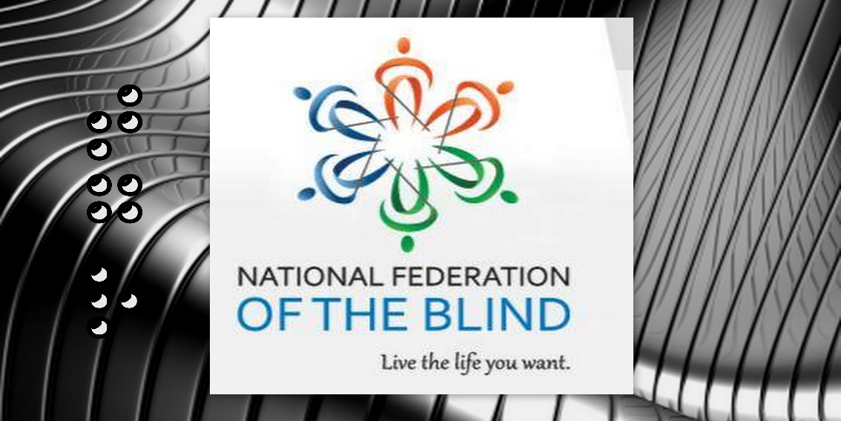
BRIGHTER FUTURE
April 11th, 12th, & 13th, 2019

Salt Lake City Sheraton
50 West 500 South, Salt Lake City, UT 84101
Register at: www.nfbutah.org

If you are using social media during our convention:
#NFBU19

You can live the life you want; blindness is not what holds you back.

The National Federation of the Blind Pledge
I pledge to participate actively in the efforts of the National Federation of the Blind to achieve equality, opportunity, and security for the blind; to support the programs and policies of the Federation; and to abide by its constitution.

NFB Mission Statement
In the National Federation of the Blind the blind and interested sighted persons come together to create programs to improve the quality of life of the blind; to provide a means of collective action for parents of blind children; to promote the vocational, cultural, and social advancement of the blind; to achieve the integration of the blind into society on a basis of equality with the sighted; and to take action which will improve the overall condition and standard of living of the blind. We work toward the removal of legal, economic, and social barriers to full participation by blind people in all aspects of community life. The NFB is the blind speaking for ourselves.

Who We Are
The National Federation of the Blind is the oldest and largest nationwide organization of blind Americans. Founded in 1940 and currently headquartered in Baltimore, the NFB consists of affiliates, chapters, and divisions in all fifty states, Washington, DC, and Puerto Rico.

Free White Cane Program
You can get a FREE white cane, every six months from the National Federation of the Blind. Visit: www.nfb.org to order yours today!

Convention Information

Convention Chairperson:
Deja Powell, 801-891-3430, deja.powell@gmail.com

Registration Chairperson:
Aaron Timm, ireneatimm@gmail.com

Door Prize Chairperson:
Jennifer Kennedy, msjenniferkennedy@gmail.com

Auction Chairperson/Auctioneer:
Daniel Ashman, djashman2007@gmail.com

Vendor Fair Chairperson:
Willie Black, judicialcorner@yahoo.com

Registration
Convention registration is $5 per person. Registration will be open before all general sessions (any additional times are stated in the agenda below). You may pay for registration, meals, and banquet tickets with cash or card. Registration will be held right outside the main general session ballrooms, in the Capitol Reef lobby.

Door Prizes
We will draw for a variety of door prizes during each general session and at the banquet. You must be registered with the convention in order to have your name placed in the drawing, and you must be present when your name is called order to win. You may win multiple door prizes, so be sure to arrive on time and attend every session.

Guide Dog Relief Areas
Parking for guide dogs is located on the north side of the hotel, across from the Alta room. There is an atrium located there for guide dog users; there are trash cans with special bags. Please be courteous and pick up after your dog at all times.

Hotel Layout
All meeting rooms are on the east side of the hotel on the main floor. When you come in the front doors of the hotel, turn right and head to the conference side/east side of the hotel. The restaurant is located on the northeast side of the lobby, and a Starbucks is in the southwest corner of the lobby. There are elevators next to the hotel restaurant that will take you to and from your rooms. There is also a gift shop, just south of the elevators, and east of Starbucks. Please feel free to explore the many restaurants and shops around the hotel, centrally located in downtown Salt Lake City.

Taffy for a Trip Program
You have a chance to WIN two roundtrip airline vouchers for anywhere JetBlue flies. Taffy is $10 a piece, and comes with a ticket for the drawing. Winner will be announced at the banquet, but you do NOT have to be present to win. Contact Jennifer Kennedy for details (phone: 330-465-6245; Email: msjenniferkennedy@gmail.com).

Special Research Opportunity:
A team of researchers at Utah State University, in partnership with the National Federation of the Blind of Utah, has received a grant from the National Science Foundation to support blind and low vision youth in Engineering. One aspect of this work involves measuring and improving spatial ability, a mental skill associated with success in engineering and related fields. The USU research team is currently developing an accessible spatial ability test by adapting an existing instrument into a new, tactile form. We are currently collecting preliminary data with this test in order to establish it as a reliable test. If you are interested in helping with the research by taking the test, please sign up for a time at a table near registration.

NFB of Utah Welcomes our 2019 Convention Honored Guests

NFB National Representative: Dr. Mark Maurer
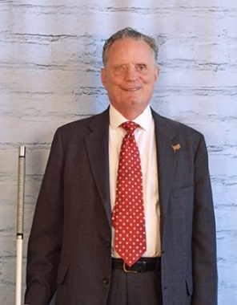
Marc Maurer was the president of the National Federation of the Blind (NFB), from 1986 until 2014. Maurer graduated cum laude from the University of Notre Dame in 1974. He later enrolled at the University of Indiana School of Law, where he received his Doctor of Jurisprudence in 1977. In 2010 he received honorary doctor of laws degrees from the University of South Carolina Upstate and the University of Notre Dame. At the 1986 NFB national convention, the membership elected Maurer as its new president, behind Dr. Kenneth Jernigan. Notable accomplishments of his tenure as president have been the building of the NFB's Jernigan Institute for research and the development of the Kurzweil-National Federation of the Blind Reader with inventor Ray Kurzweil. He continues to serve in many capacities in the National Federation of the Blind today after passing the torch to Mark Riccobono in July 2014.

Mrs. Patricia Maurer
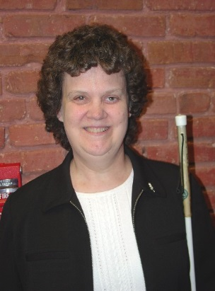
Mrs. Maurer currently works as Director of Community Relations for the National Federation of the Blind in Baltimore, Maryland. She served in a variety of capacities within the NFB organization for several years before joining the staff of the NFB Jernigan Institute in 2014. She served as the first lady of the National Federation of the Blind, where she took on many roles within the organization. Together, the Maurer’s raised two children, while working hard to advocate for blind people across the country.

Mayor Jackie Biskupski:
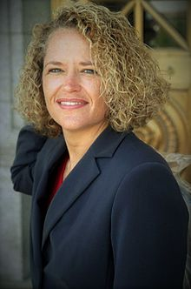
Ms. Biskupski was elected to the office of Salt Lake City mayor on January 4, 2016, becoming the 35th mayor of the city. Biskupski served in the Utah House of Representative (from the 30th district) from January 1999 to June 2011. After graduating from college, Biskupski opened her own private-investigation firm, and later went to work for the auto-insurance industry. Biskupski married her longtime partner Betty in 2016. Together they have two sons, Archie and Jack, who all live in Sugar House. This will be her final term at Mayor.

Conchita Hernandez:
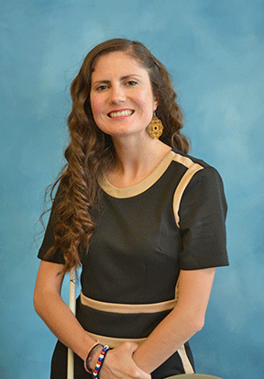
Miss Hernandez is currently the Statewide Low Incidence Specialist for the state of Maryland. She is also the founder and Chair of METAS (Mentoring Engaging and Teaching All Students), a non-profit organization that trains educators in Latin America that work with blind/low vision students. Miss Hernandez has a Bachelor's degree from Saint Mary’s College of California in International Studies, Spanish, and History. She also has a Master’s degree from Louisiana Tech University in teaching, with a focus on teaching blind students. She is currently a Doctoral student at George Washington University in Washington D.C., pursuing a degree in Special Education.

John Olsen
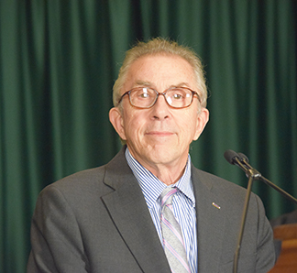
Photographer John Olsen in the president of 3DPhotoWorks, which creates tactile printing that delivers visual information to the blind who otherwise cannot access photographs. Working closely with leaders and blind volunteers from the blindness community, Mr. Olsen has developed technology that makes educational and cultural information available to blind people across the country and the world.

2019 Convention Agenda
All general sessions (beside breakout sessions) will be held in the Capitol Reef “A” Ballroom.

Thursday April 11, 2019

1:00 -4:00 pm: Early Exhibit for 3DPhotoWorks
Location: Solitude Room
Presentation on accessible art and photography including exhibition art.
Open to the public.

6:00-7:30 pm: Sponsor’s Reception & Membership Welcome Dinner
Location: Zion Ballroom
Come reunite or meet with members of the NFB of Utah. Socialize with special guests, members from across the country, convention sponsors and vendors, and enjoy free food!
*FREE to ALL registered convention attendees.

7:30-8:30 pm: Early Registration
Location: Canyons Lobby (right outside main ballrooms).
Avoid longer lines by coming to our early bird registration.
Registration Fee: $5 per person, $10 per family
Meals: Varies
Affiliate Membership Dues: $1

7:00-9:00 pm: 3DPhotoWorks Exhibit
Location: Solitude Room.
Presentation on accessible art and photography by 3DPhotoWorks. Comes experience hands-on photography like you’ve never seen before. Come experience photography from museums across the world right at your fingertips.

7:00-8:00 pm: Blind Video Gaming, Hands-On Experience
Location: Sidewinder Room
Taron Vining is a blind gamer, Salt Lake chapter member, and NFBU Project STRIVE member. Come learn how blind people play video games. Learn about the latest technology and have some fun while you’re at it. Live demonstrations will be available.

8:00-9:30 pm: Resolutions Committee Meeting
Location: Wildcat Room
Resolutions Chairperson: Karl Smith
Come learn about the 2019 resolutions that will be presented at this year’s convention. All are welcome.

8:00-11:00 pm: NFBU Bingo Night
Location: Zion Ballroom
Come play accessible BINGO for fun and prizes. It will be a great night to unwind and have fun with NFBU members. All Bingo boards are fully accessible.

Friday April 12, 2019

7:00 am: Convention Registration
Location: Canyons Lobby
Registration: $5 per person, $10 per family
Meal: Varies
Affiliate Membership dues: $1

7:45-8:45 am: Board of Directors Breakfast
Location: Capitol Reef “B” Ballroom
Invocation: Mark Turley
Moderator: Everette Bacon, affiliate president
Come hear from the board of Directors of the NFB of Utah, and various venders who will be present at this year’s convention. Come and hear a BIG ANNOUNCEMENT ABOUT NATIONAL CONVENTION!

Friday Morning General Session
Capitol Reef “A” Ballroom

9:00 am: Call to Order and Welcome Ceremony
Invocation: Dr. Edwin Lindholm
National Anthem: Miss Josie Long, violinist.
Special Welcome Ceremony
NFB Pledge: Maeve Erb, 4-years-old NFBU Bell Academy Graduate
Welcome: Everette Bacon, NFBU President.

9:20 am: Welcome to Salt Lake City, Mayor Jackie Biskupski

9:40 am: NFB National Report: Collectively Shaping our Future, Dr. Mark Maurer, immediate past president of the National Federation of the Blind,.

10:15 am: Why I’m a Federationist: Building a Life I Love
Ryan Boudwin, Salt Lake Chapter Member, blind father.

10: 35 am: State of the State, Forging Forward Together
Everette Bacon, President of the NFB of Utah & board member of the National Federation of the Blind

11:00 am: Rehabilitation Services: Making Today Count for Tomorrow’s Employment Outcomes, Sarah Brenna, Director of Utah State Office of Rehabilitation

11:20 am: Transforming Together for a Brighter Future: Training, Employment, and Success, Adam Rushforth, Training and Adjustment Services Coordinator, Division of Services for the Blind and Visually Impaired.

11:30 am: Illuminating Access to Reading Materials for the Blind:
Library Services for the Blind, Lisa Nelson, Director of Utah State Library for the Blind and Print Disabled.

11:40 am: Designing a Better Life: Vanda Pharmaceuticals, Representative from Vanda Pharmaceuticals, hear about the latest in non-24 research from our title sponsor.

11:50 am: Today’s Technology for Tomorrow’s Triumph: Humanware, Joel Zympa, product specialist for Humanware technologies.

12:00 pm: Adjourn.

Working Lunch
12:00-1:30 pm
**Pick up a boxed lunch (must have paid for this lunch at registration), and enjoy one of our many breakout sessions while you eat.

- Advocacy for Blind Kids, the Key to Success is Teamwork
Location: Capital Reef “A” Ballroom
Moderator: Conchita Hernandez, Maryland Statewide Low Incidence Disability Coordinator (Blindness and low vision).
Meeting for parents, teachers, and anyone who advocates for a blind child. Special presentation on IEP advocacy and teamwork.

- Meeting of the Utah At-Large Chapter
Location: Capital Reef “B” Ballroom
Moderator: Jennifer Kennedy,
If you live in parts of Utah without an NFB chapter, the at-large chapter is perfect for you. Come meet members from across the state and learn about the at-large chapter.

- Humanware Technology Demonstration
Location: Orion Room
Moderator: Joel Zymba,
Come learn about the latest technology from Humanware. Demo products, ask questions, and learn about what’s new in technology for the blind.

- Vanda Pharmaceuticals
Location: Wildcat Room
Moderator: Representative from Vanda Pharmaceuticals.
Come and hear the latest in Non-24-Hour Sleep-Walk Disorder.

- Aira Demonstration
Location: Canyons Lobby
Moderator: Daniel Frye, Director-Public sector Engagement and Strategy at Aira
Live demonstration of Aira, technology providing the blind with on-demand access to the visual world.

Friday Afternoon Session, Capital Reef Ballroom “A”
**Huge door prize. Be sure to be on time.

1:45 pm: Casting Tomorrow’s Leaders: Presentation of the 2019 NFBU Scholarship Finalists, Deja Powell, chairperson of the NFBU scholarship committee.

1:55 pm: Inclusion is the Key to a Brighter Tomorrow, Conchita Hernandez, Maryland statewide low incidence specialist, founder of METAS/ Mentoring Engaging and Teaching All Students.

2:15 pm: Spatial Ability and Blind Engineering Research (SABER): A research Collaboration Between the NFB and Utah State University, Dr. Wade Goodridge, Assistant Professor, Isaac Gougler and Sarah Lopez, Graduate student researchers at Utah State University.

2:30 pm: Making Art and Photography Accessible to the Blind,
John Olsen, 3DPhotoworks

2:45 pm: The History of the Braille Bill, How an Advocacy Organizations and a State Agency Can Partner Together to Make a Difference, Karl Smith, second vice president of the NFB of Utah, owner Axis Technology.

3:05 pm: Discrimination in Employment: How it Effects Blind Utahans & How we Can Help, Erik Strindberg, Principal Member at Strindberg and Scholnick law firm.

3:25 pm: Get Your News! NFB Newsline, Michael Harris, NFB of Utah Newsline Coordinator.

3:35 pm: Collaborating with Aira for Accessibility Excellence, Dan Frye, Director-Public sector Engagement and Strategy for Aira.

3:50 pm: Creating Accessible Cell Phone with Spring Communications, Warren Knight, Product Specialist with Sprint Communications

4:05 pm: Adjourn

Friday Evening
Dinner on your own—hotel restaurant is open. Several activities will be going on this evening (refer to agenda below).

4:00-7:00 pm: NFBU 2019 Vendor Fair: Building Better Together
Location: Canyons Lobby
*Refer to full vendor list at the end of the agenda.

4:00-7:00 pm: Auction Preview and Silent Bidding
Location: North Star
Moderators: Daniel Ashman, Jennifer Kennedy
Here is your chance to come preview items for Saturday’s auction. One hundred percent of funds raised through the annual auction are used for funding a summer braille enrichment program for elementary school children, and collegiate scholarships.

6:00-8:00 pm: Alumni Reception for Training Center Students and Graduates, Sponsored by Utah’s DSBVI
Location: Capitol Reef “A” Ballroom
If you are a graduate of an NFB Training Center, Utah TAS Program, the alumni reception is for you! Come let us honor and celebrate the mastering of blindness skills and the successes of these programs. Also, join us if you are interested in finding out more information on blindness training options.

7:00-9:00 pm: Blind Gaming: Inclusion in Video Games
Location: Sidewinder Room
Moderator: Taron Vining
Did you know blind people can play video games? Come learn from an expert on gaming for blind people. Demo different games, and learn what’s available.

8:00-10:00 pm: Fire and Ice Night: Ice Cream, Salsa & Karaoke
Location: Zion Ballroom
Presented by NFBU’s Project STRIVE and the Spanish Division of the NFB of Utah. Come enjoy a fun night of ice cream, karaoke, and salsa dancing. Ms. Conchita Hernandez will teach her special braille method of dancing. All are invited to this FREE event.

Saturday April 13, 2019

6:30 am: Convention Registration
Location: Canyons Lobby
Registration: $5 per person, $10 per family
Affiliate Membership Dues: $1

7:30 am: NFBU Chapter & Division Breakfast
Location: Capitol Reef “B” Ballroom
Moderator: Jerry Nealey, Weber/Davis chapter member
Invocation: Macedonia Damien
Come enjoy breakfast and hear from all the chapters, divisions, clubs, and groups of the NFB of Utah.
Willie Black, Weber/Davis
Deja Powell, Salt Lake City
Laura Vincent, Utah Valley
Helen Eckmen, Red Rocks
Jennifer Kennedy, Utah At-Large Chapter
Laura Vincent, Spanish Division
Sara Erb, Parent Division
Utah Association of Blind Students/UABS
Janae Burgmieer, National Association of the Blind Students

Saturday Morning Breakout Sessions
Location: Review list of breakout sessions for individual locations.

9:00-10:00 am: “A” Breakout Sessions

Breakout 1A: Your Voice Matters: Utah Parents of Blind Children and Utah Blind Parents Meeting
Location: Deer Valley Room
Moderator: Deja Powell
Come meet other parents and network with some of the top leaders in the state. Participate in hands-on activities on how to make things accessible for your child. Learn how to advocate for your child from some of the state’s and nation’s leaders in blindness education. Participate in parent panels, networking, break-out groups, and much more.
**Special session for blind parents will also take place.

Breakout 2A: 3DPhotoWorks
Location: Solitude Room
Moderators: John Olsen
3DPhotoWorks tactile printing delivers visual information to the blind, promotes independence, improves self-confidence and enhances learning-come learn more!

Breakout 3A: Spanish Division Meeting: Construyendo Juntos
Location: Sundance Room
Moderators: Ulvia Guadarrama and Laura Vincent
Take part in our Spanish Division so that together we can help in changing common myths and misconceptions of blindness within other cultures. Come hear from Conchita Hernandez, founder and chair of METAS, a nonprofit organization working in Mexico to build a community of inclusion around blind and low vision students.

Breakout 4A: Humanware
Location: Powder Mountain Room
Moderator: Joel Zymba
Humanware offers a wide range of innovative products, including the BrailleNote Touch, first Google certified braille tablet, the iOS compatible Brailliant braille displays, Victor Reader®, the world's leading family of digital audiobook players, the unique Prodigi® family of desktop and portable vision and reading systems, and the ultra-portable explore line of electronic handheld magnifier-come learn about them.

Breakout 5A: Aira
Location: Canyons Lobby
Moderator: Dan Frye
Aira is a service that uses artificial intelligence and augmented reality to connect people to highly trained, remotely-located agents. At the touch of a button, Aira delivers instant access to information, enhancing everyday efficiency, engagement, and independence.

10:10-11:00 am: “B” Breakout Sessions

Breakout 1B: You Have a Voice, and it Matters: Utah Parents of Blind Children and Utah Blind Parents Meeting
Location: Deer Valley Room
Moderator: Deja Powell
Come meet other parents and network with some of the top leaders in the state. Participate in hands-on activities on how to make things accessible for your child. Learn how to advocate for your child from some of the state’s and nation’s leaders in blindness education. Participate in parent panels, networking, break-out groups, and much more.

Breakout 2B: 3DPhotoWorks
Location: Solitude Room
Moderators: John Olsen

Breakout 3B: NFB Philosophy 101
Location: Alta Room
Moderators: Dr. Mark Maurer and Ron Gardner
Come discuss various issues related to blindness. Also learn more about the philosophy rooted in the National Federation of the Blind. Question and answer session with the immediate past President of the NFB.

Breakout 4B: Utah Library for the Blind and Print Disabled
Location: Powder Mountain Room
Moderator: Michael Harris
Come see a demonstration of the latest features of downloading books through the library, learn about NFB Newsline, and more.

11:00 am-Noon: “C “Breakout Sessions

Breakout 1C: Sighted Spouses/Family members meeting: Family, Friends, and Spouses of the Blind
Location: Deer Valley Room
Moderators: Dr. Angela Peters and Lucas Atkinson
This is a panel for spouses, siblings, parents, partners, teachers, or anyone who has a loved one who is blind. Come have an open discussion about issues related to blindness from the sighted person’s perspective. This interactive session is a favorite of many convention attendees. SIGHTED PEOPLE ONLY, please!

Breakout 2C: 3DPhotoWorks
Location: Solitude Room
Moderators: John Olsen

Breakout 3C: Designing Your Own Future: NFBU Student Division Meeting
Location: Brighton Room
Moderator: Everette Bacon and Willie Black
Conchita Hernandez, graduate students at George Washington University, Janae Burgmieer, National Association of the Blind Students, meet the NFBU 2019 Scholarship Class, Joel Zymba from Humanware, and so much more!

Noon-1:30 pm: Lunch

Food and Fundraising Luncheon
Noon-1:30 pm
Location: Capitol Reef Ballroom
Invocation: Barbie Elliott

2019 NFBU Annual Auction
*100 percent of proceeds go to the NFB of Utah and its many programs.
Auctioneer: Daniel Ashman, Salt Lake chapter member

Saturday Afternoon General Session
Location: Capitol Reef Ballroom

1:45 pm: Welcome and BIG Door Prize!

1:50 pm: Why I’m a Federationist: The Flame Still Shines Brightly, Mrs. Patricia Maurer, Director of Community Relation for NFB national office.

2:10 pm: Molding our Future: Utah Bell Academy, Wendy Bybee, director Utah Bell Academy.
Panel: Staff and participants of the 2018 Utah Bell Academy.

2:25 pm: STRIVE-ing Together is Always Better: NFBU Project STRIVE, Cheralyn Creer, Director Project STRIVE, Presentation by current members of NFB of Utah’s Project Strive

3:00 pm: Blind Video Gaming: It’s Totally Possible, Taron Vining, nationally ranked blind gamer, Salt Lake Chapter member.

3:15 pm: Shaping our Future through Legislation: Washington Seminar, Dr. Sachin Pavithran, NFB Utah legislative director, USU Center for Persons with Disabilities coordinator, President of the Association of University Centers on Disabilities.

3:25 pm: Why I’m a Federationist: The Erb’s go to Washington, Sara and Maeve Erb, Salt Lake Chapter members, (Sarah) Parent of a Blind child, (Maeve) 4-year-old Bell Academy graduate.

3:35 pm: NFBU Treasurer’s Report, Mark Turley, Treasurer of the NFB of Utah, Salt Lake chapter member.

3:50 pm: 2019 NFBU Resolutions, Karl Smith, NFB of Utah Resolutions Chair, 2nd Vice President NFB of Utah, owner AXIS technology.

4:20 pm: NFB of Utah Board Elections

4:45 pm: Together Forging a Brighter Future: Special Membership and Coin Ceremony.

5:00 pm: Adjourn.

You are cordially invited to the National Federation of the Blind of Utah’s 2019 Banquet

FORGING TOGETHER:
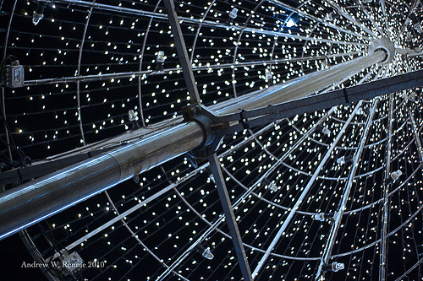
REFLECTING THE FEDERATION LIGHT

Join us the Thirteenth Day of April, Two-Thousand Nineteen
at Six-Thirty in the Evening
Master of Ceremonies:
Mr. Everette Bacon
Invocation:
Ron Gardner
Honored Guest
Representative Chris Stuart
Banquet Address:
Dr. Mark Maurer
PAC Plan Presentation
Chris Wycoff
Presentation of NFB of Utah Scholarship Winners:
Mrs. Deja M. Powell
Diamond Auction Items
Mr. Daniel Ashman

2019 NFB of Utah Vendors

3DPhotoWorks
Achilles International Utah Chapter
Aira
Auction Pre-Look (Come view items for our Saturday lunch auction).
Axis Technology
Corey Noyes, Financial Planner
Disability Law Center
Guide Dogs for the Blind
Helen Keller National Center
Humanware
JW.org
Moran Eye Center
Rocky Mountain Low Vision
Sprint
USABA
Utah Assistive Technology Program
Utah Division of Services for the Blind and Visually Impaired
Utah State Library for the Blind and Print Disabled
Utah Natural History Museum
Vanda Pharmaceuticals
Willie B’s Café

Diamond Sponsor

Vanda Pharmaceuticals
Vanda is a global biopharmaceutical company focused on the development and commercialization of innovative therapies to address high unmet medical needs and improve the lives of patients.

Vanda focuses on a serious disorder called Non-24. Non-24 is a chronic circadian rhythm disorder that’s very common in people who are totally blind or have vision loss. Non-24 causes nighttime sleep problems and a wide range of daytime difficulties, including an overwhelming urge to sleep during the day that can affect your ability to do everyday tasks or activities – at work, school, or in social settings.

Please come by and visit us at our table or call a health educator toll free at 1-855-856-2424 to find answers to your questions about
Non-24.

Titanium Sponsor
SLC Corp.

Gold Sponsors

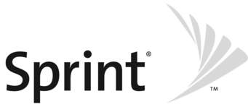
Sprint Communications

Lions Club International

Silver Sponsors
$500

Willie B’s Café Achilles International
WILLIE
B’S
CAFE

The NFB of Utah wishes to thank all our 2019 vendors and sponsors, without you we couldn’t put on such a wonderful convention. It takes the love and support of our local and national community sponsors to make what we do happen.
Thank you!

The NFB of Utah Also Wishes to Thank…

The staff at the Sheraton for making our convention run so smoothly, providing unprecedented hotel rates, and being so easy to work with.

All the members who have gone out to collect items for door prizes and auction items, and who support our organization through fundraising throughout the year.

All guests, sponsors, and vendors who traveled from all over the country to attend our convention, you helped make it unique and we hope you’ll come back to Utah again…and again.

Dr. Angela Longboat, for her convention sponsorship and support.

All those who helped behind the scenes with registration, organizing auctions and door prized, coordinating vendors, recruiting sponsors, planning meals, working with the hotel, preparing speeches, and recruiting new members to attend.

Ms. Janice Spencer, who always makes the most perfect centerpieces to fit our theme for banquet night every year. Your talent does not go unnoticed.
Thank You!
National Federation of the Blind of Utah
Board of Directors 2019

Affiliate President
Everette Bacon, baconev@yahoo.com

First Vice President
Cheralyn Creer, cheralyn.creer@yahoo.com

Second Vice President
Karl Smith, karl@axistech.net

Secretary
Barbie Elliott, barbieelliott@msn.com

Treasurer
Mark Turley, blindsquid@yahoo.com

Board Members
Willie Black, judicialcorner@yahoo.com
Jennifer Kennedy, msjenniferkennedy@gmail.com
Sachin Pavithran, sachin.pavithran@gmail.com
Deja Powell, deja.powell@gmail.com
Ian Reed, ianr11@gmail.com

NFB of Utah Chapters and Divisions Presidents

Weber/Davis Chapter
Willie Black, judicialcorner@yahoo.com

Salt Lake Chapter
Deja Powell, deja.powell@gmail.com

Utah Valley Chapter
Laura Vincent, ldvincent54@gmail.com

Red Rocks Chapter
Helen Eckman, heleneckman11@yahoo.com

Utah at-Large Chapter
Coordinator: Jennifer Kennedy, msjenniferkennedy@gmail.com

Student Division
Mikaela Stevens, mikaelastevens@gmail.com

Parents Division
Tara Purcel, tarapursel@gmail.com

Spanish Division
Ulvia Guadarrama, lindauvis@gmail.com

Project STRIVE, Transition Program
Cheralyn Creer, cheralyn.creer@yahoo.com

Utah BELL Academy
Wendy Bybee, wkbybee@gmail.com

National Association of Blind Students
Janae Burgmeier, janae.burgmeier@gmail.com

Save the date!
Dates: June 10th-21st, 2019
NFB of Utah BELL ACADEMY
we
love bell

The National Federation of the Blind (NFB) Braille Enrichment for Literacy and Learning (BELL) Academy helps blind and low-vision children, ages four through twelve, develop the literacy skills that will empower them to achieve their academic goals and live the life they want. The program provides instruction in other nonvisual blindness skills through fun, hands-on learning. A special parent’s seminar will be part of the program this year.

- Where: Utah Schools for the Deaf and Blind Salt Lake
Campus, 1655 E. 3300 S. Salt Lake City, UT 84106
- Time: Monday - Friday 8:30 am to 3:30 pm
- Who: Blind and low vision children ages 4 to 10.
- Cost: FREE!
- Contact: Wendy Bybee: 801-910-2542 e-mail:
wkbybee@gmail.com

Apply today:
www.nfbutah.org

