Spirit Night
National Federation of the Blind
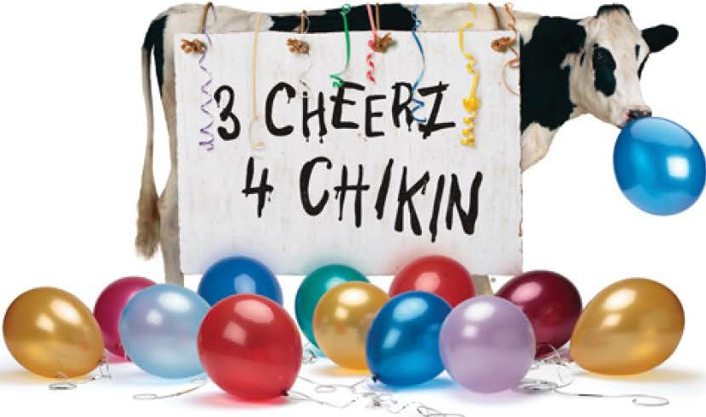
Wednesday, August 7, 2019
5:00pm - 8:00pm
Visit Chick-fil-A Sugar House and tell us that you are here to support the NFB and 20% of your transaction will be donated to the NFB Salt Lake Chapter.
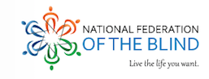
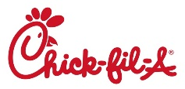
¥

Chick-fil-A., Chick-fil-A Stylzied.and the Chick-fil-A Cows.are registered trademarks of CFA Prope rties. Offer valid only at Sugar House. Ask restaurant for details. Closed Sundays .

