2020
National Federation of the Blind of Utah
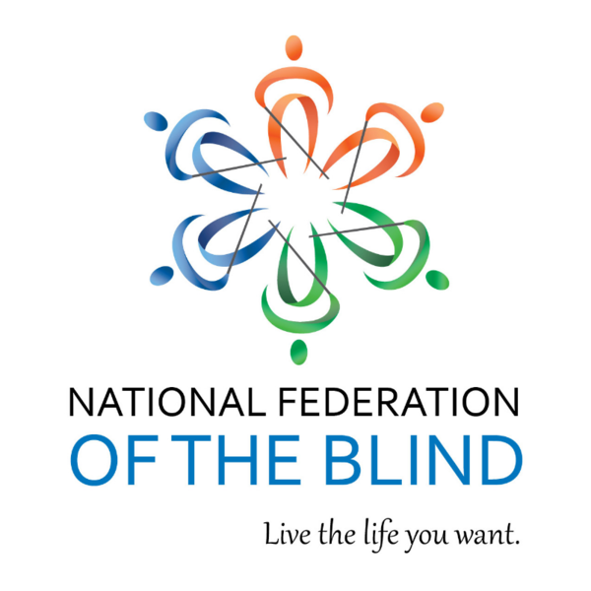
Annual Convention

BRIGHTENING OUR FUTURE BY BUILDING THE NFB OF UTAH

March 26 - 28th, 2020

Sheraton Salt Lake City
150 West 500 South, Salt Lake City, UT 84101

If you are using social media during our convention:

#NFBU20

You can live the life you want; blindness is not what holds you back.

The National Federation of the Blind Pledge
I pledge to participate actively in the efforts of the National Federation of the Blind to achieve equality, opportunity, and security for the blind; to support the programs and policies of the Federation; and to abide by its constitution.

NFB Mission Statement

In the National Federation of the Blind the blind and interested sighted persons come together to create programs to improve the quality of life of the blind; to provide a means of collective action for parents of blind children; to promote the vocational, cultural, and social advancement of the blind; to achieve the integration of the blind into society on a basis of equality with the sighted; and to take action which will improve the overall condition and standard of living of the blind. We work toward the removal of legal, economic, and social barriers to full participation by blind people in all aspects of community life. The NFB is the blind speaking for ourselves.

Convention Information

Registration Chairperson
Laura Hathaway, Member, Salt Lake Chapter

Door Prize Chairperson
Danielle Frampton, 1st Vice President, Salt Lake Chapter

Auction Chairperson/Auctioneer
Tara Pursle, Member, Weber/Davis Chapter

Scholarship Chairperson
Marnie West, Board Member, Weber/Davis Chapter

Vendor Fair Chairperson
Willie Black, President, Weber/Davis Chapter

Registration
Convention registration is $5.00 per person with children under the age of 10 being free. Registration will be open before all general sessions (any additional times are stated in the agenda below). You may pay for registration, meals, and banquet tickets with cash or card. Registration will be held right outside the main general session ballrooms, in the Canyons Lobby.

Door Prizes
We will draw for a variety of door prizes during each general session and at the banquet. You must be registered with the convention in order to have your name placed in the drawing, and you must be present when your name is called order to win. You may win multiple door prizes, so be sure to arrive on time and attend every session.

Guide Dog Relief Areas
Parking for guide dogs is located on the north side of the hotel, across from the Alta room. There is an atrium located there for guide dog users; there are trash cans with special bags. Please be courteous and pick up after your dog at all times.

Hotel Layout
All meeting rooms are on the east side of the hotel on the main floor. When you come in the front doors of the hotel, turn right and head to the conference side/east side of the hotel. The restaurant is located on the northeast side of the lobby, and a Starbucks is in the southwest corner of the lobby. There are elevators next to the hotel restaurant that will take you to and from your rooms. There is also a gift shop, just south of the elevators, and east of Starbucks. Please feel free to explore the many restaurants and shops around the hotel, centrally located in downtown Salt Lake City.

Taffy for a Trip Program
You have a chance to WIN two roundtrip airline vouchers for anywhere JetBlue flies. Taffy is $10 a piece or 3 for $20.00 and comes with a ticket for the drawing. Winner will be announced at the banquet, but you do NOT have to be present to win. Contact Daniel Ashman for details (phone: (330) 389-1472; Email: djashman2007@gmail.com).

NFB of Utah Welcomes our 2020 Convention Honored Guests

NFB National Representative: Anil Lewis
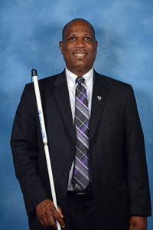
Currently employed as the executive director for Blindness Initiatives for the National Federation of the Blind, located in Baltimore, Maryland, he coordinates outreach, marketing, and fundraising activities for a national nonprofit organization. He leads a dynamic team of individuals responsible for the creation, development, implementation, and replication of innovative projects and programs throughout a nationwide network of affiliates that work to positively affect the education, employment, and quality of life of all blind people.

Lewis has dedicated his leadership skills to the development and growth of disability rights organizations that promote independence and improve quality of life. Lewis additionally volunteers as a teacher and mentor for blind kids, working with promising blind students who, because of limited resources and lack of trained professionals to teach them, are inappropriately encouraged to pursue special education diplomas. He wants blind students to set higher goals for themselves and to receive the training and tools they need to acquire the skills to reach their full potential.

Speaking of his personal life, Anil Lewis says that his proudest accomplishment is his bright, ambitious son Amari, born in 1997. Balancing his many civic responsibilities with his personal life as a father is undoubtedly his greatest challenge. His greatest success, he thinks, has been overcoming the temptation to subside into becoming an unmotivated, self-pitying person with a disability. He thinks his greatest contribution so far has been to encourage other people with disabilities to believe in themselves and to understand that they can make a difference.
NFB Distinguished Speakers: Peggy and Curtis Chong
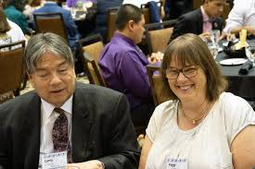
Currently, Peggy and Curtis Chong live in Aurora, Colorado.

Peggy is actively working to preserve the history of the blind of Colorado. For more than three decades, Peggy has been gathering information, stories, lists, news articles, books and more concerning the blind. For the past ten years, she has been analyzing and then re-researching the subject. The facts and stories have become enlightening, surprising and inspiring for everyone. Such a rich history we (the blind), in the United States have been left by blind people whose stories have rarely been told. Their lives have changed the lives of each American and we did not even know it.

While Chong has held significant positions in the corporate sector--namely, a 17-year career as programmer analyst, team coordinator, and designer and consultant, it was his work with the National Federation of the Blind (NFB) that propelled the organization into the modern century of technology innovation. In 1997, he became the Director of Technology in NFB's International Braille and Technology Center in Baltimore, Maryland. With his guidance and oversight, the NFB was able to expand NFB NewsLine to a nationally based service with a toll-free number. Curtis is passionate about encouraging other people who are blind to pursue computer careers and making the right tools available to people who are blind to do whatever jobs they choose to do.

Kendrick, D. (2005, September). Always Seeking Innovation: An Interview with Curtis Chong. Retrieved from https://www.afb.org/aw/6/5/14588

THURSDAY, MARCH 26, 2020

COMCAST SPONSORSHIP DINNER
6:00 to 7:30 p.m.
Location: Zion Ballroom
Come to hear about Comcast’s accessibility initiatives and programs, as well as reunite or meet with members of the NFB of Utah. Socialize with special guests, members from across the country, convention sponsors and vendors all while enjoying free food!
*FREE to ALL registered convention attendees.

EARLY REGISTRATION
6:00 to 7:30 p.m.
Location: Zion Ballroom
Registration Fee: $5.00 per person, children under the age of 10 are free
Meal(s): Prices vary
Affiliate Membership Dues: $1.00
Avoid longer lines by coming to our early bird registration

RESOLUTIONS COMMITTEE MEETING
8:00 to 9:30 p.m.
Location: Wildcat
Resolutions Chairperson: Karl Smith, 2nd Vice President, NFB of Utah
Come learn about the 2020 resolutions that will be presented at this year’s convention. All are welcome.

ACCESSIBLE GAME NIGHT
8:00 to 10:00 p.m.
Location: Zion Ballroom
Hosted by the Utah Valley Chapter and Spanish Division. Come play accessible board and card games for fun and prizes. It will be a great night to unwind and have fun with NFBU members. All games are fully accessible.
FRIDAY, MARCH 27, 2020

7:00 a.m. CONVENTION REGISTRATION
Location: Canyons Lobby
Registration: $5.00 per person, children under the age of 10 are free
Meal(s): Prices vary
Affiliate Membership Dues: $1.00

Friday Morning General Session
Capitol Reef “A” Ballroom

9:00 a.m. CALL TO ORDER AND WELCOME
Invocation: Ken Duke, President, Salt Lake Chapter
National Anthem: Karl Smith, 2nd Vice President, NFB of Utah
Color Guard Presentation: Nathan Osterguard, President, Blind Veteran Association
NFB Pledge: Jerry Nealey, Vice President, Weber Davis Chapter
Welcome: Everette Bacon, President, NFB of Utah

9:20 a.m. WELCOME TO SALT LAKE CITY
Recording from the Honorable Erin Mendenhall, Mayor, Salt Lake City

9:40 a.m. NFB NATIONAL REPORT: COLLECTIVELY SHAPING OUR FUTURE
Anil Lewis, Executive Director for Blindness Initiatives, National Federation of the Blind, Baltimore, MD

10:10 a.m. WHAT JOBS ARE THE BLIND ACHIEVING? A REPORT FROM THE UTAH STATE OFFICE OF REHABILITATION
Aaron Thompson, Rehabilitation Services Director, Utah State Office of Rehabilitation

10:25 a.m. FEDERATION TRAINING CENTERS: THE NEXT GENERATION
Jennifer Kennedy, Executive Director, Blindness: Learning in New Dimensions (BLIND), Inc., Minneapolis, MN

10:40 am: LIBRARY SERVICES FOR THE BLIND: WHAT’S NEW WITH BARD, NEWSLINE, AND MORE
Lisa Nelson, Director, Utah State Library for the Blind and Print Disabled

10:50 a.m. THE BLIND ON THE MOVE: AN UPDATE FROM UTAH TRANSIT AUTHORITY
Charissa Aldridge, PhD, ADA Coordinator, Utah Transit Authority

11:00 a.m. WHY I’M A FEDERATIONIST: AUTHENTIC TO MYSELF – A STRONG, BLIND LATINA MOTHER
Ulivia Guadelerama, Founder, NFB of Utah Spanish Division

11:15 a.m. 2020 GUBERNATORIAL CANDIDATE: IDENTIFYINGBLINDNESS ISSUES RELATED TO BLINDNESS THROUGHOUT UTAH
The Honorable Spencer Cox, Lieutenant Governor, State of Utah

11:35 a.m. COMCAST AND ACCESSIBILITY: BUILDING BRIDGES IN ENTERTAINMENT AND SO MUCH MORE!
Deneiva Knight, Director, External Affairs at Comcast

12:00 p.m. ADJOURN

BOARD OF DIRECTORS LUNCH
12:00 to 1:30 p.m.
Location: Capitol Reef “B” Ballroom
Invocation: Helen Eckman, President, Red Rocks Chapter
Moderator: Everette Bacon, President, NFU of Utah
Come hear from the Board of Directors of the NFB of Utah, and a special presentation from Katie Steed, Disability Specialist Manager, Priesthood and Family Department at the Church of Jesus Christ of Latter-day Saints

Friday Afternoon Session
Capital Reef “A” Ballroom
**Huge door prize. Be sure to be on time.

2:00 p.m. BUILDING OUR FUTURE: PRESENTATION OF THE 2020 NFBU SCHOLARSHIP FINALISTS
Marnie West, Chairperson, NFB of Utah Scholarship Committee

2:10 p.m. STATE OF THE STATE
Everette Bacon, President, NFB of Utah

2:30 p.m. THE BIGGEST FESTIVAL IN UTAH JUST GOT ACCESSIBLE!
Burchie Benton, Manager of Festival Operations, Sundance Film Festival

2:45 p.m. LEARNING FROM OUR PAST TO MAKE A BETTER FUTURE
Peggy Chong, Blind History Lady, Aurora, CO

3:05 p.m. WHY I’M A FEDERATIONIST: PERSPECTIVES FROM CHILDHOOD TO ADULTHOOD – MY PERSONAL JOURNEY THROUGH BLINDNESS
Marty Langworthy, Member, Weber/Davis Chapter

3:15 p.m. RAMONA’S STORY: ASPIRATIONS WITH STEELY DETERMINATION
Ramona Rice, Deafblind Activist and Author

3:35 p.m. THE 2020 CENSUS AND DISABILITY – DISABILITY LAW CENTER
Sheri Newton, Legal Advocate and Community Relations Director, Disability Law Center

3:45 p.m. VANDA PHARMACEUTICALS: NON-24 HOUR DISORDER
Representative from Vanda Pharmaceuticals

3:55 p.m. ANNOUNCEMENTS

4:00 p.m. ADJOURN

Friday Evening Sessions
Dinner on your own – Sheraton restaurant is open

NFBU 2020 VENDOR FAIR: BUILDING BETTER TOGETHER
4:10 to 7:00 p.m.
Location: Canyons Lobby
*Refer to full vendor list at the end of the agenda.

AUCTION PREVIEW AND SILENT BIDDING
4:10 to 7:00 p.m.
Location: North Star
Moderators: Tara Purcel, Member, Weber/Davis Chapter and Daniel Ashman, Employment Specialist, Blindness: Learning in New Dimensions (BLIND), Inc.
Here is your chance to come preview items for Saturday’s auction. One hundred percent of funds raised through the annual auction are used for funding a summer braille enrichment program for elementary school children, and collegiate scholarships.

FIRE AND ICE NIGHT: ICE CREAM, LATIN DANCE & KARAOKE
8:00 to 10:00 p.m.
Location: Zion Ballroom
Presented by NFBU’s Project STRIVE and the Spanish Division of the NFB of Utah. Come enjoy a fun night of ice cream, karaoke, and learn a few popular Latin dance moves. All are invited to this FREE event.

SATURDAY, MARCH 28, 2020

7:00 a.m. CONVENTION REGISTRATION
Location: Canyons Lobby
Registration: $5.00 per person, children under the age of 10 are free
Affiliate Membership Dues: $1.00

NFB OF UTAH CHAPTER & DIVISION BREAKFAST
7:30 to 8:45 a.m.
Location: Capitol Reef “B” Ballroom
Moderator: Jerry Nealey, Vice President, Weber Davis Chapter
Invocation: Jerry Nealey, Vice President, Weber Davis Chapter
Come enjoy breakfast and hear from all the chapters, divisions, clubs, and groups of the NFB of Utah.
- Ken Duke, Salt Lake City
- Willie Black, Weber/Davis
- Laura Vincent, Utah Valley
- Helen Eckman, Red Rocks
- Aaron Timm, At-Large Division (Chapter)
- Laura Vincent, Spanish Division
- Sara Erb, Parent Division
- David Carrillo, Utah Association of Blind Students (UABS)

Saturday Morning Breakout Sessions
Location: Review list of breakout sessions for individual locations.

9:00 to 10:00 a.m.: “A” Breakout Sessions

BREAKOUT 1A: YOUR VOICE MATTERS – UTAH PARENTS OF BLIND CHILDREN AND UTAH BLIND PARENTS MEETING
Location: Deer Valley
Moderators: Sarah Erb, President, NFB of Utah Parents Division and Tara Briggs, Member, Utah Valley Chapter
Come meet other parents and network with some of the top leaders in the state. Participate in hands-on activities on how to make things accessible for your child. Learn how to advocate for your child from some of the state’s and nation’s leaders in blindness education. Participate in parent panels, networking, break-out groups, and much more.
**Special session for blind parents will also take place.

CHILDCARE 1A: CONVENTION SENSORY ROOM
Location: Orion
The Orion Room is located just past the restrooms and to the right and has been reserved for the duration of the convention. The Convention Sensory Room is a space where convention goers have permission to be a kid. Try your balance, ninja skills, and create tactile art.
**This room is not set up as a certified childcare but will be manned by adults during the Annual Parents Meetings on Saturday. Text questions to Sarah Erb, 801-556-6649.

BREAKOUT 2A: BLIND HISTORY LADY
Location: Sundance
Moderator: Peggy Chong, Blind History Lady, Aurora, CO
Much of the history of the blind has been lost to us due to lack of storage, floods, fires and a lack of descendants to keep alive the memories, talents and accomplishments of their blind ancestors to lead normal, everyday lives. A larger portion of blind persons, discouraged to have children of their own, left fewer today to tell their story. The many blind persons who lived and died in poverty, often not even leaving a marked grave to visit, have passed without leaving a trace in this world to follow.

Peggy Chong endeavors to find out as much as possible regarding the lives of the traceable blind people, how they lived and the sometimes, extraordinary efforts it took to make it in the world as an ordinary citizen. The obstacles that they overcame, many times were very different than the sighted world around them recognized. Few realized that they, the sighted were placing barriers through their efforts to help the blind.

BREAKOUT 3A: SPANISH DIVISION MEETING
Location: Solitude
Moderators: Laura Vincent, President, Utah Valley Chapter and Ulvia Guadarrama, Founder, NFB of Utah Spanish Division
Take part in our Spanish Division so that together we can help in changing common myths and misconceptions of blindness within other cultures.

BREAKOUT 4A: UTAH LIBRARY FOR THE BLIND AND PRINT DISABLED
Location: Powder Mountain
Moderator: Michael Harris, Member, Salt Lake Chapter
Come see a demonstration of the latest features of downloading books through the library, learn about NFB Newsline, and more.

BREAKOUT 5A: SHOW & TELL AV SOLUTIONS
Location: Alta
Moderator: Ken Duke, President, Salt Lake Chapter
As technology rapidly advances, its integration into our lives is becoming more common; the idea of a “smart home” is becoming less science fiction and more of a reality. Join Show & Tell AV Solutions to learn about how you can make your home accessible using smart devices, demonstrations will include:
- In-home applications using voice commands
- Security systems to protect your home
- Lighting Automation
- Entertainment systems
- Climate Control Systems

Show & Tell AV Solutions is a Utah based home automation and home theater company providing automation, security, lighting automation, climate control integration for your house or business. They are an Authorized Diamond Control4 dealer proudly serving Salt Lake City, Park City, Bountiful, and surrounding areas.

10:00 to 11:00 a.m.: “B” Breakout Sessions

BREAKOUT 1B: STUDENT DIVISION MEETING
Location: Solitude
Moderator: David Carrillo, President, Student Division of NFB of Utah

BREAKOUT 2B: BLIND HISTORY LADY
Location: Sundance
Moderator: Peggy Chong, Blind History Lady, Aurora, CO
Much of the history of the blind has been lost to us due to lack of storage, floods, fires and a lack of descendants to keep alive the memories, talents and accomplishments of their blind ancestors to lead normal, everyday lives. A larger portion of blind persons, discouraged to have children of their own, left fewer today to tell their story. The many blind persons who lived and died in poverty, often not even leaving a marked grave to visit, have passed without leaving a trace in this world to follow.

Peggy Chong endeavors to find out as much as possible regarding the lives of the traceable blind people, how they lived and the sometimes, extraordinary efforts it took to make it in the world as an ordinary citizen. The obstacles that they overcame, many times were very different than the sighted world around them recognized. Few realized that they, the sighted were placing barriers through their efforts to help the blind.

BREAKOUT 3B: NFB PHILOSOPHY 101
Location: Capitol Reef “A” Ballroom
Moderator: Curtis Chong, Non-visual Access Technology Consultant, Aurora, CO
Come discuss various issues related to blindness. Also learn more about the philosophy rooted in the National Federation of the Blind. Question and answer session with an expert in access technology and a leader in the NFB.

BREAKOUT 4B: TACTILE BRAILLE ARTS MAKER SPACE
Location: Orion
Moderator: Steven Erb, Member, Salt Lake Chapter
The Art in the Community Service-Learning Class will be hosting a special Tactile Braille Art Maker Space.
**Text questions to Steven Erb, 801-556-4096

BREAKOUT 5B: SHOW & TELL AV SOLUTIONS
Location: Alta
Moderator: Ken Duke, President, Salt Lake Chapter
As technology rapidly advances, its integration into our lives is becoming more common; the idea of a “smart home” is becoming less science fiction and more of a reality. Join Show & Tell AV Solutions to learn about how you can make your home accessible using smart devices, demonstrations will include:
- In-home applications using voice commands
- Security systems to protect your home
- Lighting Automation
- Entertainment systems
- Climate Control Systems

Show & Tell AV Solutions is a Utah based home automation and home theater company providing automation, security, lighting automation, climate control integration for your house or business. They are an Authorized Diamond Control4 dealer proudly serving Salt Lake City, Park City, Bountiful, and surrounding areas.

11:00 a.m. to 12:00 p.m.: “C “Breakout Sessions

BREAKOUT 1C: SIGHTED SPOUSES/FAMILY MEMBERS MEETING: FAMILY, FRIENDS, AND SPOUSES OF THE BLIND
Location: Deer Valley
Moderators: Angela Peters, MD FACNS, Assistant Professor of Neurology, University of Utah Neurologist
This is a panel for spouses, siblings, parents, partners, teachers, or anyone who has a loved one who is blind. Come have an open discussion about issues related to blindness from the sighted person’s perspective.

BREAKOUT 2C: STRUCTURE DISCOVERY TRAINING CENTERS: WHAT ARE THEY AND WHY DO THEY WORK?
Location: Solitude
Moderator: Jennifer Kennedy, Executive Director, Blindness: Learning in New Dimensions (BLIND), Inc., Minneapolis, MN
Whether you are interested in the historic roots of structure discovery or are thinking about what type of blindness skills training is for you, this session is sure to stimulate and engage. Come learn where the name for this methodology of rehabilitation teaching came from and why blind people from across the world seek its practice.

BREAKOUT 3C: NFB PHILOSOPHY 101
Location: Capitol Reef “A” Ballroom
Moderators: Curtis Chong, Non-visual Access Technology Consultant, Aurora, CO
Come discuss various issues related to blindness. Also learn more about the philosophy rooted in the National Federation of the Blind. Question and answer session with an expert in access technology and a leader in the NFB.

BREAKOUT 4C: TACTILE BRAILLE ARTS MAKER SPACE
Location: Orion
Moderator: Steven Erb, Member, Salt Lake Chapter
The Art in the Community Service-Learning Class will be hosting a special Tactile Braille Art Maker Space.
**Text questions to Steven Erb, 801-556-4096

BREAKOUT 5C: SHOW & TELL AV SOLUTIONS
Location: Alta
Moderator: Ken Duke, President, Salt Lake Chapter
As technology rapidly advances, its integration into our lives is becoming more common; the idea of a “smart home” is becoming less science fiction and more of a reality. Join Show & Tell AV Solutions to learn about how you can make your home accessible using smart devices, demonstrations will include:
- In-home applications using voice commands
- Security systems to protect your home
- Lighting Automation
- Entertainment systems
- Climate Control Systems

Show & Tell AV Solutions is a Utah based home automation and home theater company providing automation, security, lighting automation, climate control integration for your house or business. They are an Authorized Diamond Control4 dealer proudly serving Salt Lake City, Park City, Bountiful, and surrounding areas.

FOOD AND FUNDRAISING LUNCHEON
2020 NFBU Annual Auction
12:00 to 1:30 p.m.
Location: Capitol Reef “B” Ballroom
Invocation: Kevin Ledford, Member, Salt Lake Chapter
Auctioneer(s): Kirt Manwaring, Member, Utah Valley Chapter and Daniel Ashman, Employment Specialist, Blindness: Learning in New Dimensions (BLIND), Inc.
*100 percent of proceeds go to the NFB of Utah and its many programs.

Saturday Afternoon General Session
Capitol Reef “A” Ballroom
Welcome and BIG Door Prize!

1:45 p.m. WHY I’M A FEDERATIONIST: FROM HAWAII TO UTAH AND EVERYWHERE IN-BETWEEN
Danielle Frampton, 1st Vice President, Salt Lake Chapter

1:55 p.m. BECOMING A BLIND FINANCIAL PLANNER AT GOLDMAN SACHS
Julian Sanchez, Credit Risk Analyst, Goldman Sachs

2:05 p.m. UTAH BELL ACADEMY: WHY THE NFB OF UTAH CONTINUES TO RING ITS BELL
Moderator: Wendy Bybee, Coordinator, Utah Bell Academy
Panel: Katie Chevalier, Instructor, Utah Bell Academy and participants of the 2019 Utah Bell Academy

2:20 p.m. LEADERSHIP SEMINAR: LEADING BY EXAMPLE – IT’S ELEMENTAL
Ned Lindholm, 2nd Vice President, Salt Lake Chapter

2:35 p.m. PROJECT STRIVE: A DECADE IN RETROSCPECT AND STRIVING TOWARDS A BETTER FUTURE
Moderator: Cheralyn Creer, 1st Vice President, NFB of Utah
Panel: Instructors, NFB of Utah Project STRIVE: Willie Black, Tara Briggs, Jared Mendenhall and participants of NFB of Utah’s Project Strive

2:55 p.m. TECHNOLOGY FOR THE BLIND: A KEY TO INDEPENDENCE OR A SOURCE OF GREAT FRUSTRATION
Curtis Chong, Non-visual Access Technology Consultant, Aurora, CO

3:10 p.m. ADVOCACY IN ACTION: A SPOTLIGHT ON WASHINGTON SEMINAR AND FIRST-TIMERS PERSPECTIVE
Moderator: Sachin Pavithran, PhD, Legislative Director, NFB of Utah
Panel: Katie Nelson, Member, Utah Valley Chapter and Valentino Jaurigue, Board Member, Red Rocks Chapter

3:25 p.m. WHY I’M A FEDERATIONIST: THE AMERICAN DREAM IS REAL – FROM UNDOCUMENTED IMMIGRANT TO FEDERATION LEADER
Laura Vincent, President, Utah Valley Chapter

3:35 p.m. NFB OF UTAH TREASURER’S REPORT
Mark Turley, Treasurer, NFB of Utah

3:50 p.m. 2020 NFB OF UTAH RESOLUTIONS
Karl Smith, 2nd Vice President NFB of Utah

4:20 p.m. NFB OF UTAH BOARD ELECTIONS

4:45 p.m. NEW MEMBER CEREMONY

5:00 p.m. ADJOURN
You are cordially invited to the:

National Federation of the Blind of Utah’s
2020 Banquet

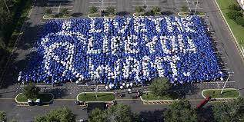

This
Twenty-Eighth Day of March Two-Thousand Twenty
At
Six-Thirty in the Evening

Master of Ceremonies
Mr. Everette Bacon
Invocation
Mrs. Barbie Elliott
Banquet Address
Mr. Anil Lewis
PAC Plan Presentation
Mr. Chris Wycoff
Presentation of NFB of Utah Scholarship Winners
Mrs. Marnie West
Diamond Auction Items
Mr. Kirt Manwaring and Mr. Daniel Ashman

The NFB of Utah wishes to thank all our 2020 sponsors and vendors, without you we couldn’t put on such a wonderful convention. It takes the love and support of our local and national community sponsors to make what we do happen.
Thank you!

TITLE SPONSOR

Comcast NBCUniversal

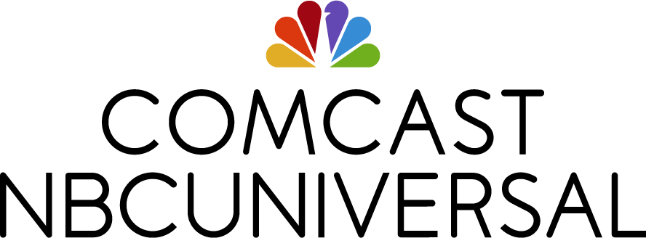

Comcast NBCUniversal is committed to making our products, services, and experiences accessible to the widest possible audiences — creating new pathways to independence and inspiration for people with disabilities. We’re continuously innovating to expand the utility of our products, from the cable industry’s first talking guide, to narrated voice descriptions of TV programs, to remotes that can be manipulated through eye-tracking devices — all of which are available today. We are also committed to making our workplaces inclusive for employees of all abilities and to building a workforce that reflects the demographics of the disability community.
GOLD SPONSOR

Vanda Pharmaceuticals
Vanda, a global biopharmaceutical company, focuses on a serious disorder called Non-24. Non-24 is a chronic circadian rhythm disorder that’s very common in people who are totally blind or have vision loss. Non-24 causes nighttime sleep problems and a wide range of daytime difficulties, including an overwhelming urge to sleep during the day that can affect your ability to do everyday tasks or activities – at work, school, or in social settings.

Please come by and visit us at our table or call a health educator toll free at 1-855-856-2424 to find answers to your questions about Non-24.

SILVER SPONSOR

Salt Lake City Corporation

Lions Club International

BRONZE SPONSORS

Sprint Communications
Willie B’s Café
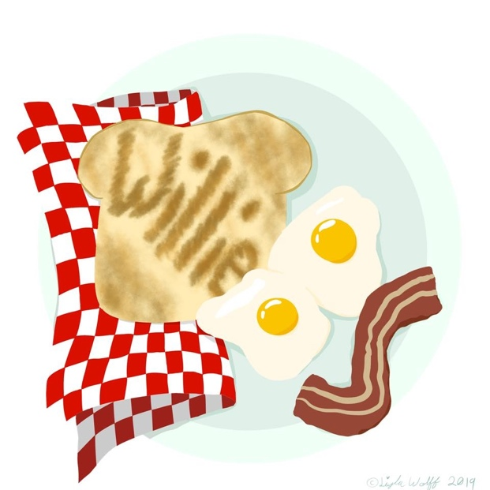

Show & Tell AV Solutions

EXHIBITOR SPONSORS

Axis Technologies
Disability In Utah
Disability Law Center
Division of Services for the Blind and Visually Impaired
Guiding Eyes
JW.org
National Ability Center
Rocky Mountain Low Vision
Utah Assistive Technology Program
Utah Library for the Blind
Utah Transit Authority

