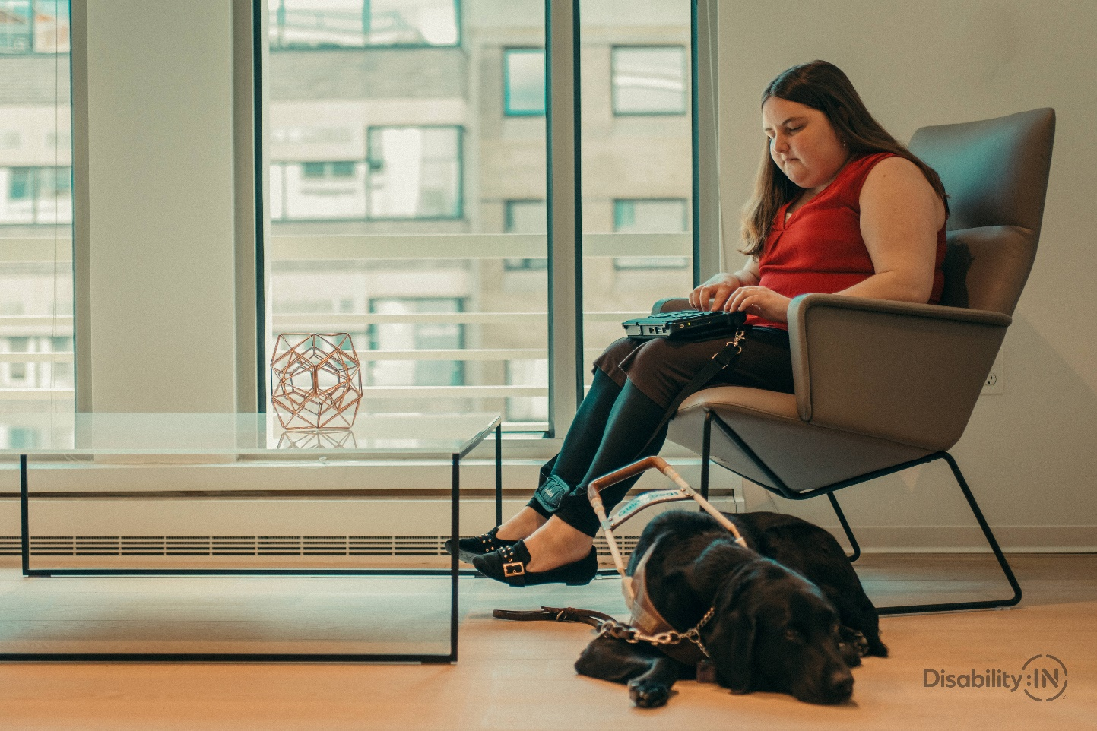

Application open for $500 Walmart Golden Key Scholarship

Applications open now, last date to apply June 18th, 2021
Apply today!
Eligible students are Utah residents between 17-21 years old with a disability
Disability must be verified by a qualified professional, mental health provider, or medical professional. Eligible students must be receiving, or have received their High School Diploma, GED, or Certificate of Completion and be transitioning or transitioned to other education program after High School.
Email leahlobato@utah.gov with questions or accommodation requests.
TO APPLY:
https://www.disabilityinutah.org/walmart-golden-key-scholarship-2021/

