NFB-Utah Convention Auction 2025

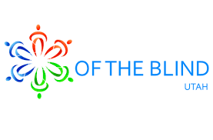

Auction Items Needed

**It’s that time again!** We would love to have you donate auction items for our annual state convention auction. You can personally donate, ask friends and family and/or local business in your area. If you donate its tax deductible. We can provide you with a donation letter with our tax ID number.

Donation items can be gift cards, cash, and/or a theme gift basket (e.g. date night, BBQ, gardening, game night etc.... When you donate, please **click on the link below** to fill out the donor’s donation form to help us document all donations items that have been donated for our auction this year.

We would like to have all donors’ donation forms filled out and auction items no later than **April 26th.** You can drop off items with Stephanie Cordova or we can plan to pick up items. If this is not possible, you can bring the donation item to the convention, we will start receiving items at the Marriot Thursday May 1st @ 4:30pm. Stephanie Cordova and Tin Reisner will be collecting the auction items at the convention.

[Donor’s Donation Form](https://forms.gle/QBqiFTSwjEURJUyS8)

Please contact the Auction Coordinator for more information.

Stephanie Cordova, 801-718-8403, [scordova63@hotmail.com](mailto:scordova63@hotmail.com)