Invitation: Glide Demo Day
Services for the Blind and Visually Impaired
Salt Lake City, Utah

Date:

October 11th, 2025
Time:
9:30-12:30
1-4
Location:
Services for the Blind and Visually Impaired
250 N 1950 W, Salt Lake City, UT 84116
Information & Registration Page:
https://glidance.io/glidance-demo-day-salt-lake-city-utah/
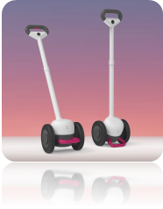 | 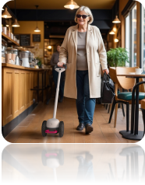 | 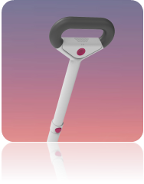
What is Glide?
Glide is an innovative, AI-powered primary mobility aid for people who are blind or have low vision. Designed to be versatile and lightweight, Glide has two wheels that rest on the ground and connect to a telescoping handle with an ergonomic grip. With a gentle nudge, you push the device in front of you, and Glide simply guides the way – using autonomous steering and braking to avoid obstacles and guide you to primary targets.
Glide is powered Glidance’s proprietary Sensible Wayfinding AI - a purpose-built model for navigation in complex and unstructured pedestrian environments.
Glide's Capabilities:
- Intelligently navigate around obstacles and hazards.
- Locate doors, elevators, stairs, and more.
- Guide you to your destination safely, indoors & outdoors.
- Freestyle Navigation – The freedom to stroll wherever you choose with the knowledge that Glide will keep you safe and walking straight.
- Directed navigation, pre-mapped and saved routes (Post-Launch)
- Describe your surroundings with an active scene description (Post-Launch)
You can learn more about Glide’s features here.

About Glidance:
Founded by Amos Miller, who led Microsoft’s ground-breaking Soundscape project, Glidance is on a mission to change the course of personal robotics by harnessing AI and cutting-edge technology to solve real human needs.
Our team of engineers, researchers, designers, and technologists, alongside a community of over 8,000 blind and low vision individuals, is developing Glide, the world’s first Intelligent Guide for individuals who are blind or have low vision. Quick to learn, easy to use, and affordable, Glide will enable millions of people to get out of their homes and navigate more confidently, safely, and independently.
Glidance has already won numerous awards and accolades for its work, including an Edison Award, RBR50 Robotics Innovation Award, CES CTA Foundation Award, Robo Business Pitchfire Award, and SXSW Pitch Competition Award.

What is a Glide In-Person “Demo Day”?
Glidance is extending an open invitation to anyone in the blind, low vision, and assistive technology community to join us for a special in-person Demo Day.
You'll have the opportunity to meet the Glidance team, hear the story behind the device, and get hands-on experience demoing our latest prototype of the Glide device. There will be plenty of time to ask questions, give feedback, and meet our Gliders community. Glidance has hosted dozens of these demo days around the world, and each one is unique, engaging, and last but not least, fun! You can view a Highlight Reel of Glide’s 2024 Toronto Demo Day in 2024 here!
------------------------------------------------------------------------------------------------------------------------------------------
You can learn more about Glide’s features here.
Have questions? You can explore our comprehensive Frequently Asked Questions here

