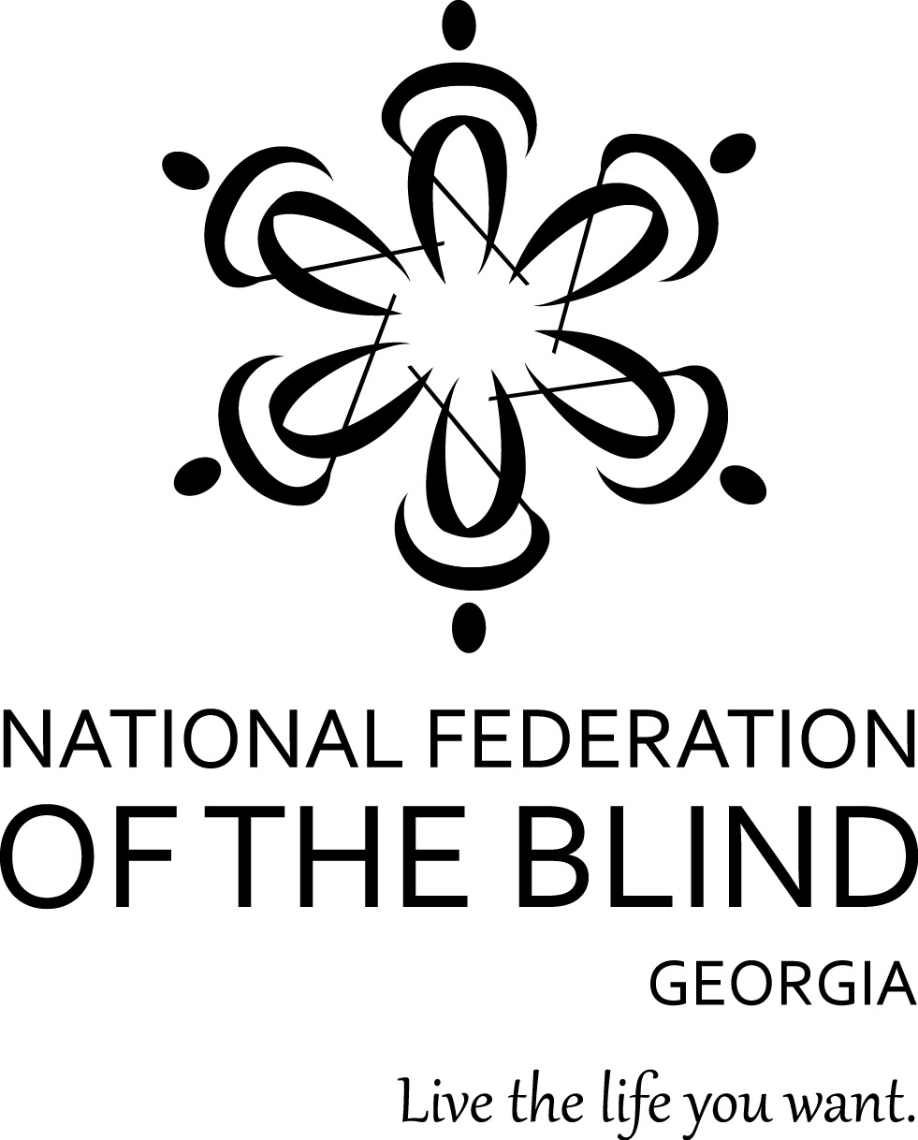
NATIONAL FEDERATION OF THE BLIND OF GEORGIA 2017 Convention Registration Form
The 2017 NFB of Georgia annual state convention will be held October 13–15 at the Holiday Inn Atlanta Airport North. Located at 1380 Virginia Avenue, Atlanta, GA 30344

Please complete this form and return it with your check to reserve your space. All forms and checks must be received by September 30, 2017.

Name: ________________________________________

Email: ________________________________________

Telephone: ________________________________________

Address:

Street Address: ________________________________________

Apt. #: _________

City: ______________

State: __________ Zip code: __________

Convention registration:
Registration costs $40 and includes a box lunch on Saturday.

______ Register me - $40.00
Lunch Preference - Choose your sandwich for Saturday’s box lunch: (Check one)

_____ Ham _____ Turkey

_____ Veggie _____ Roast Beef

Banquet Ticket – Choose a dinner choice: (Check one)

____ No Ticket _____ Chicken ($45.00)

_____ Veggie ($45.00) _____ Steak ($55.00)

Agenda Format – Choose your agenda format: (Check one)

_____ Braille _____ Large Print

_____ Standard Print _____ Electronic

Check information:

Total amount of check: $___________________

Check#: ____________________

Signature: _________________________

Date: ____________________

*Your check and completed form must be received by September 30, 2017. Mail your completed form and check to:

Natta Watkins
106 Lowe Stinson Road
Hogansville GA 30230

