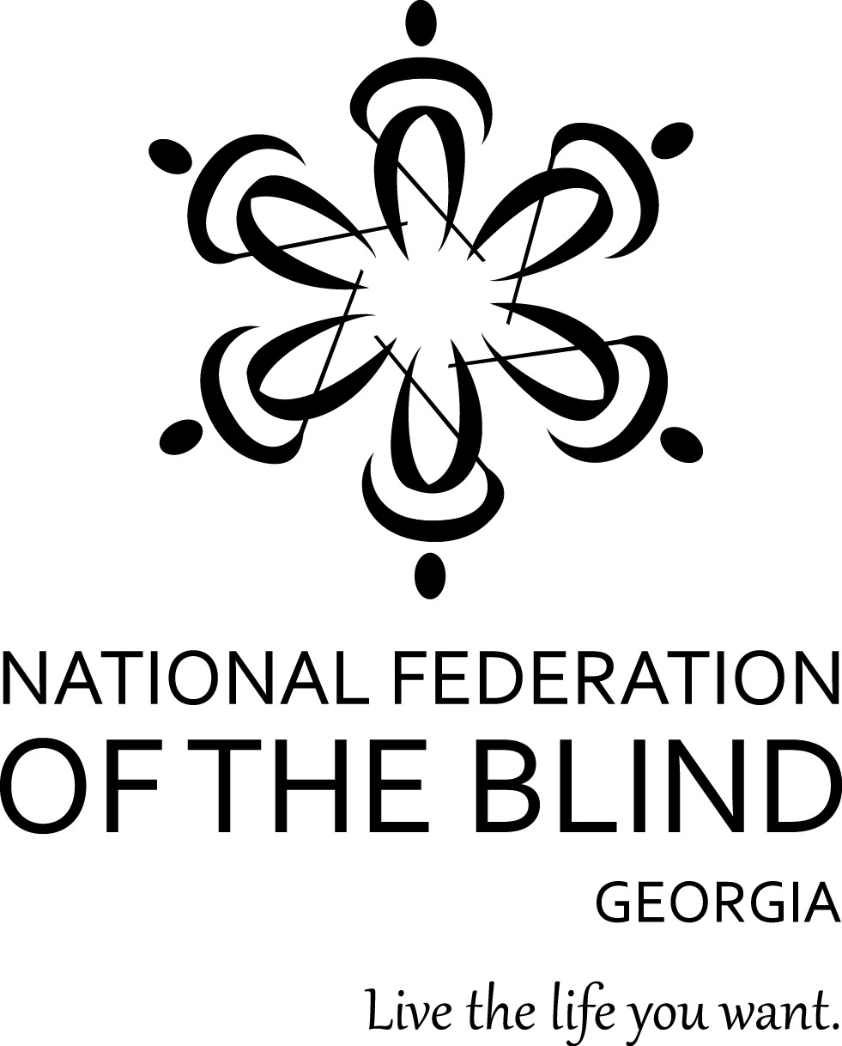
NATIONAL FEDERATION OF THE BLIND, GEORGIA 2018 Annual Convention Registration Form

The 2018 NFB of Georgia annual state convention will be held October 5th- 7th at the Hilton Garden Inn Albany Downtown
. Located at 101 South Front Street
Albany, GA 31705.

Please complete this form and return it with your check or money order to reserve your space. All forms and checks must be received no later than Saturday, September 15, 2018.

Name: ________________________________________

Email: ________________________________________

Telephone: ________________________________________

Address:

Street Address: ________________________________________

Apt. #: _________

City: ______________

State: __________ Zip code: __________
Convention registration:
Registration costs $40 and includes a box lunch on Saturday.

______ Register me - $40.00
Lunch Preference - Choose your sandwich for Saturday’s box lunch: (Check one)

_____ Ham _____ Turkey

_____ Veggie _____ Roast Beef

Banquet Ticket – Choose a dinner choice: (Check one)

____ No Ticket _____ Chicken ($45.00)

_____ Vegetable ($45.00

Agenda Format – Choose your agenda format: (Check one)

_____ Braille _____ Large Print

_____ Standard Print _____ Electronic

Check information:

Total amount of check: $___________________

Check#: ____________________

Signature: _____________________

Date: __________________________

Mail your registration information to:
Natta Watkins
106 Lowe Stinson Road
Hogansville GA 30230
Telephone: (770) 584-3953

All checks or money orders must be made out to NFB of Georgia.
When mailing your registration, please remember to include your completed registration form along with your check or money order. All registration information must be received no later than Saturday, September 15, 2018 with no exceptions.

