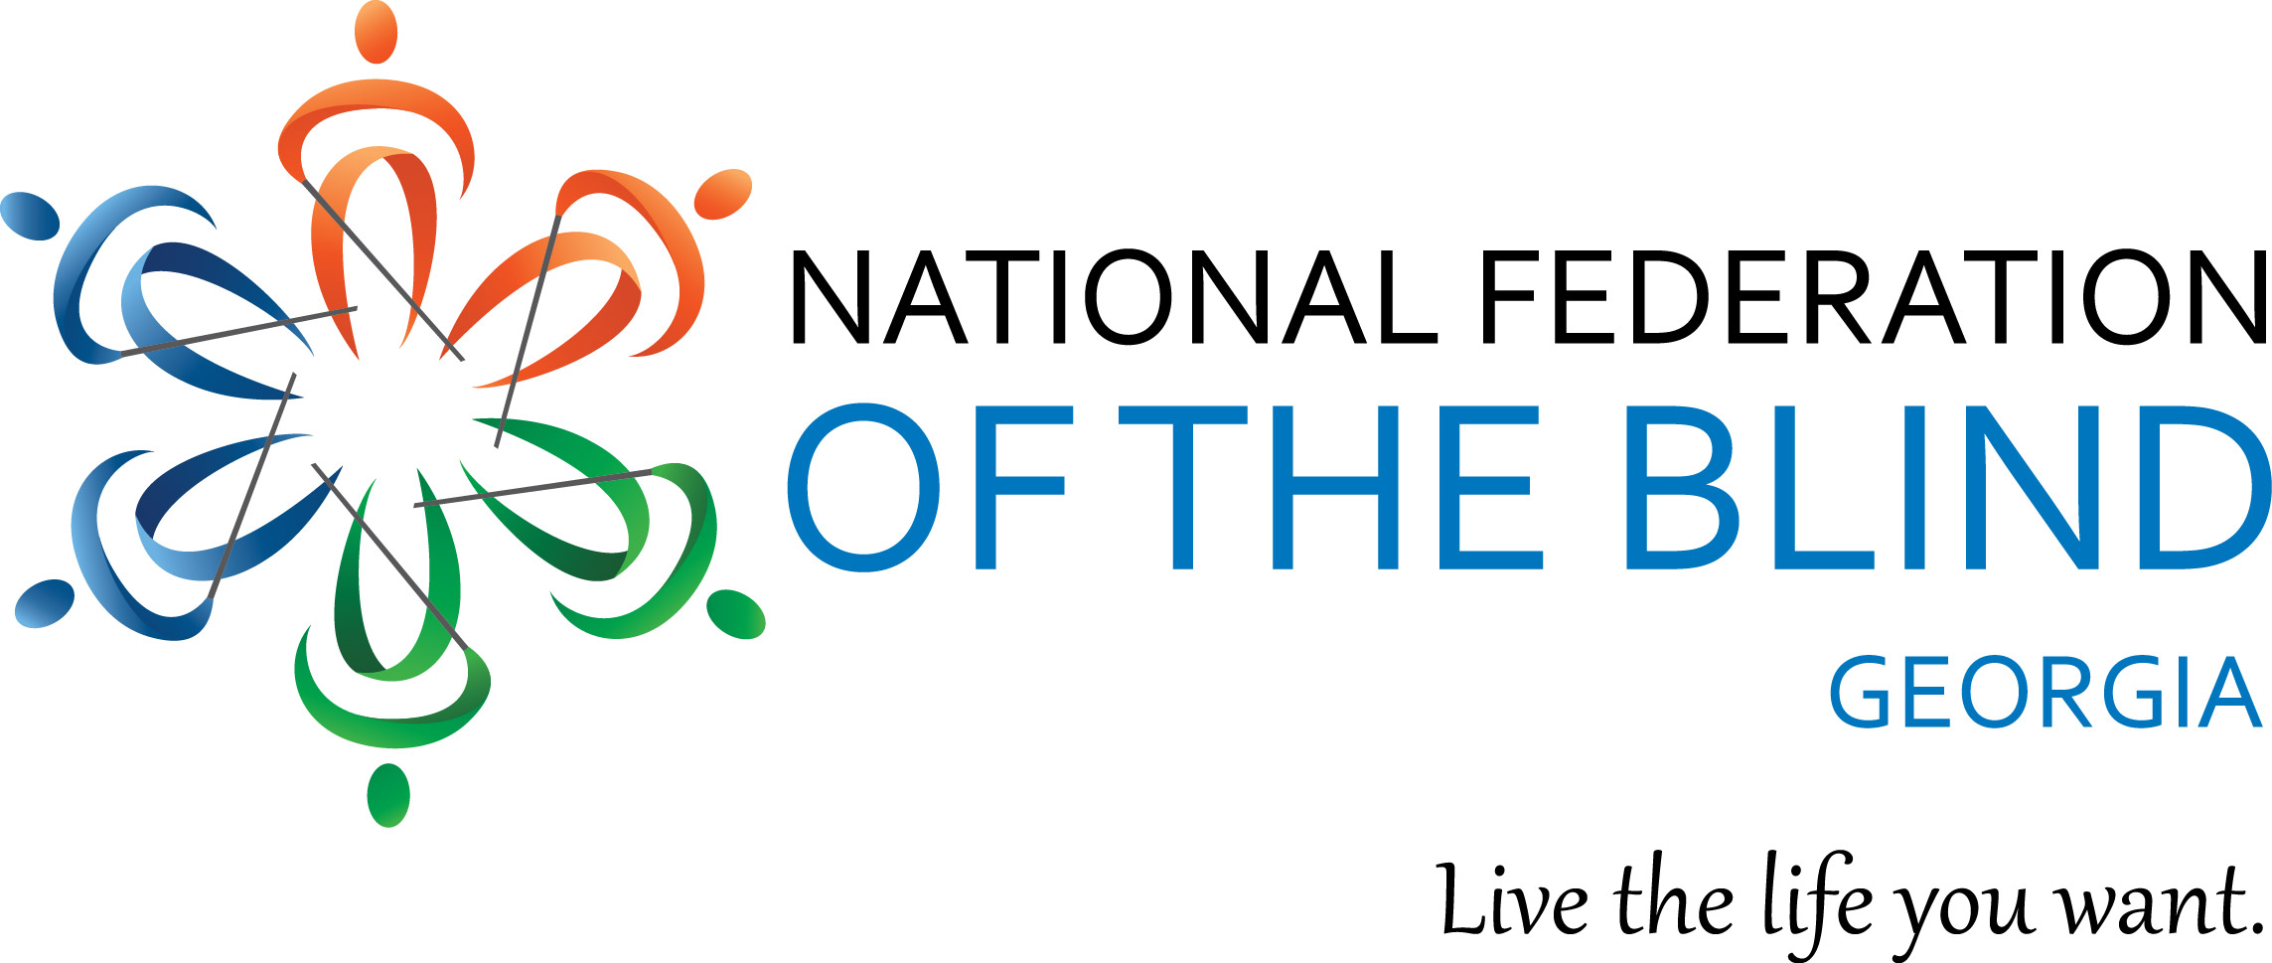

National Federation of the Blind of Georgia
2019 State Convention

Fostering Growth for a Stronger Future.
Affiliate President, Dorothy Griffin
National Representative, EVER LEE HAIRSTON, NFB National Directors Board Member, California

October 4-6, 2019
DoubleTree by Hilton Augusta
2651 Perimeter Parkway
Augusta Georgia 30909
Welcome to the 2019 State Convention
Our Affiliate President Dorothy Griffin, the board of directors and the convention committee would like to welcome you to the 46th annual state convention of the National Federation of the Blind of Georgia. Many people have worked hard over the last several months to create a dynamic and engaging agenda with something for everyone. If you have any questions or concerns while you are here, feel free to find a board member or member of the convention committee and we will help you take care of whatever you need. Daryl (Bishop) Rutledge is our point of contact with the hotel. If there is a problem with our meeting spaces, please contact Daryl first.

Our convention theme this year is “Fostering Growth For A Stronger Future.” The past year has been an exciting time of growth for the NFB of Georgia. We invested in our movement by *training leaders, supporting students, and working to protect our rights in the state legislature. We want to celebrate those accomplishments and plan the next phase of foster our growth! So, jump in. Your contributions are wanted and needed. We strongly believe that, “Many hands make light work.” Let’s go build the National Federation of the Blind of Georgia!

NFB Pledge
I pledge to participate actively in the effort of the National Federation of the Blind to achieve equality, opportunity, and security for the blind; to support the policies and programs of the Federation; and to abide by its constitution.

NFB of Georgia Officers and Board of Directors
2018-2019

President – Dorothy Griffin, Georgia Affiliate
1st Vice President – Gaylon Tootle, Central Savannah River Chapter
2nd Vice President –Vanessa Meadows, Atlanta Metropolitan Chapter
Secretary – Katey Jackson, Atlanta Metro Chapter
Treasurer – Nata Watkins, At Large Chapter

Board Seat 1 – Marcia Robinson, Cobb County Empowerment Chapter
Board Seat 2 – Angela Daniel, Southside of Atlanta Chapter
Board Seat 3 – Stancil Tootle, Bainbridge Chapter
Board Seat 4 – Shirley Robinson, Atlanta Metro Chapter
Board Seat 5 – Justin Heard, Georgia Association of Blind Students
Board Seat 6 – Melvin Scott, Southwest Georgia Chapter

Friday, October 4, 2019

Seminar Day

12:00-4:00 PM – Registration, Pre-function Hallway

2:00 PM -7:00 PM – Exhibit Hall, Richmond I & II

12:30-5:00 PM, Senior Possibilities Fair,

PGA, British Open, Masters Conference Room
Registration and displays will begin at 12:15 p.m. Admission is $5.00 per person. The fair will include a silent auction, speakers with an array of information, helpful hints along with an interesting mix of nonprofit partners, demonstrations, and displays for ALL seniors and adults to enjoy.

2:00-4:00 PM – Student Seminar, US Open Room
Come join with students from across Georgia to network, learn how to advocate for what you need in high school, college, and beyond. We will also talk about working while in college, Assistive Technology, getting access to textbooks, and getting involved in sports and recreation.

Friday, October 4, 2019 - Continued

6:00 PM - 10:00 PM - Parents and Teachers of Blind Children, -US Open Room
“Learn how to adapt your family board game’ session? Come meet other parents of blind children to network and learn about advocating for your child’s needs. Come and learn about different types of adapted sports for blind children and youth. We will share information and provide hands on experience. Let's play ball.

6:45-10:00 PM – Mardi Gras Night,

PGA, British Open, Masters Conference Room
Come join your NFB of Georgia family for New Orleans style fun! , Wear your best Mardi Gras apparel along with your beads, masks, feathers and favorite hat! The entrance fee is $5, Line up for the 2nd Line dance at 6:45 PM. FUN! GAMES! & All kinds of music with DJ West.

Saturday, October 5, 2019

8:00-9:00 AM – Registration, Pre-function Hallway

12:00 PM -4:00 PM – Exhibit Hall, Richmond I & II

General Session, PGA, British Open, Masters Conference Room
9:00 AM -Call To Order
9:05 AM – Invocation, Pledge of Allegiance
National Anthem-
NFB Pledge.
9:15 AM –Greetings from Central Savannah River Chapter, Gaylon Tootle, President
9:20 AM –Welcome to Augusta – Georgia Visitors Information Center, Augusta
9:30 AM –National Report, National Representative EVER LEE HAIRSTON, NFB National Directors Board Member, California
10:15 AM -Centers for Independent Living -Training Centers
11:05 AM -Fit Break and Door Prizes
11:10 AM -Updates from Project Independence – Kay McGill, Program Manager, Georgia Vocational Rehabilitation Agency
11:25 AM -Newsline
11:40 AM -Washington Seminar -Shikha Desai
11:50 AM – Announcements and Door Prizes
12:00 PM -Adjourn

Saturday, October 5, 2019 -Continued

12:00-4:00 PM – Exhibit Hall, Richmond I & II

12:00-2:00 PM – Lunch
All registered participants will pick up their box lunches in the Pre-function Hallway and then proceed to eat in the large conference room or wherever they choose.

12:00–1:45 PM -At Large Chapter Meet-Up -US Open Room
Are you At Large and in charge? Come join the chapter that knows no boundaries (at least geographically). If you want to get involved with the NFB of GA but do not live in an area with a local chapter, come find out about joining the At Large chapter.
Facilitator: Nata Watkins, President, At Large Chapter

2:00-4:00 PM - General Session, PGA, British Open, Masters Conference Room
2:00 PM – Call to order, Moment of silence
2:05 PM – State President Report – Dorothy Griffin, Affiliate President
2:25 PM -Fit Break, Door Prizes

Saturday, October 5, 2019 -Continued
2:35 PM -Meet your Divisions, Invitation for Members
Senior Division, Merchants Division, Students Division, Diabetes Division, Parent of Blind Children
3:25 PM -Thank You Presentation By The BELL Program

3:45 PM -Announcements and Door Prizes
4:00 PM – Adjourn

7:00-10:00 PM – NFB of Georgia 2019 State Convention Banquet, PGA, British Open, Masters Conference Room
Master of Ceremonies: Robert Smith, President, Decatur Chapter,
Keynote Speaker: National Representative EVER LEE HAIRSTON
Diamond Level Sponsor –We Fit Wellness

Saturday, October 5, 2019 -Continued

10:00 AM –5:30 PM -MINI BELL -US Open Room
10:00 AM -12:00 PM -What Can I Play?
Does your child know how to run, jump, skip or throw? Do they always sit on the sideline? Parents and Family members are invited to learn about different types of adapted sports for blind children and youth. Dr. Jeanine Fittipaldi-Wert PhD. Director of the Adapted P.E. program at Columbus State University and Director of Camp Abilities, will provide hands on experience for young children to participate and have fun while learning about staying physically active.

Saturday, October 5, 2019 -Continued

12:30 PM -1:30 PM -I love to Eat Pizza for lunch.
Come join us for a lunchtime discussion. Zelma Murray, Georgia Statewide Vision Consultant, will share information about understanding the IEP process and the importance SMART goals.
4:00 PM -5:30 PM -National Federation of the Blind of Georgia Parents division Annual business meeting and gathering.

Sunday, October 6, 2019

8:30-8:50 AM – Communities of Faith, PGA, British Open, Masters Conference Room

9:00 AM-12:00 PM Annual Business Meeting, PGA, British Open, Masters Conference Room
9:00 AM -Call to order
9:05 AM -Door Prizes
9:10 AM –Roll Call of Chapters and Divisions
9:40 AM -Officer Reports
10:00 AM -Door Prizes
10:10 AM -Business Session
Secretary, Treasurer’s Reports, President Report, Elections
12:00 PM -Adjourn

Speaker Biographies
EVER LEE HAIRSTON, NFB National Directors Board Member, California

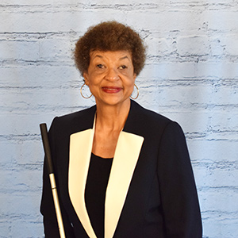

Ever Lee Hairston hails from the Tar Heels of North Carolina to the Hollywood Hills of California. She faced several challenges along the way, but each has strengthened her. She was raised by her parents and paternal grandparents who were sharecroppers on the Coolemee Plantation. She was bussed to segregated schools and used hand-me-down books.

Ever had a desire to become a nurse but after failing the eye exam she was not admitted to Duke University Nursing School. Not being defeated she became a student at North Carolina Central University, Durham, where she majored in Business Education. While in college, under the leadership of Dr. Martin Luther King, Jr., she participated in protest marches, spent one night in jail, and experienced much fear while struggling for social justice.
After graduating from college, she relocated to New Jersey to begin her teaching career. Unfortunately, it only lasted four years due to her impending blindness from Retinitis Pigmentosa. It was necessary for Ever to pursue a new career; therefore, she studied at Rutgers University and earned a degree in Counseling the old-fashioned way, hard work and determination.

In 1987 Ever attended her first National Federation of the Blind National Convention. The most profound experience, as Ever explains it, came when she started through the registration line. She remembers being asked, "Would you like a Braille or print agenda?" She could no longer read print and did not know Braille. It was then, according to Ever, that a light bulb went off. "I am illiterate," she thought. She talked to as many people as she could at that convention in Phoenix, Arizona, and learned about the NFB Centers.
In 1987 she attended the Louisiana Center for the Blind. The skills (braille, technology, orientation and mobility, and independent living) that she learned at the Center propelled her to excel in her career.

Ever has been a leader in the NFB since 1991. She has served in many capacities in the Federation, i.e., Chapter President, NJ, Affiliate First Vice President, NJ, Affiliate First Vice President, CA, Affiliate President, CA, National Board Member, and National Scholarship Committee.
She is the author of, Blind Ambition One Woman’s Journey To Greatness Despite Her Blindness, published July 2015. Her book is on BARD.
Ever is blessed with one son, a wonderful daughter-in-law, and three energetic grandchildren. She enjoys traveling, reading a good novel, and spending time with her biological and Federation family and friends.

2019 Convention Sponsors
We want to give a huge thanks to all our 2019 Convention Sponsors

Diamond Level Sponsor
We Fit Wellness

Gold Level Sponsors

*Silver Level Sponsors
I Can Connect

*Bronze Level Sponsors
E-Sight
HumanWare
Walton Options

The National Federation of Georgia would also like to give a big thank you to our Platinum sponsor Country BBQ for their $2,500 donation to support our 2019 BELL summer program. Without their generous donation our BELL summer program would not have been possible.

The National Federation of the Blind of Georgia thanks you all for attending our 46th State Convention and we look forward to seeing you all again next year.

