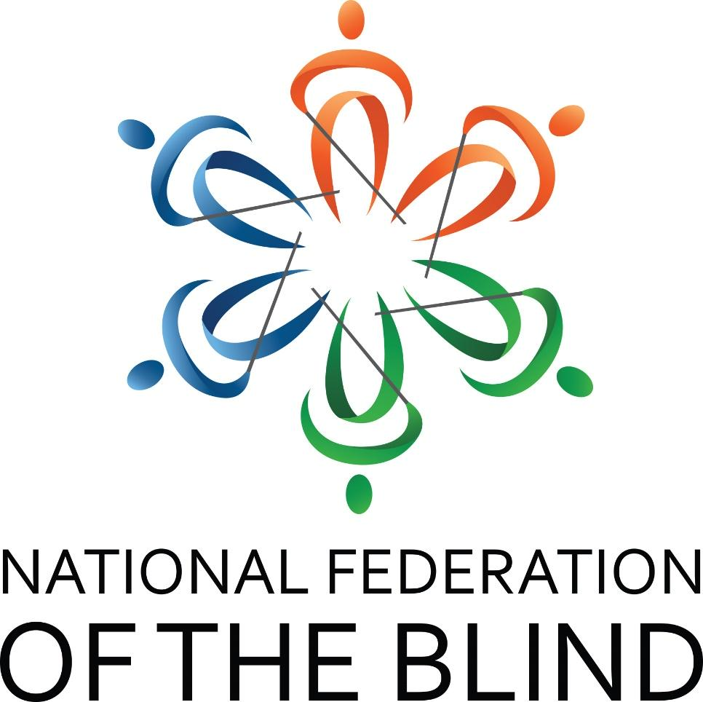

Stronger Together

68th Annual State Convention
National Federation of the Blind of South Carolina

Marty R. McKenzie, President
Embassy Suites by Hilton
200 Stoneridge Drive
Columbia, SC 29210
803-252-8700
Thursday, August 15 – Sunday, August 18, 2024

CONVENTION NOTES

NATIONAL FEDERATION OF THE BLIND PLEDGE
I pledge to participate actively in the efforts of the National Federation of the Blind to achieve equality, opportunity and security for the blind; to support the programs and policies of the Federation and to abide by its constitution.

NATIONAL FEDERATION OF THE BLIND

ONE MINUTE MESSAGE
The National Federation of the Blind knows that blindness is not the characteristic that defines you or your future. Every day we raise the expectations of blind people, because low expectations create obstacles between blind people and our dreams. You can live the life you want; blindness is not what holds you back.

INTEGRITY AND RESPECT
As with all NFB of SC functions, our members are held to the highest standards of decorum outlined in the National Federation of the Blind Code of Conduct. To allow all attendees the chance to benefit from all aspects of the convention, we are committed to providing a harassment-free environment for everyone. We appreciate your assistance in cultivating an atmosphere in which participants from diverse backgrounds may learn, network, and share with each other in an environment of mutual respect. Thank you for doing your part to contribute to our community and the high expectations we strive to maintain.

WELCOME
Welcome to the Embassy Suites Columbia-Greystone. It is our pleasure to have you here with us for your 2024 convention. We are looking forward to a couple of successful days of learning and camaraderie. We hope you enjoy your time here with us and if there is anything we can do while you’re visiting, please don’t hesitate to reach out. Nicole Blackwell is the Director of Sales and Kyle Morrison is our General Manager. Enjoy!

DOG RELIEF AREA
For those with dog guides, there are two specific dog relief areas. A trash receptacle has been placed there for convenience and tidiness. The first area is straight out the front door of the hotel across the parking lot. The second area is out a door near the elevators. This area has a set of steps that must be descended. Ask the front desk if more information is needed.

Contact Us
We have several convenient ways for you to connect with us. They are:

Website: www.nfbofsc.org

Phone: 803-254-3777

Address:
Federation Center of the Blind
119 S. Kilbourne Rd.
Columbia, SC 29205

National Federation of the Blind of South Carolina President:
Marty R. McKenzie
president@nfbofsc.org
843-939-8091

You can also find us on Facebook and X.

National Representative

Jessica Beecham, M.S.,

Business Owner

JB&K Services

Jessica Beecham was born in Murfreesboro, Tennessee to Marsha and Doug Beecham. She later became big sister to Lora Beecham. Blind from birth, Jessica has always embraced adventure and lived life with a can do attitude. Jessica attended elementary and high school at the Tennessee School for the Blind. She attended college at Middle Tennessee State University, earning a Bachelor of Science degree in Recreation and Leisure Studies with a concentration in Therapeutic Recreation and a Masters of Science Degree in Exercise Science.

Jessica has worked as a recreational therapist for children who are medically fragile as well as youth and adults with drug and alcohol dependency. In 2012, Jessica began working as Chapter and Community Development Coordinator for the National Federation of the Blind of Colorado, where she was instrumental in starting several new chapters and divisions. She then went on to direct WE Fit Wellness, a company designed to provide accessible, affordable, and achievable exercise and nutrition solutions for individuals with disabilities. In 2018, Jessica started her own business and became part of the Colorado Business Enterprise Program. She currently operates a large cafeteria, convenience store, and vending business on Buckley Space Force Base. She also works as a contractor to provide Pre-Employment Transition Services to blind youth.

Jessica enjoys volunteering with the National Federation of the Blind, the oldest and largest consumer advocacy organization of the blind. She has served as the president of the National Federation of the Blind of Colorado since 2021 and in 2023, she was elected as a member of the National Federation of the Blind Board of Directors. Jessica aspires to spread the love, hope, and true belief in blind people that she has found through her engagement with the National Federation of the Blind.

Jessica enjoys yoga, high adventure activities, and ultra running. She has completed several marathons and ultra marathon events including the Boston Marathon, Pikes Peak Marathon, Behind the Rocks 50k, and Pikes Peak 50 mile race. She also enjoys exploring the city with her guide dog Prada.

As a leader in the National Federation of the Blind, Jessica hopes to inspire others to live the lives they want, step outside of their comfort zones, and to help spread the positive philosophy of the Federation.

SCHEDULE

Thursday, August 18, 2024
5:30 – 7:30 PM Embassy Suites Complimentary Evening Reception
7:30 – 9:30 PM Blind Merchants Pre-Convention Prep Session – Consulate Board Room

Friday, August 16, 2024
10:00 – 6:00 PM Registration – Terrace Lounge Wall
10:00 – 6:00 PM Exhibit Hall – Center Atrium
10:00 – 5:00 PM Blind Merchants Snack Bags - Consulate Board Room
11:00 – 11:50 AM At-Large Chapter – Salon F
12:00 – 1:50 PM Youth Track – Salon E
Crafts & Teambuilding Activities
Make your own artwork to share with family and friends, Build the tallest tower using noodles and marshmallows, Wrap your friends in toilet paper!
1:00 – 1:50 PM Blind Merchants Division – Salon F
2:00 – 3:00 PM Pelikan Snowballs (Free to all) – Parking Lot
2:00 – 2:50 PM SC Association of Blind Students Division - Salon E
3:00 – 5:00 PM Youth Track – Salon E
PRIZES FOR WINNERS!
Bingo, Name that Tune, Trivia
2:00 – 3:50 PM SC Association of Black Leaders Division – Salon F
3:00 – 3:50 PM Computer Science and Technology Division –
Salon G
4:30 – 5:30 PM Resolutions Committee – Salon F
5:30 – 6:30 PM NFB of SC State Board Meeting – Salon D
7:00 – 10:00 PM Reception – Salons ABC

Saturday, August 17, 2024
7:30 – 8:45 AM Hot breakfast buffet in restaurant – Self-serve – Boy Scouts available to assist
8:00 – 8:50 AM Registration – Terrace Lounge Wall
8:00 – 8:50 AM Exhibit Hall – Center Atrium

MORNING GENERAL SESSION – Salons ABC

9:00 – 9:30 AM Welcome Marty R. McKenzie
Invocation Trenton Smith
Presentation of Colors Boy scouts
National Anthem Kaitland Davis, Heilyin Sanchez and Lily Pryor
Host Chapter Remarks Isaiah Nelson
9:30 – 10:00 AM National Report,
Jessica Beecham, National Representative
10:00 – 10:20 AM SC Commission for the Blind,
Darline Graham, Commissioner
Carol Anderson, Director of Consumer Services
10:20 – 10:40 AM SC School for the Deaf and the Blind,
Leslie Borton, Lead Teacher, SC School for the Blind
10:40 – 10:45 AM Fit Break, Janice Bright, Sports and Rec
10:45 – 11:00 AM SC Talking Book Services,
Jennifer Falvey, Director
11:15 – 11:30 AM Orientation and Mobility Training Program: A Journey to Success
Dr. Tina S. Herzberg, USC Upstate Professor
11:30 – 12:00 PM Presidential Report
Marty R. McKenzie, President
12:00 PM Adjourn

LUNCH BREAK

12:00 – 2:00 PM Box Lunches – Garden Atrium
12:15 – 1:45 PM Registration – Terrace Lounge Wall
12:15 – 1:45 PM Exhibit Hall – Center Atrium

AFTERNOON GENERAL SESSION Salon ABC

2:00 – 2:05 PM Welcome
2:05 – 2:20 PM Palmetto Able Savings Account
Karen Crider, State Treasurer’s Office
2:20 – 2:40 PM Kenneth Jernigan Leadership in Service Program: Reflections from a Participant
Janice Bright, NFB of SC Federationist
2:40 – 3:00 PM DART, PUP and VTrip
Ali Ruegamer, Transportation Program Coordinator
Able, SC
3:00 – 3:15 PM Filling Your Transportation Toolbox
Dr. Tina S. Herzberg, Professor
University of South Carolina Upstate
3:15 – 3:20 PM Fit Break, Lori Anne Coley
3:20 – 3:50 PM AI: What It Can Do for You
Steve Cook and Sarah Massengale
3:50 – 4:10 PM Rocky Bottom Report, Thom Spittle, RBRCCB Chair
4:10 – 4:25 PM NOPBC Update, Sonia Timmons, SCPOBC Leader
4:25 – 4:45 PM Federation Center Report, David Houck, Executive
Director and Ed Bible, FCB Board Chair
4:45 – 5:00 PM The Monarch
Marty R. McKenzie, Ex Officio Trustee
American Printing House for the Blind
5:00 PM Adjourn

EVENING BREAK
5:15 – 6:45 PM Registration – Terrace Lounge Wall
5:15 – 6:45 PM Exhibit Hall – Center Atrium
5:15 – 5:45 PM Nominating Committee – Frank Coppel, Chair – Boardroom 330

CONVENTION BANQUET
7:00–10:00 PM

Welcome Marty R. McKenzie
Invocation Debra Canty, Second Vice President, NFB of SC
Keynote Address Jessican Beecham, National Representative
Awarding of Scholarships Shannon Cook, Scholarship Chair

Recognition of Sponsors Marty McKenzie
- Sumter Lions’ Club, Silver level sponsor
- Neil’s Lawn Service, White Cane level sponsor
- Rockhill Lions’ Club, White Cane level sponsor
- Columbia Funeral Home, White Cane level sponsor

Midlands Gives Award Valerie Warrington, Treasurer
Educator of the Year Award Tracy Spittle, Chair
Donald C. Capps Award David Houck, chair
Betty R. Capps Award
Distinguished Service Award Marty R. McKenzie, President
Presidential Citation Marty R. McKenzie, President

Banquet Fundraiser
Our annual banquet fundraiser is an opportunity for individuals, chapters, divisions, and business partners to contribute to the NFB of SC to further programs, services, and policies of the affiliate. Donations can be made through Pay Pal on
www.nfbofsc.org, by cash or writing a check made payable to the NFB of SC and mailed to Federation Center of the Blind. See page 3 for the address.

Adjourn

Sunday, August 18, 2023
7:30–8:20 AM Breakfast
8:00–8:25 AM Registration – Terrace Lounge Wall

MORNING GENERAL SESSION – SALONS ABC
8:30 – 9:00 AM Remembering Those Who Went Before Us
A Memorial, Melinda Jones
9:00 – 9:15 AM Federation Legislative Update from the
Legislative and Advocacy Committee
David Houck, Chair and Anna Price, Co-chair
9:15 – 9:45 AM NFB of SC, Successful Transitions and Rocky Bottom Treasurers Reports -- Valerie Warrington, Treasurer
9:45 – 10:15 AM Resolutions, David Houck,
10:15 – 10:30 AM Update on SUN, PAC, Dream Maker’s Circle, Frank Coppel, chair, Doing Our Fair Share Committee
10:30 – 10:35 AM Fit Break – Melinda Jones
10:35 – 11:50 AM Elections
11:50 – 12:00 PM Chapter, Committee, and Division Drawings
12:00 PM Adjourn

