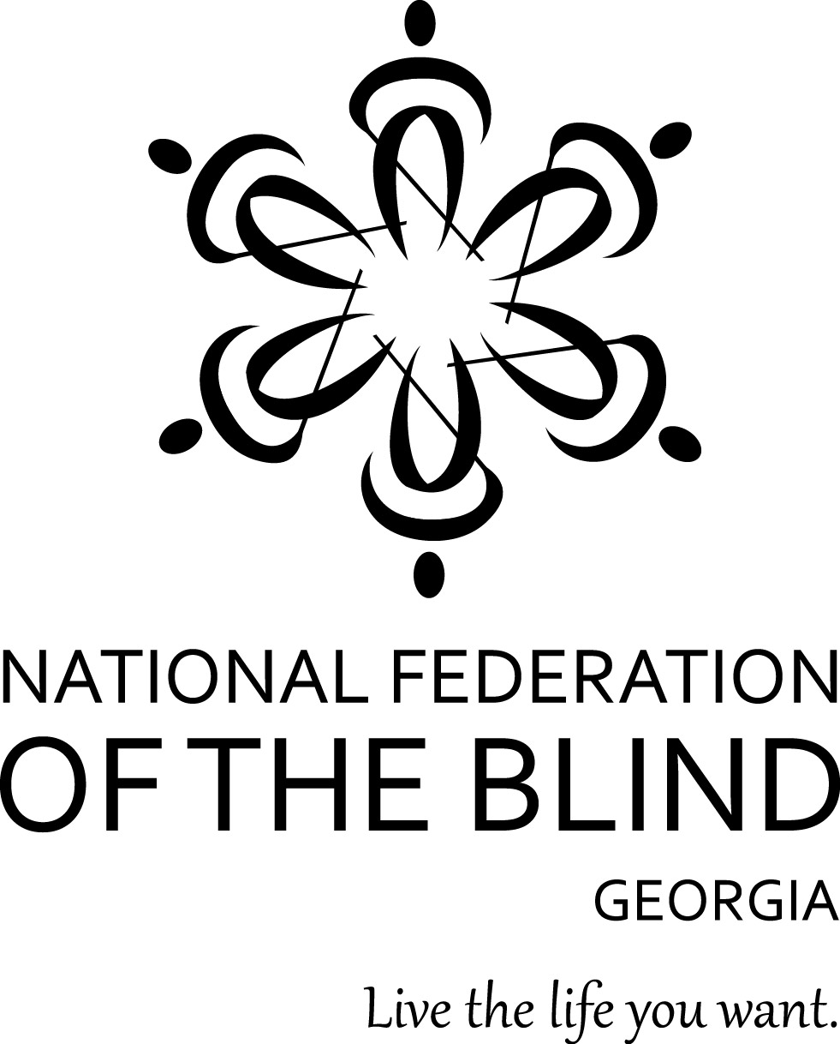

**Subject: Volunteer Opportunities for the 2025 NFBGA State Convention**

Dear Friends,

The National Federation of the Blind of Georgia (NFBGA) is excited to invite volunteers to support our 53rd Annual State Convention on Friday, October 10, and Saturday, October 11, 2025. This empowering event will take place at the Crowne Plaza Hotel, located at 590 West Peachtree Street NW, Atlanta, GA 30308.

The NFBGA State Convention is the largest gathering of blind people of all ages in Georgia. It’s a unique opportunity to connect, learn, and grow through seminars, workshops, and meaningful discussions that empower blind people to live the lives they want.

We need enthusiastic volunteers to help create a smooth, inclusive, and empowering experience for our attendees.

Below are the roles available for volunteers:

* Ambassadors: Welcome attendees and assist them with navigating the venue, including directions to meeting rooms, elevators, restrooms, and the exhibit hall. You may also help with luggage tagging and storage and assist at the registration desk.
* Media and Tech Support: Capture photos and videos of the event, assist with basic technical troubleshooting (such as microphones and projectors), and support any virtual components if applicable.

Volunteer Shifts:

* Friday, October 10 (Seminar Day & Evening Activities): 8:00 a.m. – 10:00 p.m.
* Saturday, October 11 (General Session and Banquet): 8:00 a.m. – 10:00 p.m.

**Transportation and Parking Information:**

* Public Transportation: The hotel is conveniently located across the street from the MARTA North Avenue Rail Station.
* Self-Parking: Available in the lot adjacent to the hotel at a rate of $18.00 per 12 hours (no in/out privileges). After 12 hours, the rate increases to a daily rate of $38.00.
* Hotel Valet Parking: Offered at a discounted rate of $38.00 per day, please let the valet staff know you are attending the NFB of Georgia convention.

We are grateful for your support and welcome any time you can offer to help make this event a success. To sign up as a volunteer or learn more, please contact our volunteer coordinator.

Volunteer Coordinator:

Ms. Page Carlisle

NFBGA, Board Member

PH: 762-245-9194

Email: <pcarlyle327@gmail.com

Respectfully,

**Dorothy Griffin**

Ms. Dorothy Griffin, President

National Federation of the Blind of Georgia

1696 W. Caribaea Trail S.E.

Atlanta, Georgia 30316

Phone: 404-371-1000

Email: [georgiablind@nfbga.org](mailto:georgiablind@nfbga.org)