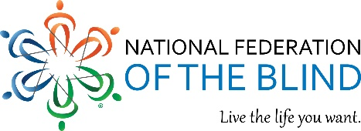

All Blind and Disabled individuals who attended or graduated from an HBCU, members of a Divine Nine Greek-letter organization, or others interested in supporting this important conversation

You’re invited!
Hosted by the National Organization of Blind Black Leaders and the Blind Greek and Masonic Group of the National Federation of the Blind, with support from the HBCU Committee, and will take place on the campus of Morehouse College.
The main program will take place on Friday, December 11, 2026, from 10:00 a.m. to 3:00 p.m.

Purpose of the Event
This event is designed to raise awareness and bring together individuals who want to engage in meaningful conversation at the intersection of race and disability. It will highlight the experiences, leadership, and contributions of blind people within HBCU, Greek-letter, and Masonic communities while inviting broader community participation in discussions about inclusion, accessibility, and equity.

Weekend Activities Include:
- Thursday, December 10, 2026 – Evening Reception at Origin Atlanta, a Wyndham Hotel
- Friday, December 11, 2026 – Main Program at Morehouse College (10:00 a.m. – 3:00 p.m.)
- Saturday, December 12, 2026 – Group attendance at the Cricket Celebration Bowl at Mercedes-Benz Stadium, featuring the champions of the MEAC and SWAC conferences
- Sunday, December 13, 2026 – Farewell Brunch (location to be announced)

If you are interested in participating in this weekend event, please complete the short survey below. This form is intended to help organizers gather interest and planning information as event details continue to develop.
https://docs.google.com/forms/d/e/1FAIpQLSe8BNVBU0PVwl2iLkFU7GqDRoybKxyfY_vFyz_pyKuOexbaTw/viewform
For questions, please email cbauc.planning@gmail.com or contact Shawn Callaway at 202-352-1511.

We look forward to seeing you in Atlanta.

Shawn M. Callaway, President
National Organization of Blind Black Leaders and
Chairman of the NFB Blind Greek Masonic Group
National Federation of the Blind
Live the life you want

