**Low Vision? No Vision? Vision and hearing loss?**

**Arizona’s Vision Rehabilitation and**

**Assistive Technology Expo is for You!**

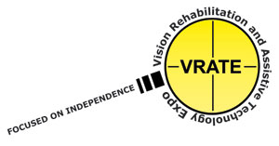

**VRATE 2019**

**Friday, November 15th and Saturday, November 16th**

**9:00 a.m. – 4:00 p.m.**

**Glendale Civic Center - 5750 W. Glenn Dr. - Glendale, AZ 85301**



**Presentations and Exhibitors Focused on:**

* **Vision loss and rehabilitation**
* **Life-changing Assistive Technology**
* **Resources for combined vision & hearing loss**
* **Government and community services**
* **Saturday’s focus is youth, family, & education**

[**https://www.vrateaz.com**](https://www.vrateaz.com)

**TELL YOUR FRIENDS! BRING YOUR GROUP!**

**VRATE is FREE to the Public**

**For information and registration go to https://www.vrateaz.com**