Independence Market

The National Federation of the Blind's Independence Market is an extensive store that offers hundreds of products and literature created by and for the blind community.

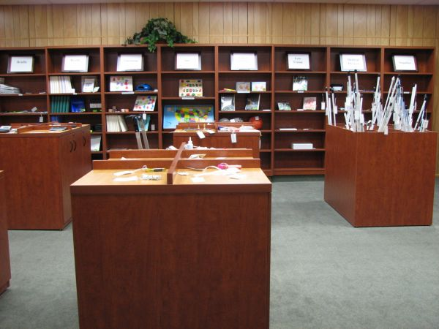Located at our national headquarters in Baltimore, Maryland, the Independence Market is a helpful resource for anyone who is blind or is experiencing vision loss.

We carry many products, including:

* Long white canes
* Talking watches and clocks
* Print and Braille writing aids
* Magnifiers
* Medical devices
* Household and kitchen tools
* NFB literature and multimedia

To request our full catalog in print or Braille, please email [independencemarket@nfb.org](mailto:independencemarket@nfb.org), specifying the format you wish to receive and your complete mailing address.

Catalog

The Independence Market catalog is now available via Word: [2023 Independence Market Catalog](https://nfb.org/sites/nfb.org/files/2023-05/FINAL-2023-Independence-Market-Catalog-for-Print-and-Braille.docx)

Online ordering returning soon!

How to Shop

Shop by Email or Phone

Our staff is available to assist you by email or phone. We answer phone calls Monday through Friday from 9:00 a.m. to 4:00 p.m. ET. Please email us at [independencemarket@nfb.org](mailto:independencemarket@nfb.org) or call 410-659-9314, extension 2216.

Shop in Person

If you will be visiting the National Federation of the Blind's [national headquarters](https://nfb.org/about-us/national-headquarters), and would like to shop in person, please call in advance to schedule an appointment. Our address is 200 East Wells Street, Baltimore, Maryland 21230. Please come up to the fourth floor and let the receptionist know that you have an appointment to visit the Independence Market.

More Information

For more information about the Independence Market, please email us at [independencemarket@nfb.org](mailto:independencemarket@nfb.org) or call 410-659-9314, extension 2216.

# NFB-NEWSLINE®

It’s more than news—access a world of content in this free audio and Braille service for blind and print-disabled people.  
NFB-NEWSLINE® is a free audio news service for anyone who is blind, low-vision, deafblind, or otherwise print-disabled that offers access to more than 500 publications, emergency weather alerts, job listings, and more.

How to Sign Up for NFB-NEWSLINE

Anyone who cannot read printed publications due to vision loss, dyslexia, or a physical disability is eligible to receive NFB-NEWSLINE. Please register by calling the Arizona Talking Book Library at (602) 255-5578 your state's [Library for the Blind and Print-Disabled](https://www.loc.gov/nls/braille-audio-reading-materials/find-a-local-library/) or the National Federation of the Blind at 866-504-7300 to request an application. You may also [download and mail an application](https://nfb.org/Images/nfb/documents/pdf/newslineapp.pdf) or complete our [online application](https://www.nfbnewsline.net/Nl2/NL2NewUserReqInput.jsp). After your registration is processed, you will receive a message containing your activation codes and instructions.

Ways to Access NFB-NEWSLINE

After you sign up for NFB-NEWSLINE, you will be able to access it in any of the following ways. If you are a current subscriber, you do not need to create a new account or obtain new codes to use additional methods. Your current codes will allow you to access NFB-NEWSLINE using any method you choose. If you’ve forgotten your codes, please call us for assistance.

iOS Mobile App 3.0 with KNFB Reader Basic

NFB-NEWSLINE Mobile includes these features and much more:

* KNFB Reader Basic, a free version of KNFB Reader with the core functions necessary to quickly scan any printed text – just point, shoot, and read
* The ability to share articles from publications in the breaking news category to social media channels
* Multiple customization options to organize, save, and manage both NFB-NEWSLINE content and documents scanned with KNFB Reader Basic

NFB-NEWSLINE Mobile 3.0 is fully accessible with VoiceOver so that users can hear content read aloud or read it in Braille with a connected refreshable Braille display or notetaker, making the app ideal for blind and deafblind users.

Phone

* Access NFB-NEWSLINE through your phone with the touch of a few buttons
* Create your own favorites list, skip articles or sections, and repeat items you wish to re-read
* Enable the continuous reading mode which allows you to start, stop, and skip articles
* Alter the reading voice by changing the volume, speed, and pitch

For more information, please visit our [NFB-NEWSLINE phone instructions](https://nfb.org/programs-services/nfb-newsline/phone-instructions) page.

Amazon Alexa

* Access NFB-NEWSLINE hands-free on any Amazon Alexa product, including Echo and Echo Dot
* Alter the reading voice by changing the volume, speed, and the voice itself
* Use dozens of voice commands to navigate to sections and articles that interest you

Learn more about the [Amazon Alexa family of devices](http://www.amazon.com/Amazon-Echo-And-Alexa-Devices/b?ie=UTF8&node=9818047011) and enable the [NFB-NEWSLINE Alexa skill](http://www.amazon.com/National-Federation-the-Blind-NFB-NEWSLINE/dp/B07KZZZ8C9/ref=sr_1_1?s=digital-skills&ie=UTF8&qid=1545945092&sr=1-1&keywords=national+federation+of+the+blind) today. For more information, please visit our [Alexa instructions](https://nfb.org/programs-services/nfb-newsline/alexa-instructions) page or check out [our training video](https://www.youtube.com/watch?v=tu-Q4VgBSJw) on YouTube.

iOS Mobile App

* Access NFB-NEWSLINE on your iPhone, iPod, or iPad
* Global search function allows you to find articles on specific topics
* Immediate access to breaking news stories

Download the free ["NFB-NEWSLINE Mobile" app in the Apple App Store](https://itunes.apple.com/us/app/nfb-newsline-mobile/id530470425?mt=8).

Website

* Access NFB-NEWSLINE on a secure, text-only website that is screen-reader friendly
* Easily navigate and search every available publication
* Email a full publication, a section, or single article to your inbox

Visit [nfbnewslineonline.org](http://www.nfbnewslineonline.org/) to access NFB-NEWSLINE online.

Email

* NFB-NEWSLINE can email your news, customized job listings, and information directly to your inbox
* Provide us with an email address, choose your favorites, and select frequency (once daily or updates throughout the day)

Please call us at 1-866-504-7300 to set up your NFB-NEWSLINE email service.

Portable Players

* Access NFB-NEWSLINE through many popular digital talking book players
* Portable, plug and play, wireless download for Victor Reader Stream 2nd Generation
* Easily navigate sections and articles with the use of DAISY-standard formatting

Visit [nfbnewslineonline.org](http://www.nfbnewslineonline.org/) to learn more.

More Information

For more information, please call us at 866-504-7300 or 410-659-9314, extension 2317, or email us at [nfbnewsline@nfb.org](mailto:nfbnewsline@nfb.org).