Games People Play and Costume Showcase

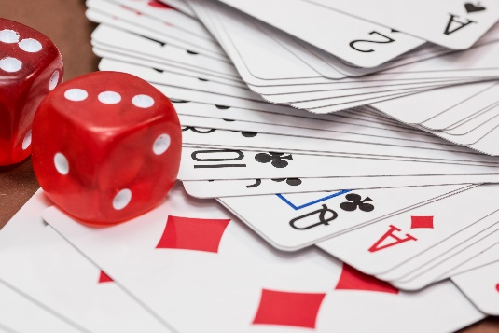

Description: The image shows a close-up of a deck of playing cards spread out in a fan shape on a surface. Two red dice with white dots are prominently displayed on top of the cards. The visible cards include various suits like diamonds, clubs, and hearts, with some aces and numbered cards clearly visible.

You're invited to the first-ever Game Night hosted by the Phoenix chapter of the National Federation of the Blind! Join us for an evening of fun with cards, Family Feud, delicious food, and more exciting activities. We’ll also be auctioning off homemade baked goods, and don’t forget to participate in our costume showcase! Come dressed in your favorite costume and be ready to share the story behind it.

The entrance fee is $10 per person or $20 per family, and kids 15 and under get in free. All proceeds will support the National Federation of the Blind Phoenix chapter. Please RSVP and let us know how many will be attending. Get ready for a fantastic night filled with games, great costumes, and plenty of laughter!

The event will take place on Saturday, October 26. Location: Saavi Services for the Blind. 2920 North 7th Street

Time: 3-7 pm.