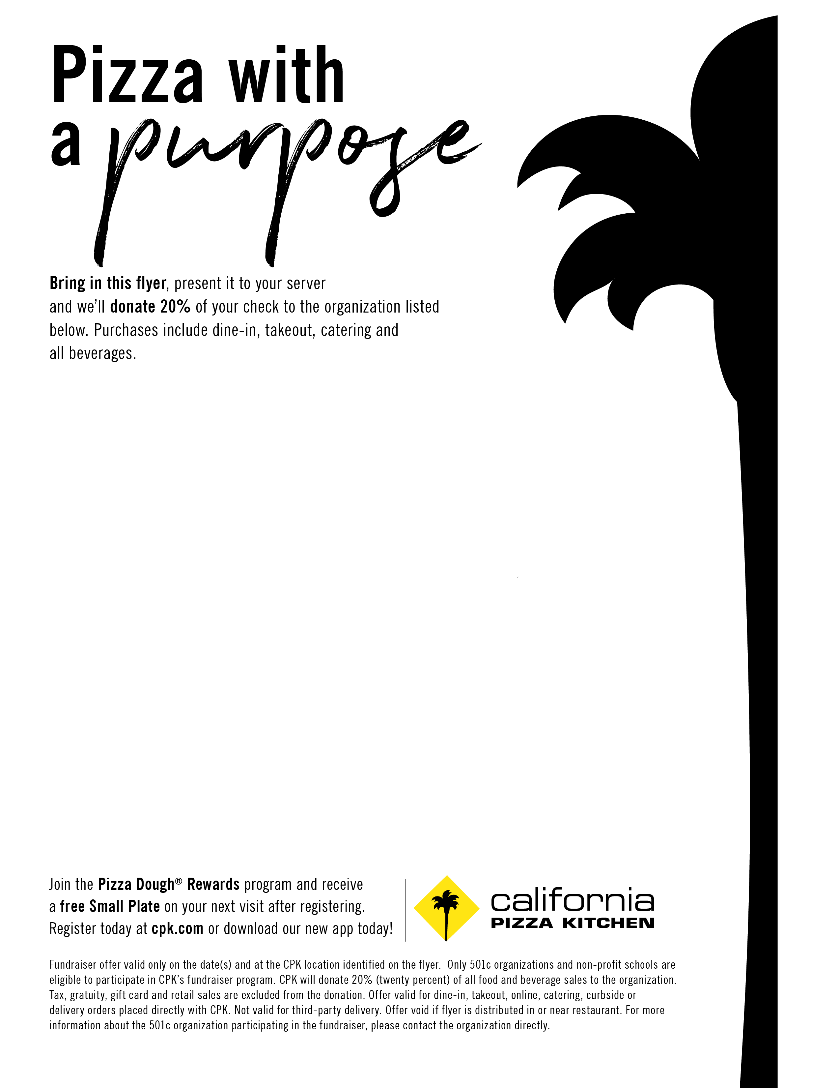

**Fundraiser in support of:**

**National Federation of the Blind**

**Saturday June 8th- Sunday June 9th**

**11am-10pm**

**Dine-In or Take-out**

**Valid at the following location:  
California Pizza Kitchen**

**Biltmore Fashion Park**

**2400 E Camelback Rd.**

**(602)553-8382**

**Tempe Marketplace**

**2000 E Rio Salado Pkwy**

**(480)967-0498**