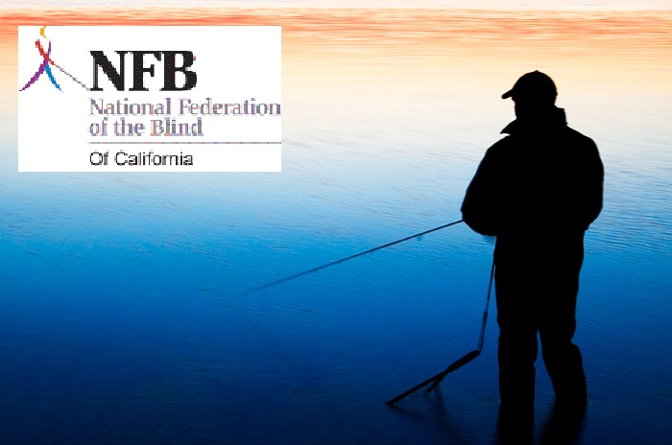

DEEP SEA ADVENTURE

The captain steers the bow of the boat out of the harbor and increases the throttle. The gentle sea breeze caresses my face along with the sunshine. A broad smile plays across my face because I am going out deep sea fishing with family and friends.

The National Federation of the Blind San Fernando valley Chapter presents its second annual deep sea fishing adventure.

Marina Del Rey Sport Fishing
Saturday August 18, 2012

Cost is $39 for adults and $25 for Children UNDER 12
Boat departs at 12:30 and returns approximately at 5:30 pm

Pick up and drop off address
Berth 52 off Fiji Way and Lincoln
13552 Fiji Way, Marina Del Rey, CA 90292
Phone: 310-822-3625

Basic fishing techniques will be taught if requested

For general information
2012 Free Fishing Licenses

** Please note you will still need an enhanced ocean validation - OCEAN ENHANCEMENT VALIDATION - $4.89**

http://www.dfg.ca.gov/licensing/fishing/sportfishingfreereduced.html

Marina Del Rey website
http://mdrsf.com/

For more information or to reserve your rod and reel call, Gordon Chan 909-576-2934

Please RSVP if you plan to attend

