Please join us in celebration of a special life,

Michael Couey
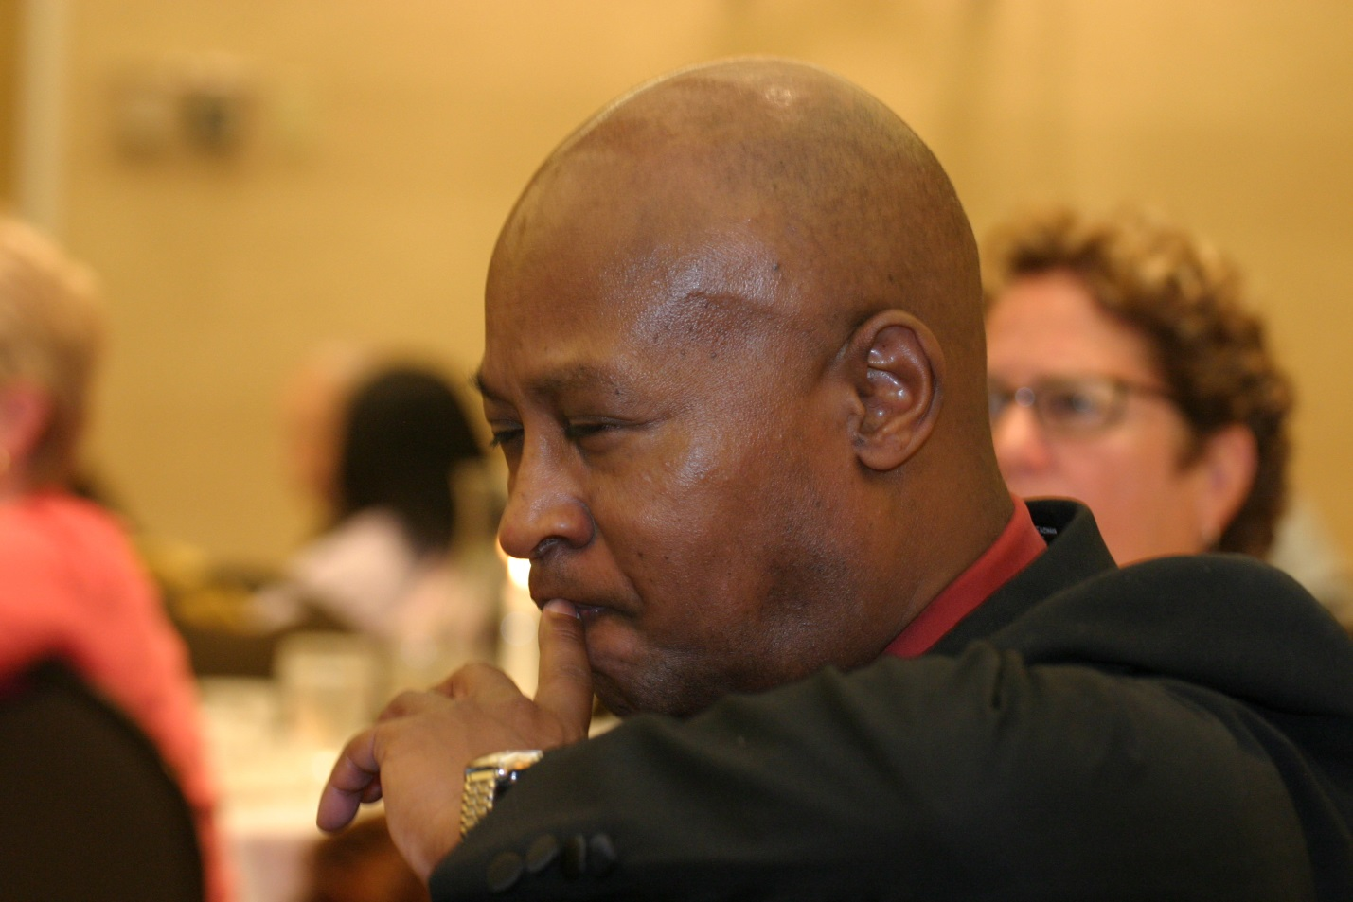
Date: Saturday, March 8, 2014
Time: noon – 1:00 p.m.
Location: California State Capitol Building
Tenth and L Street, Room 317
Sacramento, CA 95814
(Enter on L Street. Parking is either on L Street or in the parking garage on 10th Street)

