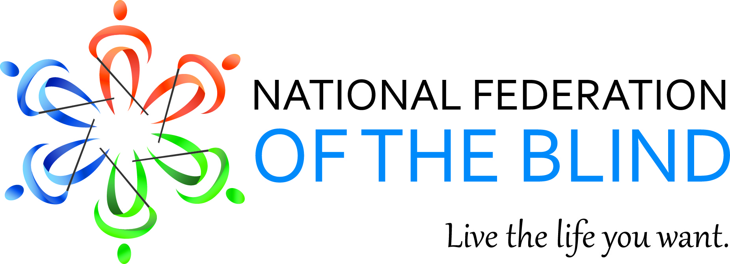

Mary Willows, President
National Federation of the Blind of California
3934 Kern Court
Pleasanton, CA 94588
925) 895-2778
mwillows@sbcglobal.net

January 2014 Bulletin

“Many things are thrown our way in this game of life. It's how you deal with them that shows your true character. I want all of you to feel the hope, love & passion I feel for the upcoming year & the rest of my life. I want ALL of you to not only go for your dreams, but have a darn good time doing it!” - May Waters

Dear Fellow Federationists,

“The National Federation of the Blind knows that blindness is not the characteristic that defines you or your future. Every day we raise the expectations of blind people, because low expectations create obstacles between blind people and our dreams. You can live the life you want; blindness is not what holds you back.”

National Federation of the Blind 2015 Scholarship Program
Deadline: March 31, 2015
Help us to spread the word about the largest scholarship program in the county for visually impaired and blind students. Are you a legally blind college student living in the United States or Puerto Rico? This annual program offers 30 scholarships worth from $3,000 to $12,000 to eligible students, from high school seniors beginning their freshman year in the fall semester of 2015, up through grad students working on their PhD degrees. These merit scholarships are based on academic excellence, community service, and leadership. In addition to the money, each winner will receive assistance to attend the July 2015 NFB annual convention in Orlando, Florida, providing an excellent opportunity for high-level networking with active blind persons in many different professions and occupations. To apply, read the rules and the Submission Checklist, complete the official 2015 Scholarship Application Form (online or in print), supply all required documents, and request and complete one interview by an NFB affiliate president (unless the president requests a later date). Applications are accepted for five months, from November 1, 2014, to March 31, 2015. Go to www.nfb.org/scholarships for complete rules and requirements.

Dr. Perry comes home to the California School for the Blind
On December 10, 2014, the superintendent of the California School for the Blind, Dr. Sharon Sacks, ceremoniously hung a bas-relief picture of Dr. Newell Perry in the library. A bas-relief is a projecting image with a shallow overall depth, for example used on coins. The sculpted picture shows the characteristic French goatee. President Mary Willows contributed to the occasion by telling stories about experiences students had with Dr. Perry. Former students were pestered about their plans for the future where they will go and how they will pay for their needs. Dr. Perry was committed to the education of blind children on social, economic, and educational levels with the ultimate goal of employment. All are invited to feel the bas-relief at CSB which hangs next to the only known portrait of Dr. Newell Perry.

2015 TIME Act
The “fair wages” bill has a new name. In 2015 our advocacy efforts will again demand the repeal of Section 14(c) of the Fair Labor Standards Act. This year it is called The Transitioning to Integrated and Meaningful Employment (TIME) Act. The TIME Act explains exactly what we are advocating for: Section 14(c)-certificate-holding entities need to transition their business models to ensure that people with disabilities are reaching their full potential in integrated and meaningful employment.
California Federationists will visit Washington DC to educate our representatives about our 2015 issues concerning blind Americans during January 27, 28, and 29. Your support, phone calls, and email messages will help to make sure our team is heard. Watch for more information.

Accessible Employment Survey
The Department of Labor would like to hear from users of Accessible Technology about experiences with online job applications. The program is called the Partnership on Employment & Accessible Technology (PEAT). We encourage you to participate in this survey found at http://usodep.blogs.govdelivery.com/2014/12/15/charting-a-pathway-to-a-technology-accessible-workplace/.

2015 Writer’s Contest
The 2015 Writer’s Division Contest has a theme this year. Since it is the 75th anniversary of the National Federation of the Blind, entries should have “75” as a theme. Let your imagination take over. For example, 75 balloons, 75 steps to your destination, 75 aliens. Adult contests, poetry, fiction, non-fiction, and stories for youth are open to all entrants eighteen and over. The contest opens January 1 and closes April 1. For contest guidelines, http://writers.nfb.org

