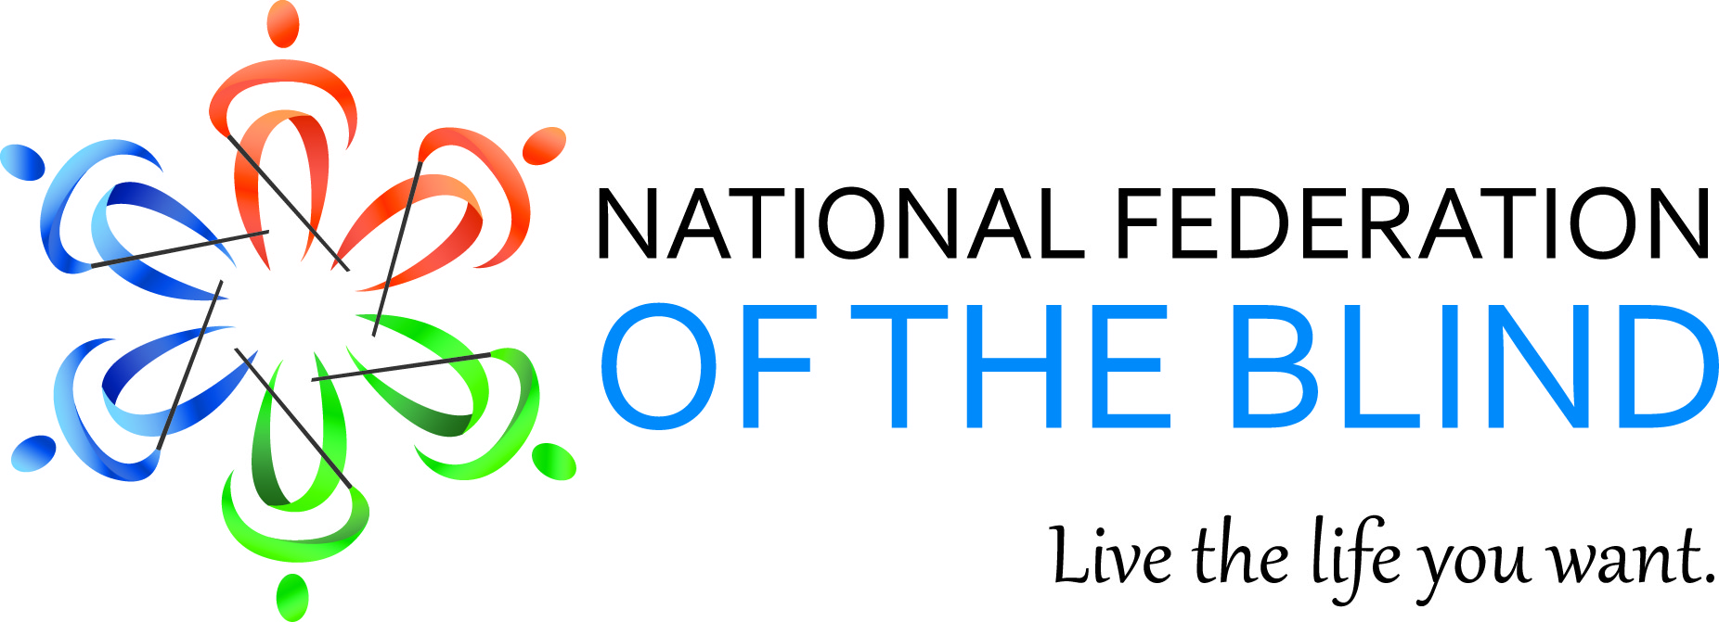

Mary Willows, President
National Federation of the Blind of California
3934 Kern Court
Pleasanton, CA 94588
925) 895-2778
mwillows@sbcglobal.net

March 2015 Bulletin

Dear Fellow Federationists,

I start this March Bulletin with our new branding. The following is the essence of the 75 years of love, hope and determination. Commit it to memory. It will get you through all kinds of situations.
“The National Federation of the Blind knows that blindness is not the characteristic that defines you or your future. Every day we raise the expectations of blind people, because low expectations create obstacles between blind people and our dreams. You can live the life you want; blindness is not what holds you back.”

2015 Summer Internship Application Deadline
If you or someone you know has a desire to learn about current legislation, education, technology, civil rights, public relations, and much more, applications and accompanying documentation should be submitted to Anil Lewis at jerniganinstitute@nfb.org by March 13, 2015. The program runs from June 1 to August 7 and includes a trip to the 75th anniversary convention of the National Federation of the Blind. This opportunity is being made available through the Jernigan Institute located in Baltimore, Maryland. More information can be found at: https://nfb.org/blog/vonb-blog/national-federation-blind-2015-summer-internship-program

The U.S. Bureau of Engraving and Printing Money Reader is Still Available
If you did not attend the National Convention in 2014 and receive a free money reader, you can still apply for one at the web site: www.moneyfactory.gov/uscurrencyreaderform.html You must be a qualified patron of the National Library Service for the Blind and Physically Handicapped (NLS). On a personal note, I would like to tell everybody these very helpful, portable readers have been very handy for sorting and organizing paper currency when I did not have sighted assistance readily available. I recommend that everyone apply now.

Chapter Development in California
Two of our NFB of California Board Members, Rochelle Houston and Ever Lee Hairston travelled to our Riverside / San Bernardino Chapter to build membership in California. Rochelle told of her journey into blindness and shared tips on fundraising ideas for building the organization.
The Pathfinders Chapter held the annual membership recruitment reception. Ever Lee Hairston spoke to the group about her experiences learning to become an independent blind adult. The reception was a success resulting in four new members.

Viejas Casino Trip
If you want to try your luck at the role of the dice on your way to the pot of gold, join the Pathfinders and San Fernando Valley Chapters on Saturday April 4, 2015.
If you live in the Los Angeles Area, lucky participants will meet at the
Greenline Park & Ride at 8 a.m. which is located at 11901 South Crenshaw Blvd, Hawthorne, CA.
If you live in the San Fernando Valley Area, meet at 7 a.m. at the home of Robert Stigile located at 19831Friar Street, Woodland Hills, CA 91367.
Donation $2. This fun filled event will help raise money to get people to the 75th Anniversary Convention of the National Federation of the Blind in Orlando, Florida this summer.
For reservations and more information, contact Rochelle Houston at
323-807-0300 or email rhouston58@gmail.com or Robert Stigile at 818-381-9568 or email rstigile@gmail.com

First Annual Senior Division Seminar Saturday, April 11, 2015
The National Federation of the Blind of California Senior Division is inviting you to join us for a seminar in knowledge, information, & methods of living with blindness. We are planning on door prizes and lots of fun!

WHEN: Saturday, April 11, 2015
TIME: Noon – 3pm
WHERE: Hometown Buffet
12139 Hawthorne Blvd. Hawthorne, CA 90230

ALL LEGALLY BLIND SENIOR GUESTS will be treated to a FREE LUNCH.
RSVP by March 31st, CONTACT:
Charlotte Carroll – (310) 625-6558, email mizzcharlotte@sbcglobal.net
Cheryl Thurston – (909) 821-9589, email cthurston74@gmail.com

