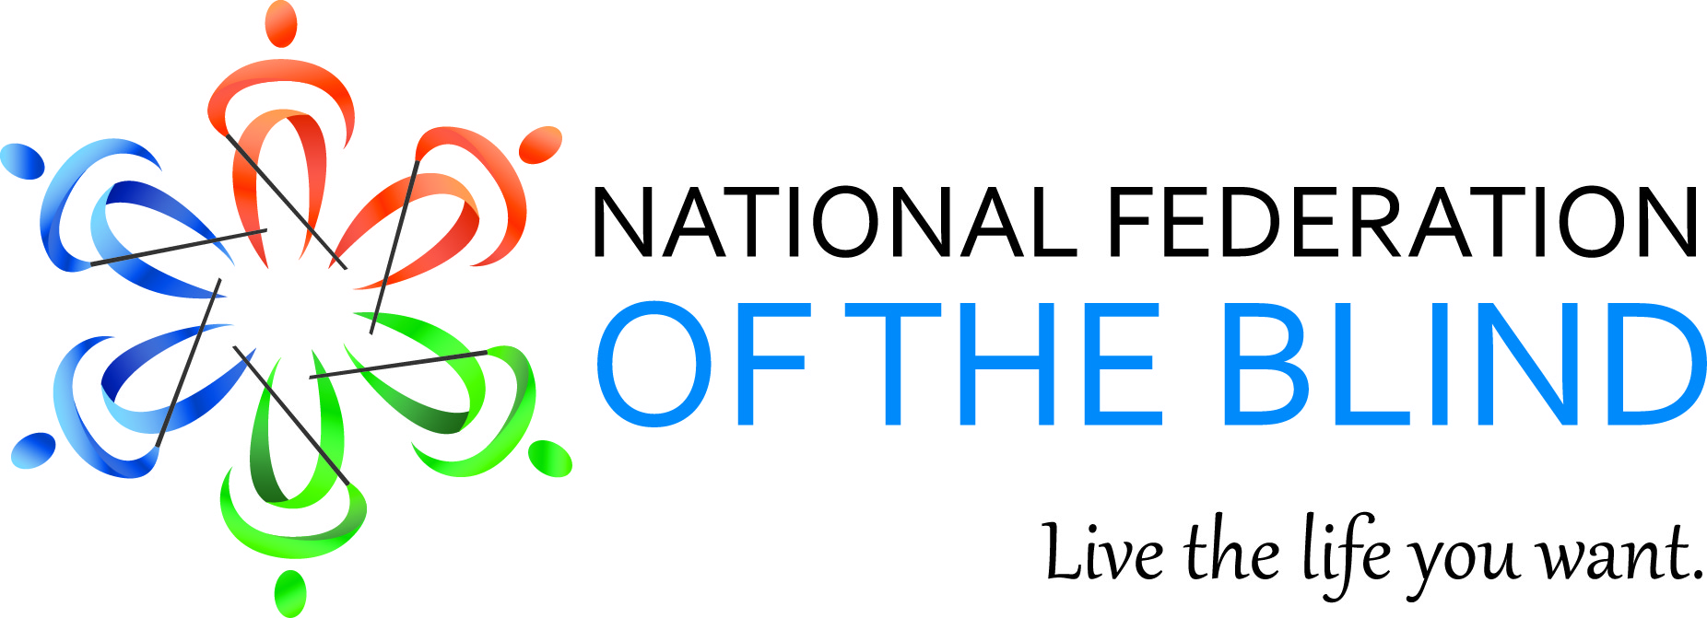

Mary Willows, President
National Federation of the Blind of California
3934 Kern Court
Pleasanton, CA 94588
925) 895-2778
mwillows@sbcglobal.net

April 2015 Bulletin

Dear Fellow Federationists,
I start this April Bulletin with our new branding. The following is the essence of the 75 years of love, hope and determination. Commit it to memory. It will get you through all kinds of situations.
“The National Federation of the Blind knows that blindness is not the characteristic that defines you or your future. Every day we raise the expectations of blind people, because low expectations create obstacles between blind people and our dreams. You can live the life you want; blindness is not what holds you back.”

Chapter Development in California
I am pleased to announce that the Pathfinder Chapter Los Angeles of the National Federation of the Blind of California has increased membership dramatically since the start of the 75th anniversary campaign. We hold an annual chapter development reception every February. This year, like the past four years since we started this event, the reception has brought in even more members. Not only is the chapter growing in numbers, but the new members are coming in with new and fresh ideas. They are eager to learn about the organization. Since the start of the campaign in November 2014, the Pathfinder chapter Los Angeles has brought in ten new members. -Rochelle Houston
Treasurer, National Federation of the Blind of California President, Pathfinder Chapter Los Angeles.

First Annual Senior Division Seminar Saturday, April 11, 2015
The National Federation of the Blind of California Senior Division is inviting you to join us for a seminar in knowledge, information, & methods of living with blindness. We are planning on door prizes and lots of fun!

WHEN: Saturday, April 11, 2015
TIME: Noon – 3pm
WHERE: Hometown Buffet
12139 Hawthorne Blvd. Hawthorne, CA 90230

ALL LEGALLY BLIND SENIOR GUESTS will be treated to a FREE LUNCH.
RSVP by March 31st, CONTACT:
Charlotte Carroll – (310) 625-6558, email mizzcharlotte@sbcglobal.net
Cheryl Thurston – (909) 821-9589, email cthurston74@gmail.com

Join us for our First Senior Division Seminar in Sacramento in May
We will also be holding a Senior Seminar in Sacramento, May 16, 2015. It will be held in conjunction with the Hair in the Wind fundraising event for the River City Chapter. RSVP by May 10, 2015.

WHEN: Saturday, May 16, 2015
TIME: 1:00 – 4:00
WHERE: Society for the Blind
1238 S Street, Sacramento, CA 95811
CONTACT: Charlotte Carroll – (310) 625-6558
email mizzcharlotte@sbcglobal.net
Stay Connected With the New App, NFB Connect
There’s now another easy way to stay connected with the National Federation of the Blind (NFB) if you have an iPhone, iPad, or other iOS device. Our new mobile app, NFB Connect, is finally here! You can find it in the Apple App Store, or just use the following link on your iOS device to download it directly:
https://itunes.apple.com/us/app/nfb-connect/id968434124
With NFB Connect, you can quickly and easily read the latest news about the NFB, find information about upcoming events, access the Braille Monitor and other publications, listen to the presidential releases, find the NFB in your community, learn about ways to support the National Federation of the Blind, and more! Download the free NFB Connect app today! Any feedback regarding the app can be sent via email to mobileapp@nfb.org
“I personally use this every day. This app is fabulous!” – Mary Willows

Sending Our Get Well Wishes to Mr. Whozit, Cal Sanders
Recently our good friend and member, Cal Sanders, underwent some pretty extensive surgery to remove cancerous cells from his kidney. I am so pleased to report that Cal is up and about and recovering right on schedule. If you remember, Cal Sanders dressed up in full regalia as Whozit for several public education events held in California. Here’s to a speedy recovery. See you at the next convention.

Stand Up 4 Transportation Day
April 9, 2015 is Stand Up 4 Transportation Day. Moving Ahead for Progress in the 21st Century (MAP-21) is the current transportation funding bill. MAP-21 will expire on May 31, 2015. Blind and visually impaired people must have good and reliable public transportation to travel independently to school and work. Please call your congressional representative on April 9 and voice your support for federal funding commitment for MAP-2. For more information, go to:
http://www.apta.com/members/memberprogramsandservices/advocacyandoutreachtools/Stand%20Up%20for%20Transportation/Pages/default.aspx

Your Phone Service is Changing – Here’s What You Need to Know
Experts estimate that by 2020, customers will be required to switch from old landline phone networks to cell phone and Internet-based phone service. We have requested that the three informational brochures be made available in Braille. Let our voices be heard to the Consumer Action Group by calling or emailing Ken McEldowney and tell him that we need to have this information produce in Braille. Contact: Ken McEldowney 800-999-7981or info@consumer-action.org.

750 Braille Books Needed
The National Organization of Parents of Blind Children will once again hold a Braille Book Fair at the annual convention of the National Federation of the Blind in Orlando, Florida on July 7, 2015 from 5:00 – 7:00 p.m. Gently used but no longer needed children’s books are being accepted at the following address:
UPS, Elainna Moore - HR Dept, 8901 Atlantic Avenue, Orlando, FL 32824. For more information contact, Krystal Guillory at 318-245-8955 or kguillory@lcb-ruston.com
Please note: it is helpful if you write the content/ type of book on the outside of the box. And, remember: all books can be shipped FREE MATTER FOR THE BLIND.

