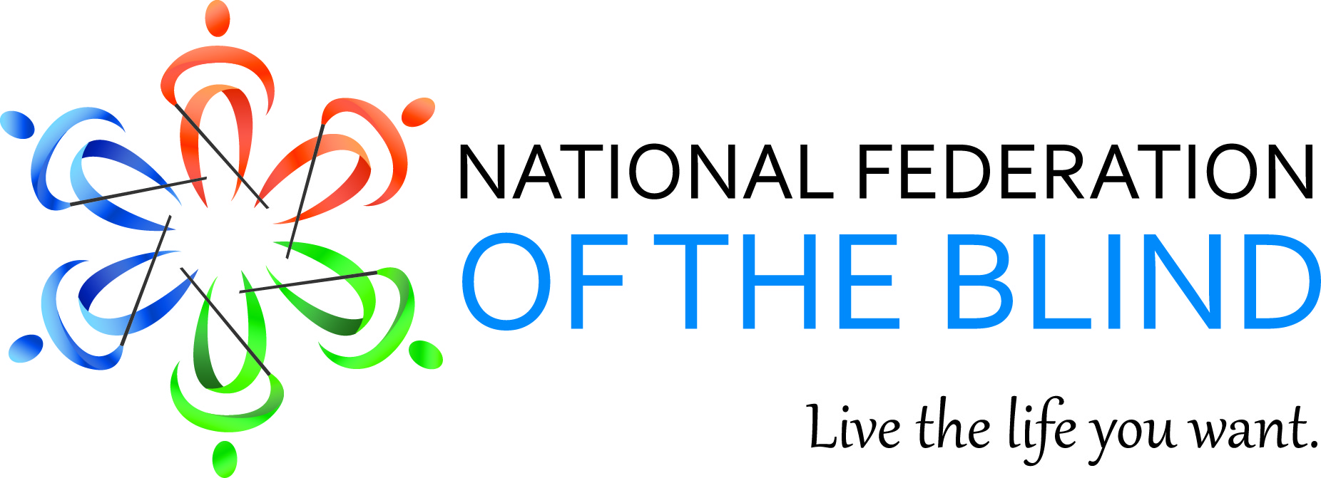

Mary Willows, President
National Federation of the Blind of California
3934 Kern Court
Pleasanton, CA 94588
(925) 895-2778
mwillows@sbcglobal.net

August 2015 Bulletin

Dear Fellow Federationists,

“The National Federation of the Blind knows that blindness is not the characteristic that defines you or your future. Every day we raise the expectations of blind people, because low expectations create obstacles between blind people and our dreams. You can live the life you want; blindness is not what holds you back.”

75th ANNUAL CONVENTION:
After 75 years of love, hope, and determination, the National federation of the Blind continues to break records. On July 8, 2015, two thousand four hundred and eighty enthusiastic supporters filled the parking lot behind the Rosen Center Hotel in Orlando, Florida to create the world’s largest umbrella mosaic. You can watch the Youtube video of this landmark event documented by the Guinness World Record by going to
https://www.youtube.com/watch?v=OeMp9TjbHXY

This year, President Mark Ricobonno delivered his first Banquet speech and Presidential Report. Californians cheered when he mentioned three of our members who are involved in disputes which have required legal assistance. Nearly three thousand Federationists’ roared and cheered when President Ricobonno sang with the band on stage Friday morning as the General Session opened.

The 75th Anniversary Ball was a smashing success. President Ricobonno and his wife Melissa dressed up for the occasion in 1940’s attire. The Resolutions Committee brought twenty nine resolutions to the floor for adoption. You can read all of them at the nfb.org website. Again, the bulk of the resolutions concerned information, accessibility, and technology.

California will continue the celebration at our 2015 State Convention, which will be held on October 30, 31, and November1 at the Doubletree By Hilton Hotel located at 39900 Balantine Drive in Newark, CA 94560. Room Rates are as follows: Singles-$119.00 per night, plus taxes, include 1 breakfast. Doubles-$129.00 per night, plus taxes, includes 2 breakfast. Please spread the word that we are celebrating 75 for $75. Registration, Diabetes Action NETWORK Luncheon and Banquet, will cost $75. The pre-registration forms will be available on our website at www.sixdots.org.

SCHOLARSHIPS:

The 2015 NFB of California Scholarship Committee is accepting applications. This year, we will award $5,000 to three outstanding college students (two at $1,500 and one at $2,000). The applications and guidelines are available at www.sixdots.org/scholarships. The deadline for submissions is midnight, September 25, 2015.

CONGRESS AT HOME:

During the month of August, Congressional representatives will be in their home districts meeting with constitutes. Please gather two or three chapter members together and make an appointment to meet with your representative to educate them about the need for “Integrated Competitive Employment”. This will phase out 14c of the Fair Labor Standards Act. It is time for blind and disabled Americans to earn a fair wage. Also, remind them that we are actively seeking to pass legislation that will address the accessibility of instructional materials in post-secondary education institutions.

The Life Story of Ever Lee Hairston:

NFB OF California, First Vice-President, Ever Lee Hairston has opened her life and shred her story in a book entitled “Blind Ambition”. Adventures and disappointments as she grew up and made her way across the country. We are lucky to have her as one of our leaders and a member of the National Board of Directors. Order your copy by going to Amazon.com and search for “Blind Ambitions” or download it on ibooks.

