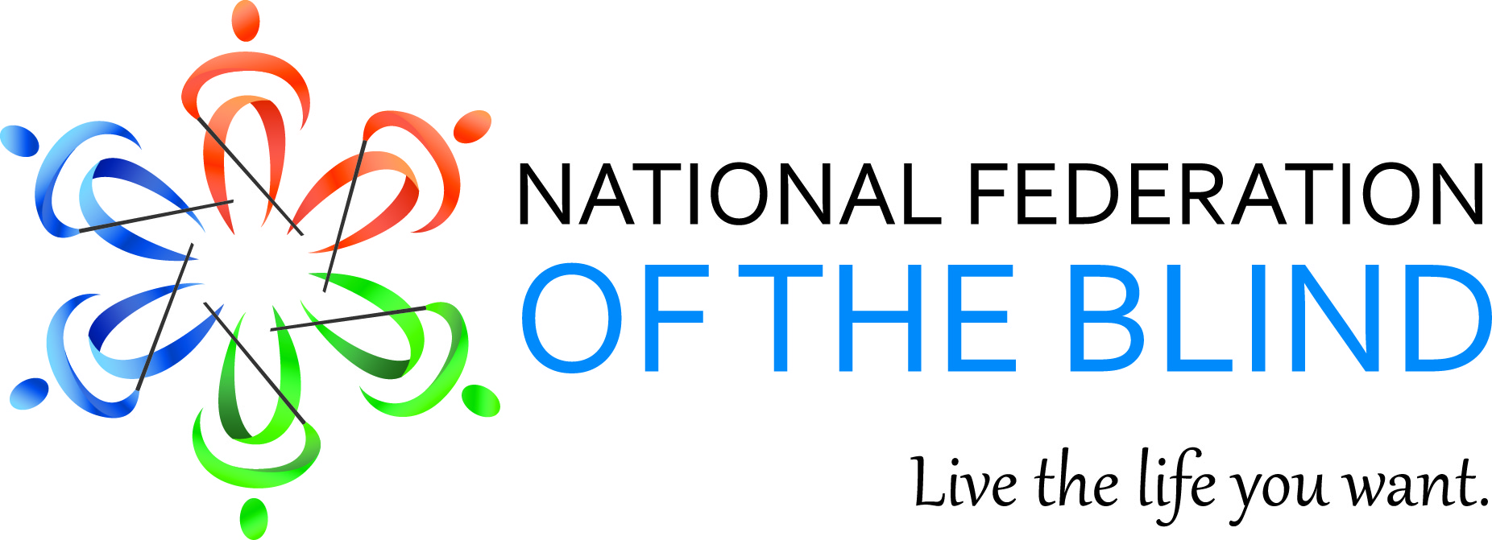

Mary Willows, President
National Federation of the Blind of California
3934 Kern Court
Pleasanton, CA 94588
(925) 895-2778
mwillows@sbcglobal.net

September 2015 Bulletin

Dear Fellow Federationists,

“The National Federation of the Blind knows that blindness is not the characteristic that defines you or your future. Every day we raise the expectations of blind people, because low expectations create obstacles between blind people and our dreams. You can live the life you want; blindness is not what holds you back.”

The National Federation of the Blind of California
IS
Uniting Blind People
THROUGH
Love, Hope and Determination to live the life we want.

The National Federation of the Blind of California is a membership organization dedicated to improving the lives of blind and visually impaired people through peer mentor and training opportunities. Sixteen chapters and divisions meet throughout the year in the major metropolitan areas to support and encourage individuals and their families who are experiencing vision loss. Once a year, we hold a statewide convention to educate blind people and the public about services which will enhance their lives and address social, educational, employment and training needs.

We are now accepting pre-registration forms for our 2015 State Convention which will be held on October 30, 31 and November 1
Where: The Doubletree by Hilton Newark/Fremont
39900 Balentine Drive
Newark, CA 94560
For hotel reservations call: (510) 490-8390. Press 2 on the option menu to make your reservation with staff at the front desk.
Group code: NFC.
Note: You will need your hotel reservation confirmation number to complete the pre-registration form.
Room rates: $109.00 + tax – without breakfast buffet
$129.00 +tax – with breakfast buffet for two guests
Some of the activities will include:
An Exhibit Hal l which will open Friday, October 30. Doors will open at 8:30A.M with coffee and muffins for an exhibitor showcase. The Board of Directors meeting will begin at 10:00 A.M. followed by the Resolutions Committee meeting.
The Orientation Center for the Blind Alumni Association Inc. will meet for lunch at 12:00 noon ($20.00).
At the same time, the Louisiana Center for the Blind alum will also meet for lunch. ($20)
In addition, the Colorado Center for the Blind alum will reunite for lunch. ($20.)

Don’t forget to bring your best Halloween costume for the Masquerade Ball and contest at 8:00 P.M. on Friday evening.
On Saturday, October 31 the general session will begin promptly at 9:00 A.M. The afternoon sessions will break out into “Round Table” discussion groups. The highlight of our convention will be the banquet on Saturday evening where we will hear the keynote address from our national representative, Pamela Allen, First Vice- P president, National Federation of the Blind and the Director of the Louisiana Center for the Blind.
Sunday morning will wrap up the event with elections, resolutions and other Federation traditions.
Please note: If you would like to take advantage of bus transportation to the convention on Thursday, October 29 you will need to pre-register soon so we can reserve the buses. You will need your hotel reservation confirmation number to fill in your pre-registration form.
Southern California Departure Location, Los Angeles Greenline Park and Ride
11301 South Crenshaw Blvd.
Hawthorne, CA.
San Diego
Denny’s 4365 University Ave.
San Diego CA.
Escondido: Casa Escondida Senior Building A,
75 North Broadway Ave.
Escondido, CA.
Northern California: exact location to be announced. The bus will originate in Redding: stop in the Chico Area: Sacramento Amtrak Station: Stockton Area.
Register now for the NFB of California 2015 convention
http://tinyurl.com/nfbcpreregistration

CABS GOT TALENT
The California Association of Blind Students second annual talent contest welcomes all musicians, poets’ singers, comedians, and actors. If you are blind or visually impaired and have a talent you would like to show off, Upload a 1 to 3 minute video of yourself showing off. Send the link via email to the Cabs got talent committee chair person Roselyn Perez at::rp1rules@gmail.com Make sure you write cabs got talent on the subject line

The Grand Prize winner will receive $50.00 and either perform at or have their entry video shown during the Cabs board meeting at the 2015 National Federation of The Blind Convention. Deadline to enter is September 15

Scholarship’s Scholarship’s Scholarship’s
If you are a college student who is legally blind, you may be eligible for one of three scholarships for up to $2500. Applicants must have a GPA. of 3.0 or higher and carrying a full load of classes. For guidelines and a application go to, www.sixdots.org and click onto 2015 NFBC Scholarship Guidelines & Application
The deadline for submitting your Application is midnight, September 25th, 2015.

