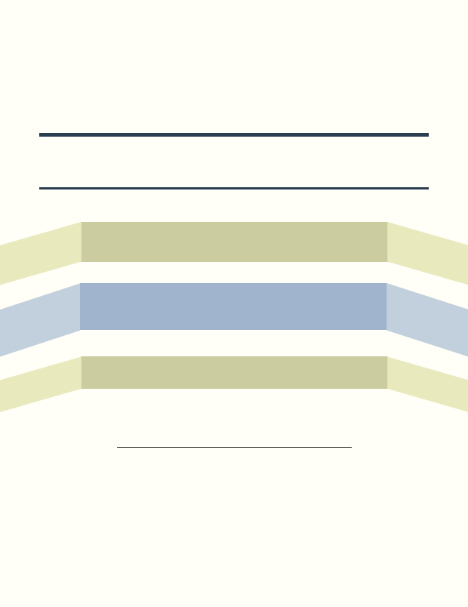

NDEAM 2015
National Disability Employment Awareness Month.

"My Disability is One Part of Who I Am".

Department of Rehabilitation Central Office
721 Capitol Mall, Sacramento, CA 95814.

OCTOBER 26, 2015

Time: 11:30 AM - 1:30 PM

Learn about tools, services, and programs
at this free resource fair.

Each October, NDEAM educates the public about disability employment issues and celebrates the many and varied contributions of America's workers with disabilities.

Together we foster a disability-friendly work culture.
