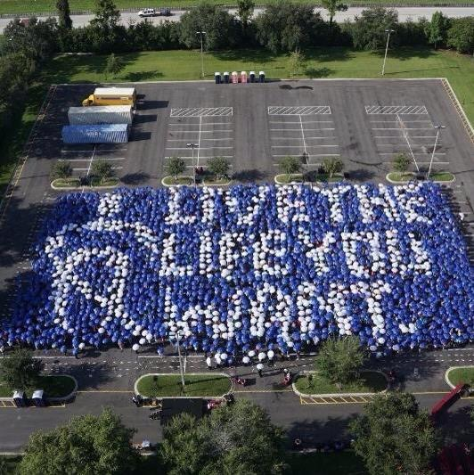
National Federation of the blind of California Pathfinder chapter is having it's 5th annual chapter development reception. Come join us as we enjoy great food, drinks and door prizes while listening to awesome speakers that will give us informed information about this wonderful organization. Date and time will be Thursday, February 18 from 9 AM to 11:30 AM. Located at the WLCAC senior center. Address 10957 South central Avenue Los Angeles Ca cross street 109th. If you have any questions please contact Michael Richardson at (323) 898-3223 or email at michaeljr66@yahoo.com. National Federation of the blind knows that blindness is not the characteristic that defines you or your future. Every day we raise the expectation of blind people because low expectations create obstacles between blind people and our dreams.. You can live the life you want. Blindness is not what holds you back.

