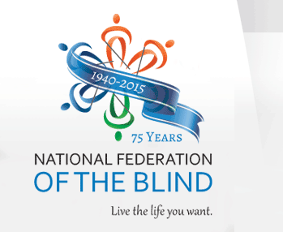
Second Annual
Senior Division
Seminar
Presented by
The National Federation of the Blind of
California, Senior Division
Come Join Us For:
Knowledge, Information & Methods of Living with Blindness
Door Prizes and LOTS of Fun!!!
WHEN: Thursday, May 12, 2016
TIME: 11:00am – 2:00 pm
WHERE: Hometown Buffet
5247 Arrow Highway, Montclair California

ONLY LEGALLY BLIND SENIOR Guests who RSVP by April 30, will be treated to a free lunch.
CONTACT:
Charlotte Carroll – (310) 625-6558 mizzcharlotte@sbcglobal.net
Cheryl Thurston – (909) 821-9589 cthurston74@gmail.com

