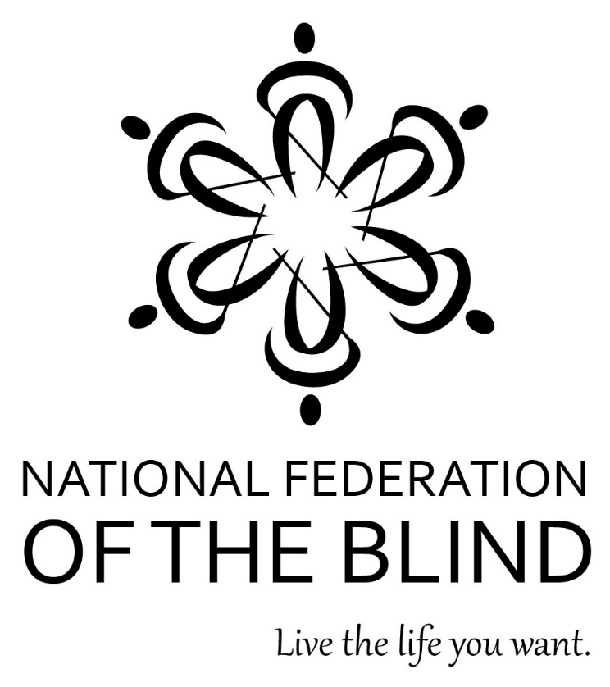

2016 ANNUAL CONVENTION

ORLANDO, FLORIDA

JUNE 30 to JULY 5

THE MEMBERS OF THE
HOST AFFILIATE COMMITTEE
WELCOME YOU TO THE
76th ANNUAL CONVENTION OF THE
NATIONAL FEDERATION OF THE BLIND

Mark Riccobono, President
National Federation of the Blind
200 East Wells Street at Jernigan Place
Baltimore, Maryland 21230

John Berggren, Chairman
Convention Organization and Activities

Pam Allen, President
National Federation of the Blind
of Louisiana
Chairperson; First Vice President
National Federation of the Blind
Board of Directors

Jeannie Massay, President
National Federation of the Blind
of Oklahoma
Treasurer
National Federation of the Blind
Board of Directors

Everette Bacon, President
National Federation of the Blind
of Utah
Board Member
National Federation of the Blind
Board of Directors

Cassandra McKinney, President
National Federation of the Blind
of New Hampshire

Rosen Shingle Creek
9939 International Drive
Orlando, Florida 32819
(866) 996-9939

WELCOME!

Welcome to the 76th annual convention of the National Federation of the Blind being held in Orlando at the Rosen Shingle Creek Hotel. A detailed description of the layout of the hotel can be found immediately after the “Convention Notes,” which are at the end of the program listings. Check the “Convention Notes” for further information about a variety of convention topics. When you check in to the hotel, you will be asked to confirm your departure date. If you decide to leave earlier than the departure date you confirm when you check in, there may be a change fee.

ROOKIE ROUNDUP
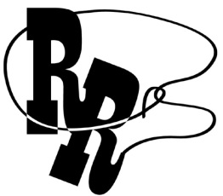
All first-time convention attendees are cordially invited to attend a reception from 8:00 to 9:30 pm on Thursday in the Panzacola Ballroom G-1, Level 1. President Riccobono and other Federation leaders will be on hand to welcome you to the convention and preview the week’s activities. Veteran conventioneers should urge all first-timers to attend this special event.

PREREGISTRATION AND ON-SITE REGISTRATION
Registration activities take place in the Sebastian Ballroom Pre-function area, Level 1 beginning at 9:00 am on Friday, at 8:30 am on Saturday, and at other times as listed throughout the week. All convention attendees (both local and out-of-town) are asked to register. Those who preregistered for convention may pick up their registration packets in the area designated “Preregistration.” Those who did not preregister may go to the area designated “Registration.” Please have your check or cash ready to pay the registration fee of $30 per person; we cannot accept credit cards at registration. Convention registration is a requirement for door prize eligibility and a number of other convention activities. We condition rates for hotel rooms on proof of registration, including the showing of an NFB registration badge, if requested.

EXHIBIT HALL AND INDEPENDENCE MARKET
The Exhibit Hall and the NFB Independence Market are located in Sebastian Ballrooms K and L, Level 1. There is a special sponsor-only exhibitor preview for convention attendees on Friday morning from 9:00 to 11:00 am.

Exhibit Hall hours of operation are:
Friday 9:00 to 11:00 am (sponsors only)
Friday 11:00 am to 5:00 pm
Saturday 8:30 am to 5:00 pm
Sunday Noon to 1:45 pm and 7:00 to 9:00 pm
Monday Noon to 1:45 pm (final opportunity to visit the Exhibit Hall)

Independence Market hours of operation are:
Friday 9:00 am to 5:00 pm
Saturday 8:30 am to 5:00 pm
Sunday Noon to 1:45 pm
Monday Noon to 1:45 pm (final opportunity to visit the Market)

MAKE THE PRINT YOURS WITH THE APP THAT READS
KNFB Reader uses the power of digital photography and a specially designed mobile device app, to read print on the go, using just your iOS or Android phone or tablet. Come see this award-winning, life-changing technology at demonstration and training sessions on Friday from 1:30 to 4:30 pm and on Monday from 7:00 to 8:30 pm. All sessions are held in Suwannee 11, Level 2. Go totally mobile and make the print yours today!

THE CONVENTION QUEST
Dots from Space! In the year 2525, a race of interstellar travelers comes upon the abandoned city of Baltimore, Maryland, and discovers a building well known to the members of the Federation. Follow these intrepid adventurers as they explore the mysterious secrets of the NFB Jernigan Institute and learn that it is respectable to be blind. Our heroes will face many challenges, but you can help by solving puzzles, answering trivia, and collaborating with your friends! To join in this unique and interactive experience, please visit http://quest.nfb.org. For more information on how to play, please send an email to quest@nfb.org, or call (203) 364-4263.

SPECIAL ATTENTION ITEMS
- The Presidential Suite (13217); Dr. Maurer’s Suite (13216); John Berggren’s Suite (13230), Chairman of Convention Organization and Activities; and the Host Affiliate’s Suite (10201) are all open during much of the convention. All are welcome to come to these suites to visit. Appointments to meet with President Riccobono may be made at the Presidential Suite.
- Banquet tickets may be purchased for $65 by cash or check at the on-site registration area. No tickets will be available after 2:00 pm on Sunday. At the banquet exchange table you may make arrangements to reserve a specific seat for yourself or for a group of up to ten people. On the evening of the banquet, tickets will be required to enter the ballroom and will be collected at the tables. Tickets may be exchanged for vegetarian or kosher meals at the banquet exchange table if done so by 2:00 pm on Sunday.
- General Sessions will be held in Sebastian Ballrooms I and J, Level 1.
- Individuals needing to conduct business with the NFB Treasurer may do so by going to the Wekiwa Registration Desk, Level 2 on Sunday between 5:30 and 7:30 pm, or on Monday between noon and 2:00 pm.

