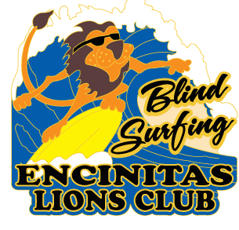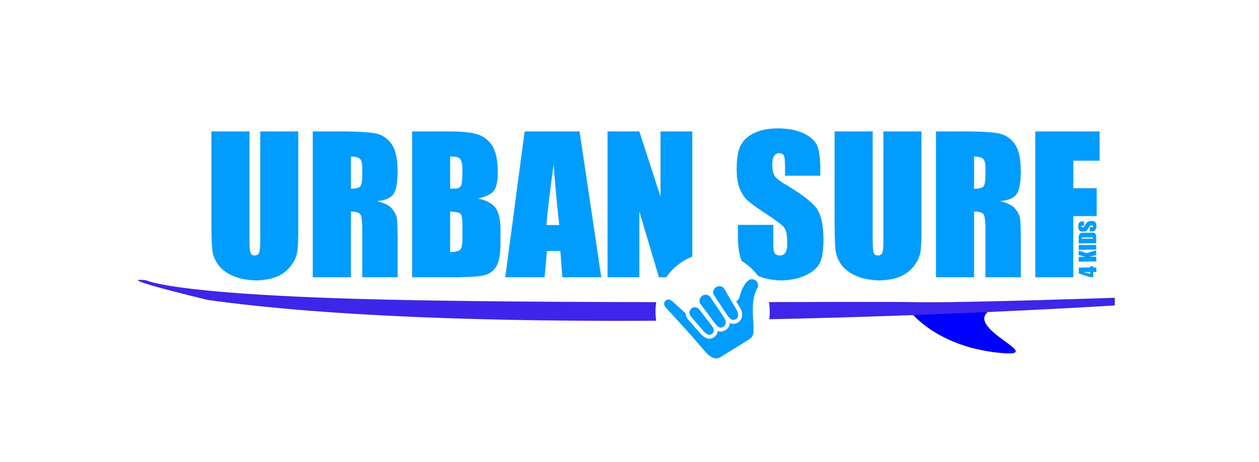
ENCINITAS LIONS
BLIND SURF EVENT
SEPTEMBER 10, 2017
9:00 AM TO 2:00 PM

SAN DIEGO’S VISUALLY IMPAIRED WILL ONCE AGAIN HIT THE WAVES AT SOUTH PONTO BEACH

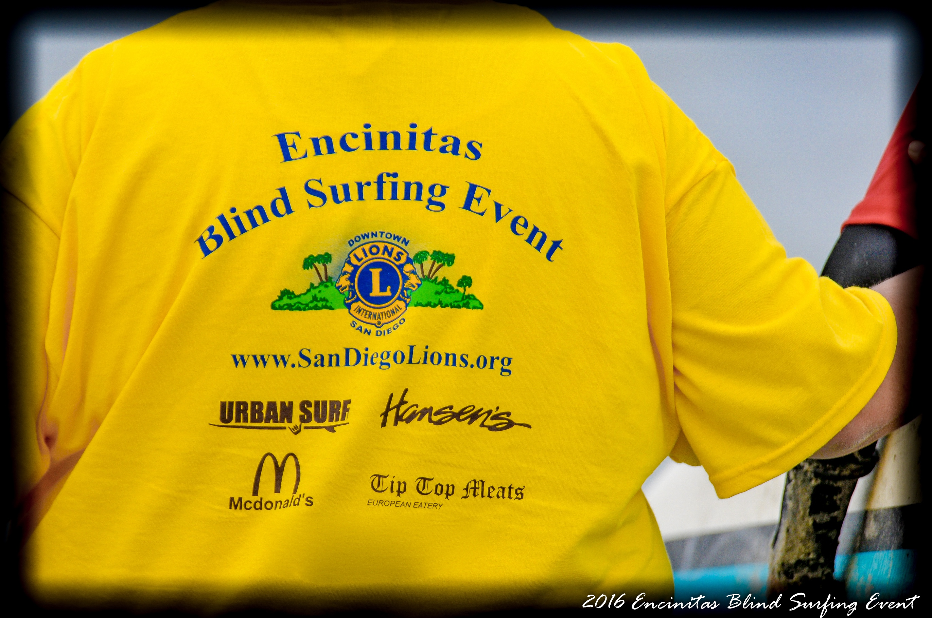
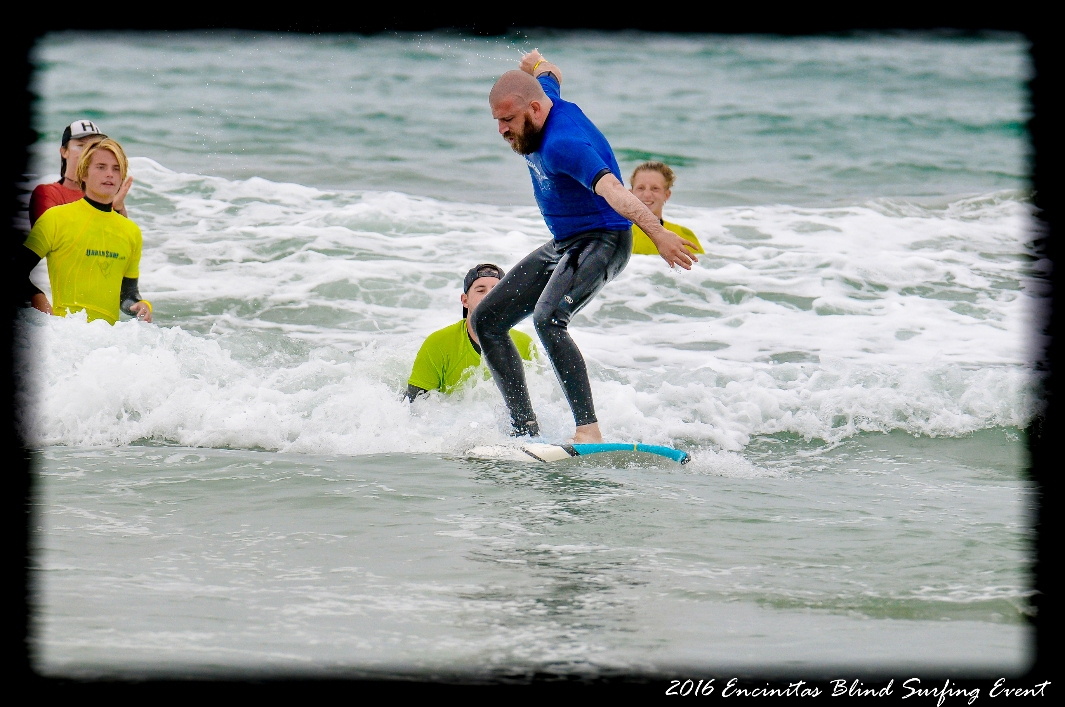
MARK YOUR CALENDAR, The Encinitas Lions Club in partnership with Urban Surf will hold their 22th Annual Surfing Clinic for the blind and visually impaired. All participants will be given free event T-Shirts. Surfers are provided wet suits, surfboards and instruction, in the water by Certified Surfing Instructors as they challenge themselves to balance atop surfboards. Breakfast and a BBQ lunch for all our guests will be included, weather you surf or come to enjoy a day at the beach. Of course there will be no charge and no age limit.
In 1925 Helen Keller challenged the Lions Club to become the “Knights of the Blind”. Thus our club identifies needs within our community and work together to fulfill those needs. In addition to the annual Blind Surfing Event, the Encinitas Lions Club works on a variety of projects specifically designed to help the sight impaired, such as free diabetes and eye testing clinics, eye glass recycling, prescription eye glasses, Guide Dogs for the Blind and Audible Traffic Signals throughout our city.

Our BLIND SURFING EVENT received international recognition when featured on the 2015 Lions Rose Bowl Parade float. Our own (sight impaired) surfer Sebastian De Long rode the float as well as other sight impaired surfers from our community.
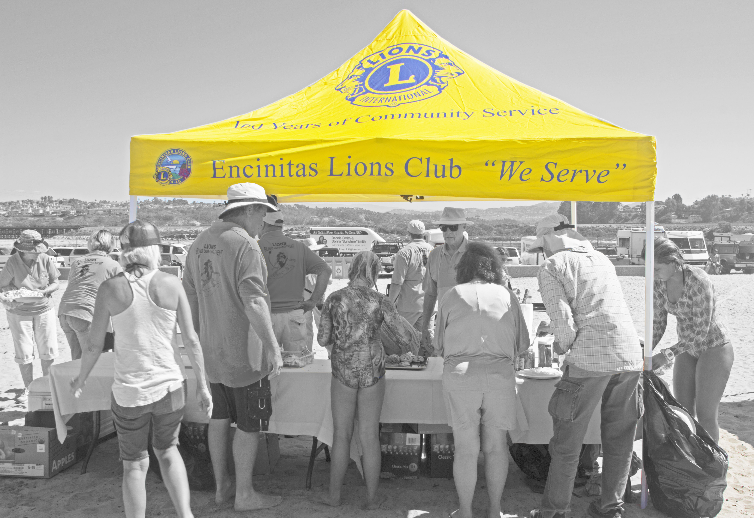
Free Surfing Instruction
Free: Breakfast & BBQ Lunch
Free: Commemorative T-Shirts
Free: Transportation for those in need.

Directions: In Carlsbad, from the 5 Freeway, take the Poinsettia turn off, go west to Pacific Coast Highway. Turn left (south) and proceed about two miles to South Ponto Beach on your right. You will see our canopy from the street and can park free.

To RSVP or for more information, please contact Lion Bob Mangini at 760 436 7338 or email blindsurfersmail@gmail.com

