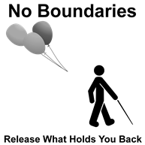
National Federation of the Blind of California, Ever Lee Hairston, President
18440 Oxnard St., Tarzana, CA 91356 office: 818) 217-8330 c: 323) 252-9188 ever.hairston@gmail.com

Welcome to the 2017
National Federation of the Blind of California Convention
November 2 – November 5, 2017
Embassy Suites 901 East Calaveras Blvd., Milpitas, CA 95035

Convention Hosts:
President, Ever Lee Hairston
First Vice-President, Bryan Bashin
Second Vice-President, Robert Stigile
Secretary, Shannon Dillon
Treasurer, Rochelle Houston
Board Members: Karen Steele, Jim Barbour, Charlotte Carroll,
Jana Littrell,Tim Elder, Carmen Weatherly, Carla Scroggins

The National Federation of the Blind is a community of members and friends who believe in the hopes and dreams of the Nation’s blind. Every day we work together to help blind people live the lives they want.
Convention Information
Thursday movie night with snacks; Friday begins with the Vendor Showcase and Exhibit Hall; Friday night Federation Feud Game; Saturday luncheon and Banquet are all included in the $75 fee. If you prefer to attend only the convention sessions, the fee is $35.

Vendors’ Showcase
The Vendors’ Showcase takes place in the Amalfi room from 8:30 am to 9:30 am on Friday, November 3. At the Showcase you will hear vendors describe the current products and services which they will have on display in the Exhibit Hall.

Convention Exhibits
The Exhibit Hall will be open on Friday, November 3rd from 9:30 am to 3:30 pm. Exhibit tables are located in the Grand Ballroom.

Guide Dog Relief Area
Please take dogs to the rear of the hotel either through the side door or the front door exit.

Chapter & Division Presidents
Shasta Cascade - Debbie Worstman
San Joaquin - Ken Volonte
San Francisco - Christina Daniels
Tri-Valley - Carl Martin
River City - Tiffany Manosh
Bay Area - Shannon Dillon
At Large - Allison Depner
Inland Empire - Cheryl Thurston
San Fernando - Robert Stigile
Pathfinders of Los Angeles - Rochelle Houston
Escondido - Yvette Lee
Riverside/San Bernadino - Carmen Weatherly
San Diego - Lisa Irving
California Association of Guide Dog Users (CAGDU) - Tina Thomas
California Association of Blind Students (CABS) - Carla Scroggins
Senior Division - Charlotte Carroll
Diabetes Action Network - Joy Stigile

Please encourage every member to participate in all convention activities!

Thank you to our generous sponsors!
Platinum Level $10,000 plus
VOTEC Corporation

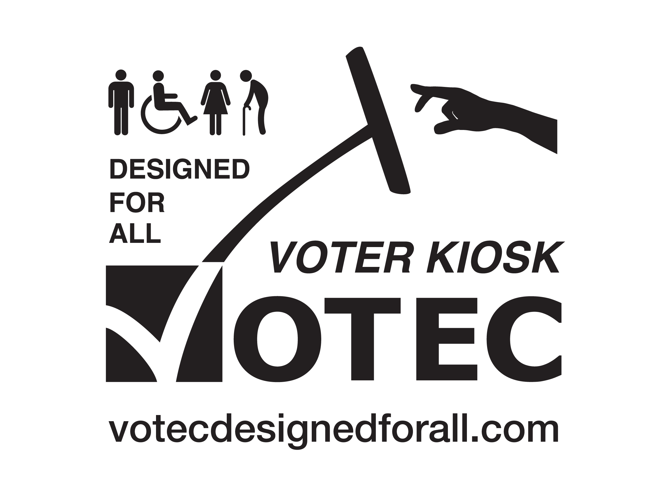

2017 National Federation of the Blind of California Convention Agenda
Thursday, November 2

8:00 pm Movie and Snacks, “Do You Dream in Color?”
Cordoba Room

Friday, November 3
7:30 am – 8:30 am Registration Packet Pickup
Area in front of the Grand Ballroom

8:30 am - 9:30 am Vendor Showcase
Amalfi Room
Coordinator, Cheryl Thurston
Listen to a brief description of products and services

9:30 am - 3:30 pm Exhibit Hall
Grand Ballroom

1:00 pm – 2:00 pm Board of Directors meeting
Amalfi Room

Meetings of the Board of Directors are open to the public. Please join us as we greet our scholarship finalists, and our National Representative, Scott LaBarre, President of the National Federation of the Blind of Colorado.

2:00 pm - 4:00 pm Registration Packet Pickup
Area in front of the Grand Ballroom

2:00 pm – 3:00 pm Resolutions Committee
Amalfi Room
Chairperson, Bryan Bashin

The Resolutions Committee comes together once a year to decide on the policies and direction of the affiliate for the upcoming year.

3:00 pm – 4:15 pm California Association of Blind Students (CABS)
Amalfi Room
President, Carla Scroggins

4:15 pm – 5:30 pm California Association of Guide Dog Users (CAGDU)
Amalfi Room
President, Tina Thomas

5:30 pm - 6:15 pm Orientation Center for the Blind
Amalfi Room
President, David Chan

6:00 pm - 7:30 pm Registration Packet Pickup
Area in front of the Grand Ballroom

8:00 pm – 10:00 pm Federation Feud
Amalfi Room
Emcee, Michael Richardson
Saturday, November 4

9:00 am General Session Call to Order
Grand Ballroom
President, Ever Lee Hairston

Opening Ceremony
2017 Convention Coordinators, Jim Barbour, Christina Daniels, Rochelle Houston and the California Association of Blind Students

Pledge of Allegiance
Jim Barbour

NFB Pledge
Denise Bravell

Invocation, Carlos Miyares

“God Bless America”
Rachel Elizabeth Grider

9:15 am - 9:45 am National Report
National Representative, Scott LaBarre, National Federation of the Blind of Colorado President

9:45 am - 10:00 am Douglas G. Towne
Chairman, Disability Relations Group

10:00 am – 10:20 am Braille Enrichment for Literacy and Learning (BELL) Academy Northern California Coordinator, Debbie Worstman
10:20 am – 10:50 am Why I am a Federationist?
Tim Elder, Tiffany Manosh, Rochelle Houston

10:50 am – 11:05 am Mike L. Marlin, Director
Braille and Talking Book Library
California State Library

11:05 am – 11:35 am Employment Panel
Moderator, Robert Stigile
Shannon Dillon
Ahmet Ustunel
Elizabeth Campos

11:35 am - 11:50 am Philosophy Skit

11:50 am - 11:55 am Senior Division Skit

11:55 am Shout out to First Time Attendees

Noon Adjourn

12:00 pm – 2:00 pm Luncheon
Special Presentation, Ruth Sager, National Senior Division President
Speaker, Christina Daniels, San Francisco Chapter President
Atrium

2:00 pm General Session resumes
Grand Ballroom

2:00 pm - 2:10 pm President’s Report
President, Ever Lee Hairston
2:10 pm - 2:20 pm Vanda Pharmaceutical

2:20 pm - 2:30 pm California Association of Guide Dog Users Skit

2:30 pm - 2:35 pm Exploring Round Table Options

2:35 pm – 3:45 pm Round Table Discussions

Topics:

KNFB Reader – Michael Richardson
iPhone for Beginners – Ed Davis
iPhone Apps including News Line and BARD - Christina Daniels
California Dept. of Rehabilitation (DOR) – Joe Xavier, Director/ Elena Gomez
Interview Preparation – Jannette Stewart
Parents of Blind Children – Debbie Worstman
How to Become a Leader - Scott LaBarre, National Representative
VOTEC, Disability Relations Group – Douglas G. Towne
California Association of Guide Dog Users - Tina Thomas
Legal Issues – Tim Elder

3:45 pm – 4:30 pm General Session resumes
“No Boundaries: Release What Holds You Back”
Grand Ballroom

4:30 pm Adjourn

7:00 pm Banquet
Emcee, Bryan Bashin, NFBA First Vice President
Banquet Address, Scott LaBarre, National Representative
Scholarship Presentation, Jana Littrell
Auctioneers, Michael Richardson & Michael Hingson
Grand Ballroom

Sunday, November 5

9:00 am General Session
President, Ever Lee Hairston
Grand Ballroom

9:10 am – 9:25 am Elections: Report from Nominating Committee,
Chairperson, Robert Stigile

9:25 am – 9:40 am Resolutions
Chairperson, Bryan Bashin

9:40 am – 9:50 am Financial Report
Treasurer, Rochelle Houston

9:50 am – 10:50 am Chapter Reports - Pledges and Donations

11:00 am Adjourn

Thank you to all of our Vendors and the generous donations from:
VOTEC, Douglas G. Towne
San Diego Foundation
Charitable Grant Rosen Bien Galvan and Grunfeld, LLP
Vanda Pharmaceuticals

Thank you to all of the chairpersons and members of the committees that have helped to make this convention a success.

Convention Coordinators – Christina Daniels, Rochelle Houston and Jim Barbour
Resolutions Committee - Chairperson Bryan Bashin
Door Prize Committee - Chairperson Carmen Weatherly
Exhibit Hall Committee – Chairperson Cheryl Thurston
Scholarship Committee – Chairperson Jana Littrell
Auction - Chairperson Karen Steele
PAC Committee – Chairperson Michael Hingson
Ambassador Committee - Chairperson Michael Richardson

