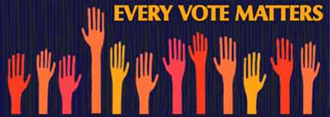
FREED Center for Independent Living and Disability Rights California invite members of the disability community and family and friends to join a discussion on Nevada County’s plan for changing elections in 2018!

Who: Everyone in the disability community with an interest in voting

What: Meeting for the disability community to discuss Nevada County’s plan for changing elections in 2018

Where: FREED Center for Independent Living, 2059 Nevada City Hwy #102, Grass Valley, CA 95945

When: November 9th, 2017, 4:00 - 5:30 pm

Why: Nevada County Elections is seeking community input on the draft of the plan to change how elections are conducted in 2018. This meeting also provides an opportunity for the disability community to gather and discuss elections before a larger public meeting hosted by Nevada County Elections on November 14th.

