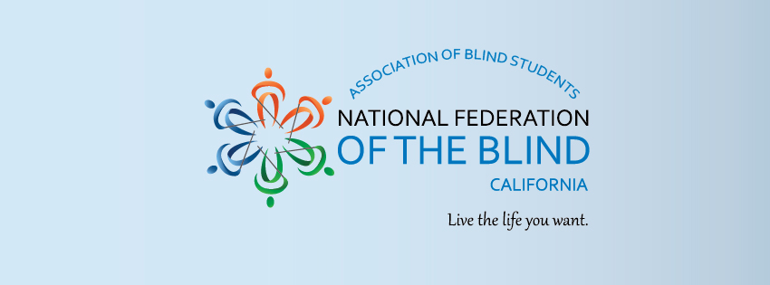
California Association of Blind Students
(CABS)
Presents:
“1st Annual Southern California Reception”
When: April 28, 2018 12:00 - 3:00 pm
Where: Shakey’s Pizza, 935 West Arbor Vitae Street, Inglewood, California 90301

CABS invites all blind/low vision students to our first annual spring reception in beautiful Southern California. Come enjoy a day of delicious food, meet other blind students, and find out more about our student division!

- Are you a blind student in or near Southern California?
- Are you interested in meeting other blind students?
- Would you like to learn more about CABS and what we do?
- Do you like pizza and other delicious foods?
If you answered yes to any of the questions above, then our spring reception is for you!

Food will be provided, along with prizes and surprises! Bring a fellow blind/low vision friend to our event; whoever brings a friend will have their name thrown into a raffle and whoever brings the most friends will win a grand prize!

To RSVP, go to https://cabs2018.wordpress.com/2018/03/19/8/.

If you have any questions or would like to attend, please call President Matthew Gip at (559) 375-2068 or email him at matthewhgip@gmail.com

