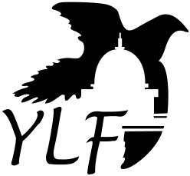

2020 CALIFORNIA YOUTH LEADERSHIP FORUM For Students with Disabilities

Date: July 12 to 17, 2020 (Dates subject to change.)

Develop your leadership skills, and learn how to reach your academic, career, and independence goals.

Live on the California State University, Sacramento campus for a week…and make new lifetime friends!

Talk with policy makers and educate them on ways they can improve the lives of young people with disabilities!

APPLICATION INFORMATION AVAILABLE AT:
www.dor.ca.gov/home/ylf

For additional information and how to complete the application, please email or call us at:

Email: ylf@dor.ca.gov

Phone: (855) 894-3436 or Dial 711 for California Relay Service

