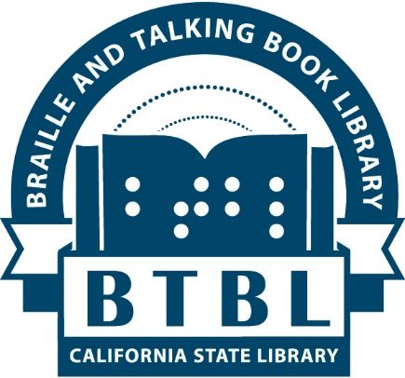

The California Braille and Talking Book Library (BTBL), the National Library for the Blind and Print Disabled (NLS) Northern California Regional Library serving blind/low vision residents and persons with other print disabilities in 43 Nor Cal counties, is seeking applicants for its Braille and Talking Book Library User Advisory Council (BUAC) for the 2020 calendar year. To find a list of the 43 counties, please visit http://www.library.ca.gov/btbl/apply/.

The BUAC desires a strong representation of the richly diverse range of ethnic, cultural, and print disability demographics in Northern California. Patrons who are U.S. Veterans, bilingual Spanish speakers, persons of color, persons with organic reading disabilities such as dyslexia, young adults, parents of minors with print disabilities, and patrons who possess other physical disabilities that prevent them from reading conventional print are strongly encouraged to apply.

Prospective applicants are encouraged to explore the Council by-laws and online application form on our web page: http://www.library.ca.gov/btbl/advisory-council/, and apply. There is always a possibility of bringing new members on mid-year so please feel free to apply anytime.

The BTBL User Advisory Council meets four times per year with all travel expenses paid/reimbursed to convene at the California State Library in Sacramento, with the occasional option to participate via teleconference. Council member terms last for 2 years.
The purpose of the Council is to provide advice to the California State Library (CSL) and BTBL. Council members have the opportunity to advise and make recommendations to BTBL and CSL management for improvements to library services. The Council is not a policy-making body.

The BUAC Recruitment and Selection Committee will review applications. The first meeting of the calendar year generally takes place in January.

For more information, please visit http://www.library.ca.gov/btbl/advisory-council/, email btbl@library.ca.gov or call (800) 952-5666 (Toll free in CA).

