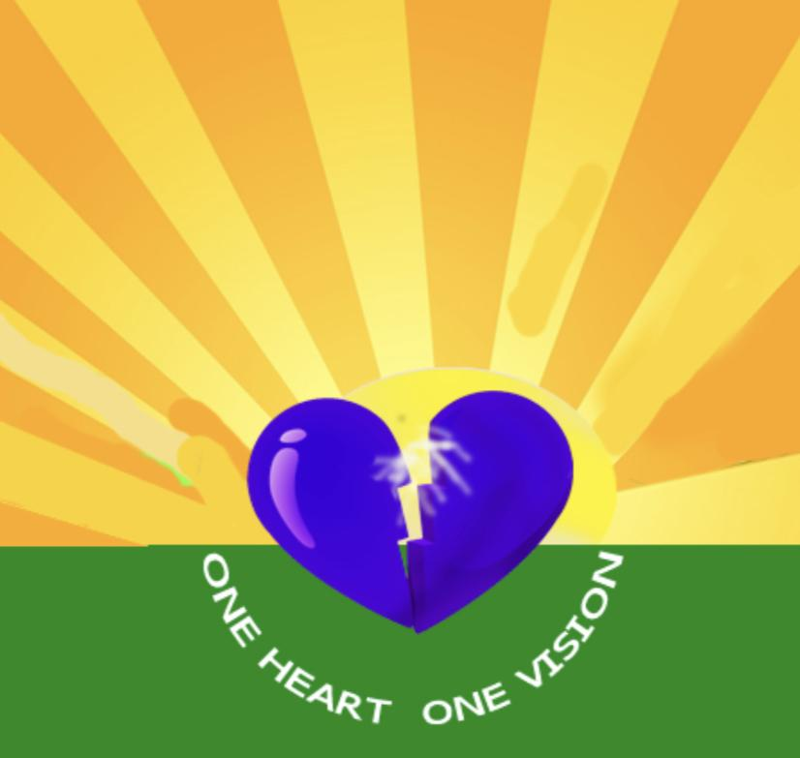Presents:
The OHOV Vixens
Women empowerment group
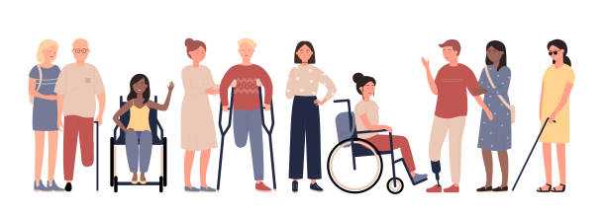
people standing together of various races and abilities
If you are a blind woman with sparkle & shine, glitz & glam and a whole lot of pizzazz, then you are an OHOV Vixen! This is the group for you. Come out and share ideas, stories and learn tactics to overcome barriers. Join us and network with other like-minded women.

Topic: The Key To Being An Empowered Woman
When: September 8, 2022; 5 PM-6 PM EST
Where: Join Zoom Meeting
https://us02web.zoom.us/j/89919685595

Meeting ID: 899 1968 5595
One tap mobile
+16465588656,,89919685595# US (New York)
+13126266799,,89919685595# US (Chicago)

Dial by your location
+1 646 558 8656 US (New York)
+1 312 626 6799 US (Chicago)
+1 301 715 8592 US (Washington DC)
+1 346 248 7799 US (Houston)
+1 669 900 9128 US (San Jose)
+1 253 215 8782 US (Tacoma)
Meeting ID: 899 1968 5595
Find your local number: https://us02web.zoom.us/u/kb67DBb6Qk

