

Twin Vision Library

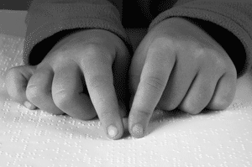

Open House

Sunday, June 4 12:00PM-4:00PM

**Presented by:**

**Action Fund for the Blind: Creators of Twin Vision Books**

18440 Oxnard St.

Tarzana, CA 91356

Come explore this hidden gem of Tarzana where we produce books with both print and braille so that blind parents can read with their sighted children OR blind children can read with their sighted parent. Join us on **SUNDAY, JUNE 4 from 12:00pm-4:00pm** to learn how we change lives!

**Why join us for our open house?**

This is an opportunity for members of the community to:

* Learn the astounding history of how one woman’s dream has grown into a library that serves patrons across the United States.
* Get an up close look at the Braille production process
* Learn how we produce our Braille Calendars
* Meet the great volunteers who run the show
* Meet blind authors and Twin Vision Enthusiasts Michael Hingson (9/11 survivor and author of *Thunder Dog*) and Ever Lee Hairston (author of *Blind Ambition*)
* Children will go home with their own Braille alphabet card and a copy of their name in Braille!

**To learn more call us at 818-343-2022 or email** [**jbbeecham@gmail.com**](mailto:jbbeecham@gmail.com).