**Install Beta WMR App on iPhones via using below URL.**

1. Go to <http://apps.itcurves.us/> on your iPhone browser. Scroll to bottom right of the page.
2. Download the app from **‘Access Booking App (Beta)’** link.

1. After installation, if you click on the app, you will see ‘Untrusted Enterprise Developer’ popup. Press Cancel on the message.

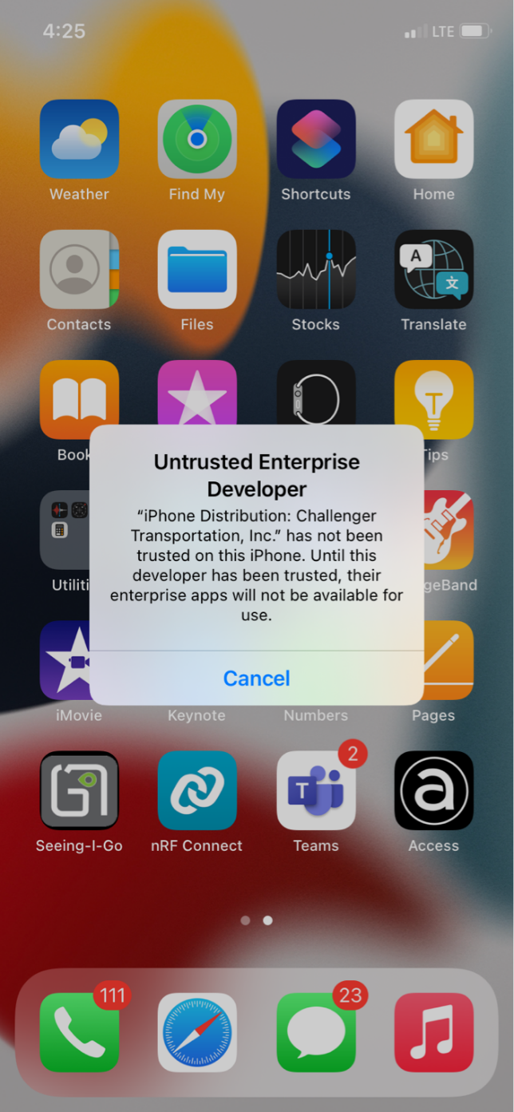

1. Go to Settings, then go to General menu.

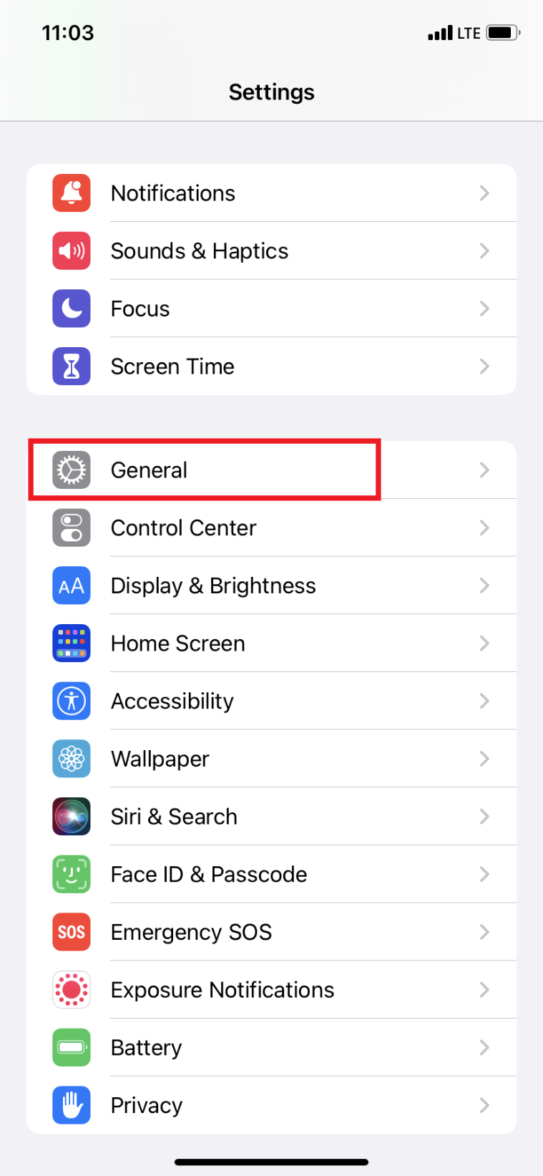

1. Go to Device Management (or ‘VPN and Device Management’ on some iPhones).

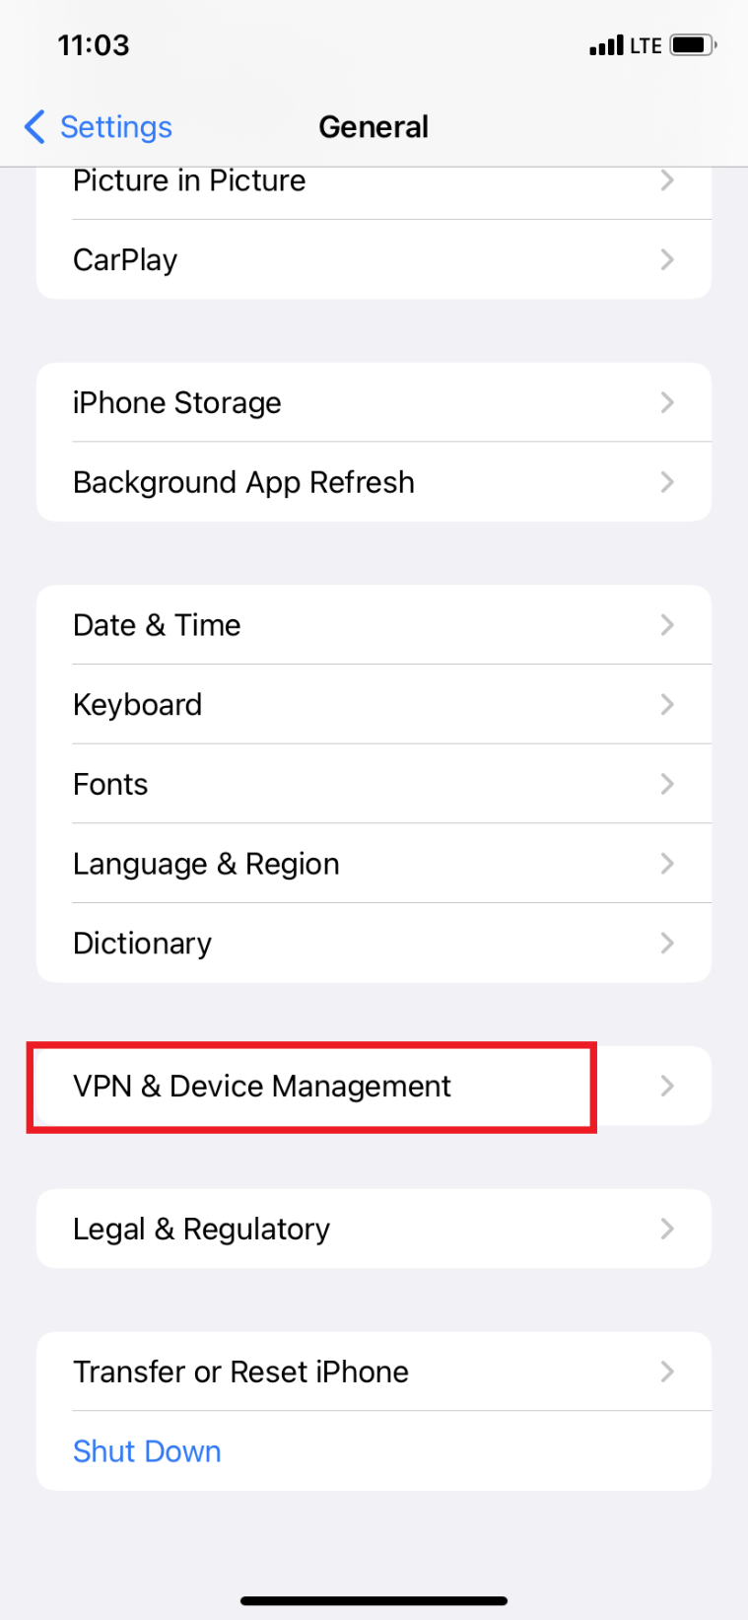

1. Click on ‘Challenger Transportation’.

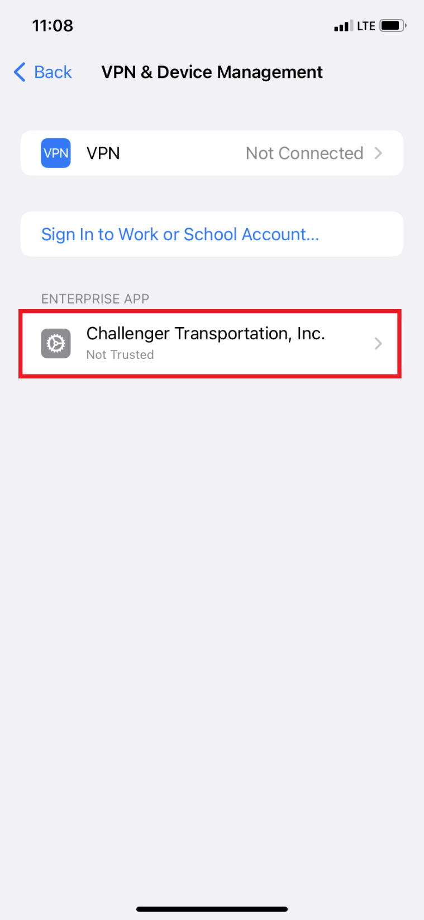

1. Click on ‘Trust Challenger Transportation’. And click on 'Trust’ on the popup message. Your app is ready to use.

