**Install Beta WMR App on Android phones via using below URL.**

1. Go to <http://apps.itcurves.us/> on your Android phone browser. Scroll to bottom right of the page.
2. Download the app from **‘Access Booking App (Beta)’** link.

1. Tap on the downloaded file “mars-access-booking.apk” to install it. You may need to allow apps from unknown sources or enable developer options to proceed with installation. It varies on different Android phones.

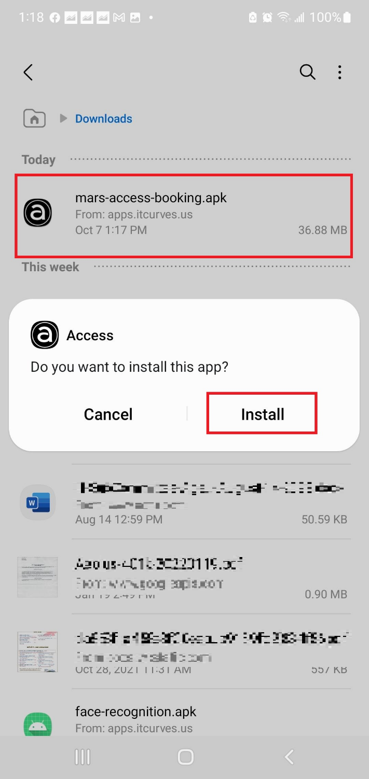

1. You can open the app after installation.

