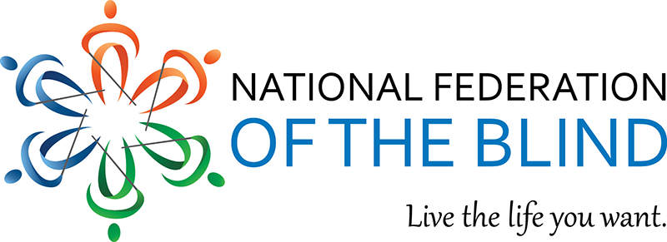

Hello everyone,
calling all blind individuals who are members of a nationally recognized Fraternity, Sorority, Masonic or Eastern Star Organization. Please join the National Federation of the Blind Greek and Masonic Group for their first annual luncheon held on Tuesday, July 5th from 11 AM -2 PM. The purpose of this event is for members of the blind community to network and share their experiences as members of these prestigious organizations. This event is open to individuals who are blind and not members of the NFB and sighted member of these organizations to share in the fellowship and networking. This event will be held during the first day of the National Federation of the Blind annual convention in New Orleans, Louisiana. Participants for this event will dine at the Oceana Grill located at 739 Conti St. The cost of the luncheon is $50.00 and is due by June 29th. You can select your four course entree from the list below. To RSVP or for additional questions, please contact Shawn Callaway at callaway.shawn@gmail.com or call (202) 352-1511. When submitting your RSVP, please indicate your entrée selection. Payments can be sent to the following:
CashApp: $NFBDCfundraising
Pay Pal, email, rbellavancenfbme@gmail.com or 207-212-8613
Checks made out to: NFB Greater Portland Chapter.
Send to:
Randy Bellavance
201 Park Ave Apt. 314 Portland ME 04102
Crescent City 4-COURSE SIT DOWN DINNER
Includes Appetizer, Guests’ Choice of Soup or Salad, Entrée, & Dessert
Appetizer
A sample of Oceana’s signature appetizers selected by our Chef.
Soup or Salad
Seafood Gumbo or Caesar Salad
Entrées
10 oz Blackened Ribeye
Cooked medium & served with vegetables & jambalaya.

Half-Shrimp, Half-Catfish Platter
Fried shrimp & catfish served with french fries, coleslaw, jalapeño hushpuppies, cocktail & tartar sauce.

Redfish Oceana
Our signature dish! Sautéed redfish topped with crawfish mushroom cream sauce. Served with potatoes & vegetables.

Crawfish Pasta
Louisiana crawfish tails tossed in our homemade Alfredo with freshly diced green bell peppers, onions, & New Orleans seasonings. Served over pasta.

Dessert
Bread Pudding
A sweet & delightful New Orleans treat! Served with our famous praline & rum sauce.
Chocolate Kahlua Mousse
Golden toffee crunches float among clouds of creamy, rich Kahlua chocolate mousse.
Includes Beverage
(Soda, Coffee, or Tea)

Thanks, I will see you there

Shawn M. Callaway
Alpha Phi Alpha Fraternity Inc.
Chairman
NFB Blind Greek & Masonic Group

