Spaghetti 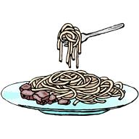 Dinner
Date: Friday September 23rd, 2011
Time: 5:30-7:30pm
Where: VFW Post 4360 (located behind ball park)
226 Cypress Lane
Palm Springs, FL 33461

Tired of eating fast foods but don’t feel like cooking? How about a delicious home cooked spaghetti dinner with all of the trimmings? You will find the price just as delightful as the meal, $7.00 per person. Your meal includes a fresh salad, spaghetti dinner with garlic bread and a delicious dessert.

Your tax deductable gift will enable the Florida Outreach Center for the Blind to provide important programs, at no charge, to any blind person who needs help.

Contact Carolyn Lapp at (561) 642-0005 or email at info_focb@bellsouth.net

