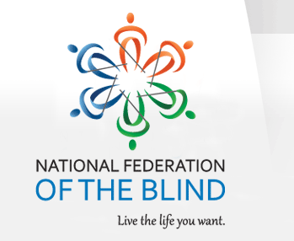

NATIONAL FEDERATION OF THE BLIND OF FLORIDA ANNOUNCEMENT
NFBF NOW ACCEPTING student scholarship APPLICATIONS

The National Federation of the Blind of Florida (NFBF) is now accepting student scholarship applications for 2015. Recipients will receive their scholarships at the 2015 NFBF State Convention scheduled for the Martin Luther King, Jr. Day Weekend. From Friday January 16 thru Monday January 19.

Qualified high school seniors and college students should complete the NFBF Scholarship Application Form in Microsoft Word format and return to:

Paul Martinez
Scholarship Chairperson
paul09ms@gmail.com
Cell Phone: (813) 390-5720

NOTE: Please ask that your letters of recommendation and transcripts also be sent by email to Mr. Martinez.
The National Federation of the Blind of Florida will be awarding three scholarships in the amount of $1,500 each at the annual convention banquet scheduled for Sunday evening, January 18, 2015. To qualify, students must be legally blind, have a minimum cumulative grade point average of 2.70, and attend the entire State Convention with assigned mentors. In addition, all scholarship applicants must provide academic transcripts and complete all components of the scholarship form. Winners will have their ground transportation, convention registration and banquet fees, as well as room and board, covered by the NFBF state affiliate. Completed applications are due to Paul Martinez no later than November 15, 2014. Winners will receive their awards at the annual convention banquet on Sunday evening, January 18, 2015.

NATIONAL FEDERATION OF THE BLIND OF FLORIDA (NFBF)
2015 STUDENT SCHOLARSHIP APPLICATION

FULL NAME:

ADDRESS:

TELEPHONE NUMBER DAYTIME:

EVENINGS & WEEKENDS:

EMAIL:

EDUCATION:
Name of college you are attending or to which you have been accepted:

ACADEMIC MAJOR:

NUMBER OF COLLEGE CREDITS COMPLETED:

CUMULATIVE GRADE POINT AVERAGE:

COLLEGE-RELATED ACTIVITIES & HONORS:

NAME OF HIGH SCHOOL ATTENDED:

HIGH SCHOOL GRADE POINT AVERAGE:

HIGH SCHOOL ACTIVITIES & HONORS:

PERSONAL:
HOBBIES AND SPECIAL INTERESTS:

EMPLOYMENT HISTORY:

Please describe why you believe you should be selected as an NFBF scholarship winner, including accomplishments and aspects of your personality that the scholarship committee should consider in 500 words or less.

Are you an active member of the National Federation of the Blind?

If "yes," please provide your Chapter’s name:

Have you ever attended an NFBF state convention?

Have you ever attended a national NFB convention?

Please provide at least two letters of support along with a current transcript.

The National Federation of the Blind knows that blindness is not the characteristic that defines you or your future. Every day we raise the expectations of blind people, because low expectations create obstacles between blind people and our dreams. You can live the life you want; blindness is not what holds you back.

