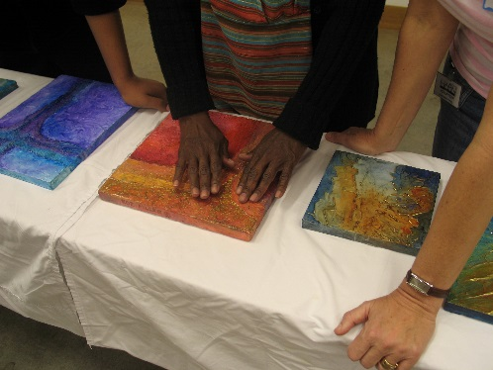
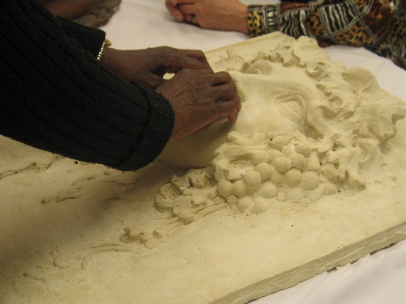

Access Art
Harn Museum of Art
Saturday, March 21, 2015
3259 Hull Road, Gainesville, FL

Community Art Installation
11 a.m. – 2 p.m.
Experience art through senses other than sight as you enjoy this touchable installation and engage in conversation with local artists. Individuals with all levels of sight are invited to participate. No registration necessary.

Guided Tours
10:15 a.m. – 11:15 a.m., 11:15 a.m. – 12:15 p.m.
Visitors who are blind or have low vision are also invited to register for guided tours incorporating verbal descriptions and tactile images of select oil paintings on view in Highlights from the Modern Collection and Monet and American Impressionism. To register, visit harn.ufl.edu/accessart or call 352-392-9826 ext. 2172.

Questions? Contact Elizabeth King, Visitor Engagement and Volunteer Coordinator at 352-392-9826 ext. 2172 or eking@harn.ufl.edu
