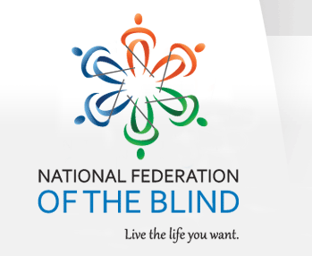
December 28,2015

National Federation of the Blind
Treasure Coast Chapter

Come join the Treasure Coast Chapter of National Federation of the Blind for its monthly meeting on Tuesday, January 12, 2016, From 11am-2pm at WQCS Radio Station @ IRSC, 3209 Virginia Avenue, Fort Pierce. Our guest speaker this month will be Rosemary Mulero. Rosemary works at the Lighthouse for the Blind in the Palm Beaches. She will explain all of the programs that are available for the blind and will be able to answer any questions that you may have. Please RSVP to Tim Edwards, President of the Treasure Coast Chapter, at 630-432-5090 or you can email Tim at tred34990@gmail.com

Please feel free to share this flyer with other families and professionals, so that they would be able to attend this lecture with our special speaker.

Mark your calendar for the following guest speakers
February 9th Mayor Gregory Oravec Mayor of Port ST. Lucie County
March 8th Cathy Alice Koyanagi Caregivers
April 12th Dr. Timothy Schoen Foundation fighting Blindness
May 10th Fun Day

