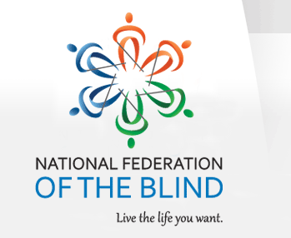
March 3, 2016

National Federation of the Blind
Treasure Coast Chapter

Come join the Treasure Coast Chapter of National Federation of the Blind for its monthly meeting on Tuesday, March 8th, From 11am-2pm at WQCS Radio Station @ IRSC, 3209 Virginia Avenue, Fort Pierce. Our guest speaker this month will be Gertrude Walker; Gertrude is the Supervisor of Elections in St. Lucie County. She will be able to answer any concerns that we may have in reference to voting/using the voting machines. Please RSVP to Tim Edwards, President of the Treasure Coast Chapter, at 630-432-5090 or you can email Tim at tred34990@gmail.com

Please feel free to share this flyer with other families and professionals, so that they would be able to attend this lecture with our special speaker.

Mark your calendar for the following guest speakers
April 12th Dr. Timothy Schoen PhD Foundation Fighting Blindness
May 10th Fun Day
June 14th

